UNIT 5: NATURAL WONDERS OF VIET NAM.
Period 34: Getting Started. (On Zoom)
I. OBJECTIVES:
- By the end of the lesson, students will be able to:
+ Identify the lexical items related to the topic Natural wonders of Viet Nam;
+ Use the vocabulary and structures to describe wonders of Viet Nam.
1. Knowledge:
a. Vocabulary: Words related to “Things in nature”
b. Grammar: Making suggestions and superlatives of short adjectives.
2. Ability: Reading, listening and speaking skill.
3. Qualities:
- Ss have positive attitude in English language learning so that they actively participate in all classroom activities.
- Ss know more about natural wonders in Viet Nam.
- Ss love our coutry and have good attitude to preserve the nature.
II. MATERIALS:
1. Teacher: Textbooks, plan, computer.
2. Students: Text book, workbook, notebook and computer or phone with internet.
III. TEACHING PROCEDURE:
1.Warm up :
a. Aims: Attracts students’attention to the lesson.
b. Content: Net work.
c. Product: Ss can do the task.
d. Organization: T - WC
Teacher’s Activities | Students’ Activities
- Greetings.  - Check attendances and the date.  *Net work:  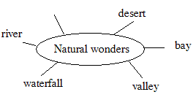 | - Greetings.  - Monitor answers: ………………  - Ss work in two teams.
2. Presentation:
a. Aims: Help students understand the dialogue, explain the meanings of words and phrasals in the dialogue.
b. Content: - The dialouge
- Vocabularies related to the topic ‘Natural wondres”.
c. Product: Ss can practise the dialouge.
d. Organization: Group work and individual work
Teacher’s Activities | Students’ Activities
* Pre teach vocabulary  - Teacher use different techniques to teach vocab (pictures, situation, realia)  - Follow the seven steps of teaching vacab.  * Checking vocab: What and where  * Listen and read:  - Teacher draws students’ attention to the picture in the textbook and asks them questions about the picture.  - Tell Ss that Alice, Elena, Nick and Tommy are in the Geography Club, talking about natural wonders of Viet Nam such as Ganh Da Dia and Ha Long Bay, and that they are going to listen to their talk.  - Play the recording two or three times, or more if necessary for Ss to listen and read along.  - Have Ss underline the words related to the topic of the unit while they are listening and reading.  - Call on some pairs of Ss to read the conversation aloud. | I. Vocabulary:  - scenery (n): khung cảnh  - natural (adj): tự nhiên  - forest (n): rừng  - amazing (adj): đáng ngạc nhiên  - island (n): đảo  - desert(n): sa mạc  - waterfall (n): thác nước  - cave (n): hang động  - Repeat in chorus and individually  - Copy all the words  II. Listen and read:  - Ss listen and answer:  - Who are they?  - What are they looking at?  - What are they talking about?  Suggested answers:  - They are Alice, Elena and Nick.  - They are looking at some photos/ pictures.  They are talking about attractive places in Viet Nam.  - Ss role play
3. Practice:
a. Aims: Ss can practise the dialogue and more vocabularies about nature.
b. Content: The dialogue and vocabularies about nature.
c. Product: Ss can complete exercises.
d. Organization: Team work, pair work and individual work
Teacher’s Activities | Students’ Activities
- Teacher tells students to read the text again in order to find the words to complete the sentences independently.  - Teacher allows students to share their answers before discussing as a class.  - Teacher nominates students to give answers and corrects them if necessary.  - Teacher asks students to look at the words in the box, listen and repeat.  - Teacher has students match the pictures with the appropriate words independently.  - Teacher allows students to share their answers before discussing as a class.  - Teacher asks students to give answers and corrects them if necessary. | Task 2: Complete the following sentences with the words from the box. (p. 49)  - Ss work individually  - amazing  - islands  - scenery  - natural  5. wonders  Task 3: Listen and repeat the words, then label the pictures. (p. 49)  - Ss work individually  a. desert  b. island  c. cave  d. river  e. waterfall  f. mountain  g. forest  h. beach
4. Production:
a. Aims: To help Ss know more about natural wonders of Viet Nam.
b. Content: Natural wonders of Viet Nam.
c. Product: Ss can do the task.
d. Organization: Group work
Teacher’s Activities | Students’ Activities
- Teacher divides the class into groups of four or five and provides each group with a set of A and B signs.  - Teacher gives students time to read the quiz carefully and choose the correct answers.  -Then, teacher lets students randomly select a number on the screen to choose the question.  - Students raise the correct signs of A or B choose the answer and say the answer aloud.  - The quickest group gets 5 points for each correct answer.  - At the end of the activity, 3 groups having the high points are the winners. | Task 4: QUIZ  Work in groups. Choose the correct answer to each of the questions. (p. 49)  1. Which is an island in Viet Nam?  - A. Con Dao.  2. Where is Mount Fansipan?  - A. In Lao Cai.  3. Which of the following is a national park?  - B. Cat Tien Park.  4. Which of the following wonders is a cave?  - B. Phong Nha.  5. Which waterfall is in Cao Bang?  – B. Ban Gioc Waterfall.
* Homework:
- Learn by heart Vocabulary.
- Practice the dialogue
- Prepare “Unit 5: A closer look 1”

Prepare: ...../....../2022
Teach: ...../....../2022
UNIT 5: NATURAL WONDERS OF VIET NAM.
Period 35: A closer look 1.
I. OBJECTIVES:
By the end of the lesson, students will be able to:
- Use the lexical items related to the topic Natural wonders of Viet Nam;
- Use the vocabularies and structures to talk about famous natural places; pronounce and recognize the sounds /t/ and /d/.
1. Knowledge:
a. Vocabulary: words related to the topic “things in nature” and “travel items”
b. Grammar: The present simple.
c. Pronunciation: Practise pronouncing the sounds /t / and /d/ in isolation in context.
2. Ability: Reading, listening and speaking skill.
3. Qualities:
- Ss have positive attitude in English language learning so that they actively participate in all classroom activities.
- Ss know more about natural wonders in Viet Nam.
- Ss love our coutry and have good attitude to preserve the nature.
II. MATERIALS:
1. Teacher: Textbooks, plan, computer.
2. Students: Text book, workbook, notebook and computer or phone with internet.
III. TEACHING PROCEDURE:
1.Warm up:
a. Aims: Attracts students’attention to the lesson.
b. Content: Brainstorming.
c. Product: Ss can do the task.
d. Organization: Individual work and pair work.
Teacher’s Activities | Students’ Activities
- Greetings.  - Check attendances and the date.  *Brainstorming:  - Imagine you are going to have a picnic, What things can you bring with?  TRAVEL ITEMS  Sleeping bag | - Greetings.  - Monitor: ………………………  - Ss work in two teams:
2. Presentation:
a. Aims: Students can know to use some new words about travel items.
b. Content: Vocabularies about travel items.
c. Product: Ss can understand and use the vocabulary.
d. Organization: Individual work and team work.
Teacher’s Activities | Students’ Activities
* Pre teach vocabulary:  - Teacher use different techniques to teach vocab (pictures, situation, realia)  - Follow the seven steps of teaching vocab.  - Check Vo by matching. | A. Vocabulary:  - plaster (n): miếng dán, gạc y tế  - sleeping bag (n): túi ngủ  - backpack (n): ba lô  - compass (n): la bàn  - suncream (n): kem chống nắng  - scissors (n): cái kéo  - Repeat in chorus and individually  - Copy all the words
3. Practice:
a. Aims: Ss can know how to use words about travel items pronounce correctly the sounds /t/ and /d/ in isolation and in context.
b. Content: Vocabularies about travel items; sounds /t/ and /d/.
c. Product: Ss can complete exercises
d. Organization: Individual work.
Teacher’s Activities | Students’ Activities
A. Vocabulary:  - Teacher asks students to write the suitable word under each picture in 2 minutes.  - Students do the task.  - Teacher calls some students to give their answers.  - Teacher gives feedback and corrections (if necessary).  - Teacher asks students to use the words in task 1 to complete the sentences.  - Students work individually.  - Teacher calls some Ss to share their answers with the whole class.  - Teacher gives feedback and corrections (if necessary).  - Teacher asks students to work in groups of three.  - Teacher gives students 3 minutes to discuss and put the item in the order of usefulness.  - Teacher asks students to share their answers as a whole class.  - Teacher gives corrections (if necessary).  B. Pronunciation:  - Teacher introduces 2 sounds /t/ and /d/ to students and lets them watch a video about how to pronounce these two sounds.  - Teacher asks students to give some words they know containing these sounds.  - Teacher asks students listen to the recording for the first time.  - Teacher asks students to listen and repeat the words for the second time. | A. Vocabulary:  Task 1: Write a word under each picture. Practise saying the words.  - Ss work individually  - plaster  - suncream  - sleeping bag  - scissors  - backpack  6. compass  Task 2: Complete the sentences with the words in task 1. (p. 50)  * Answer key:  - compass  - suncream  - sleeping bag  - backpack  - plaster  Task 3: Now put the items in order of usefulness. Number 1 is the most useful, number 6 is the least useful on holiday.  1. backpack 2. sun cream 3. plaster  4. scissors 5. compass 6. sleeping bag  B. Pronunciation:  * Sounds /t/ and /d/  * Suggested answers:  /t/: plaster, tower, letter, desert, want  /d/: need, island, guide, holiday, pagoda  Task 4: Listen and repeat the words. (p. 51)
  /t/ | /d/
  mountain  waterfall  desert  plaster | wonder  island  guide  holiday
4. Production:
a. Aims: Ss can practice the sounds /t/ and /d/.
b. Content: Listen and repeat sounds /t/ and/d/.
c. Product: Ss can do the task.
d. Organization: Individual work
Teacher’s Activities | Students’ Activities
- Teacher plays the recording for students to listen and asks students to repeat the sentences after they listen.  - Teacher calls some students randomly to read the sentences and gives correction (if necessary).. | Task 5: Listen and repeat. Pay attention to the bold-typed parts of the words. (p. 51)  1- Where's my hat? - Oh, it's on your head.  2. Where do they stay on their holiday?  3. I need some meat for my cat.  4. The Sahara is a very hot desert.  5. I want to explore the island by boat.
* Homework:
- Learn by heart all the new words.
- Do exercise A1, 2 in work book.
- Prepare: Unit 5: A closer look 2.
Prepare: .../.../2022
Teach: .../.../2022
UNIT 5: NATURAL WONDERS OF VIET NAM.
Period 36: A closer look 2.
I. OBJECTIVES:
- By the end of the lesson, Ss can:
+ Use countable nouns and uncountable nouns;
+ Use quantifiers some, many, much, a few, a little with countable nouns and countable nouns;
+ Use “must” and “mustn’t” to make classroom rules.
1. Knowledge:
+ Vocabulary: Lexical items related to the topic: Natural wonders of Viet Nam.
+ Grammar: Countable & uncountable nouns; Modal verbs: must and musn’t
2. Ability:
- Reading, speaking and writing skill.
3. Quality:
- Ss have positive attitude in English language learning so that they actively participate in all classroom activities.
- Ss know more about natural wonders in Viet Nam.
- Ss love our coutry and have good attitude to preserve the nature.
II. MATERIALS:
1. Teacher: Textbooks, plan, computer or phone with internet.
2. Students: Text book, workbook, notebook, computer or phone with internet.
III. TEACHING PROCEDURES:
1. Warm - up:
a. Aims: Review the old lesson, warm up the class and lead in the lesson.
b. Content: Game: Unscrambled words
c. Product: Ss’ can do the task.
d. Organisation: Whole class, group.
Teacher’s Activities | Students’ Activities
- Greetings.  - Check attendances.  * Unscrambled words  - Teacher divides the class into groups of 3-6 students.  - Teacher delivers a set of unscrambled words which are some countable and uncountable nouns to each group.  - Students will have to work in groups to solve the quiz.  - The group with more correct sentences will be the winner.  - Teacher provides or confirms the answers and lead in the grammar focus of the lesson:  - Lead in : Today we are going to learn more about countable and uncountable nouns. | - Greetings.  - Monitor……………………………….  * Game: Unscrambled words  * Answer key:  The words “cream, rice, juice, butter” are uncountable nouns.  The words “rock, island, backpack, plaster” are countable nouns.
  1. cream  2. rock  3. island  4. rice | 5. juice  6. butter  7.backpack  8. plaster
2. Presentation:
a. Aims: Help Ss know how to use countable, uncountable nouns; must / mustn’t
b. Content: Countable, uncountable nouns; must / mustn’t
c. Product: Ss understand the grammar.
d. Organisation: Whole class.
- Teacher draws students’ attention to the underlined words and confirm the use of countable and uncountable nouns  - Teacher then asks students to give some more examples of uncountable nouns that they know.  - Teacher reminds students to the “definition of countable nouns”  - T explains the usage and the form.  - Ss listen and copy down.  - Teacher gives students a handout of each definition of each quantifiers.  - Teacher has students work in groups of 4 to match the words in column A with definitions in column B.  Teacher then asks students to exchange their handout to check their classmates’ answers  - T explains the usage and the form.  - Ss listen and copy down.  - Ask Ss to recall the conversation from GETTING STARTED: Alice - the leader of the Geography Club tells Elena: But remember you must always be on time.  Alternatively, T may ask Ss such questions: Are you sometimes late for class? What does your teacher say?  Then encourage Ss to answer, using must I mustn't.  For a weaker class, T may call on some Ss to give the Vietnamese equivalent of must I mustn't.  - Tell Ss to study the Remember! box, then give the rules of the modal verb must I mustn't.T may give some examples to clarify the use of must I mustn't to Ss. | 1. Countable and Uncountable nouns:  - “Countable nouns are for the people and things we can count using numbers. Countable nouns can be singular."  - “Uncountable nouns are for the things that we cannot count with numbers. They usually do not have a plural form.”  1. uncountable nouns don't have a plural form: cream, chocolate,...  2. countable nouns can be singular: a rock, an island ..., or plural: rocks, islands...  2. Some, many, much, a few, a little:  - * Answer key:  How to use: Some, many, much, a few, a little:  3. Modal verb: must / mustn’t  + Form: subject + must + base form  subject + mustn’t + base form  + Usage:  - We use must to say that something is very necessary or very important.  - We use mustn’t to say that doing something is not allowed.
  QUANTIFIERS | USE
  1. many | countable nouns, usually in negative statements and questions
  2. much | uncountable nouns, usually in negative statements and questions
  3. a few | countable nouns, means ‘some’
  4. a little | uncountable nouns, means ‘some’
  5. some | countable nouns, uncountable nouns
3. Practice:
a. Aims: Help Ss use countable, uncountable nouns; must / mustn’t to do some exercises.
b. Content: Countable, uncountable nouns; must / mustn’t
c. Product: Ss can do the tasks.
d. Organisation: Whole class, individual work, pairwork, groupwork.
Teacher’s Activities | Students’ Activities
- Teacher has students complete the underlined activity individually.  - Teacher then asks students to give out the answers.  - Teacher has students work on the exercise individually.  - Teacher gives feedback as a class discussion.  - Ss work individually. Tell them to read the sentences carefully and find the right words to complete the sentences.  - Check the answers as a class  - Teacher has students work on the exercise individually before they compare answers with each other.  - Teacher gives feedback as a class discussion. | Task 1: Is the underlined noun countable or uncountable? Write C (countable) or U (uncountable). (p. 51)  - Ss work individually  1 – C 2 – U 3 – U 4 – C 5 – U  Task 2: Choose the correct option for each sentence. (p. 52)  - Ss work individually  - A – 2.B – 3.A – 4.B – 5.A  Task 3: Fill each blank with a, any, some, much, or many.  - Ss work individually  1. Many 2. Any 3. Much 4 . some 5. A  Task 4: Fill each blank with must or mustn’t  - Ss work individually  - must  - musn’t  - must  - mustn’t  5. must
4. Production:
a. Aims: To help students more practice on using must or mustn't in the real context of their classroom.
b. Content: More practice on using must or mustn't.
c. Product: Ss can do the task.
d. Organisation: Group work.
- Ask Ss to study sentence 1 (positive), and sentence 2 (negative).  Then ask them to think of the classroom rules (what they must do and what they mustn't do) and complete the sentences 3 and 4, and write their own sentences for 5.  - Ss can share their ideas in pairs, and give as many sentences as possible.  - Call on some Ss to read their sentences in front of the class. Discuss answers as a class. | Task 5: Read the classroom rules below. Write some more rules for you and your classmates.  1. We must arrive school on time.  2. We mustn't get out of class before breaktime.  3. We must raise our hands when we want to ask questions in classroom.  4. We musn't gossip in class.  5. We must be gentle with each other.  6. We mustn't eat during lesson.
* Homework: - Prepare: Unit 5: Communication.
- Do exercise B4, 5, 6 (WB).

Prepare: .../.../2022
Teach: .../.../2022
UNIT 5: NATURAL WONDERS OF VIET NAM.
Period 37: Communication.
I. OBJECTIVES:
- By the end of the lesson, students will be able to:
+ Make and accept appointments;
+ Have knowledge about a travel guide;
+ Use must and mustn’t to talk about what to prepare for a trip.
1. Knowledge:
a. Vocabulary: lexical items related to the lesson.
b. Grammar: Making and accepting appointments.
2. Ability:
Reading, speaking and listening skills.
3. Quality:
- Ss have positive attitude in English language learning so that they actively participate in all classroom activities.
- Ss know more about natural wonders in Viet Nam.
- Ss love our coutry and have good attitude to preserve the nature.
II. MATERIALS:
1. Teacher: Textbooks, plan, computer or phone with internet.
2. Students: Text book, workbook, notebook, computer or phone with internet.
III. TEACHING PROCEDURES:
1. Warm - up:
a. Aims: To warm up the class and lead in the lesson.
b. Content: Revision old lesson
c. Product: Ss’ answers.
d. Organisation: Whole class, individual work.
Teacher’s Activities | Students’ Activities
- Greetings.  - Check attendances.  * Revision:  - Asks Ss to make 2 sentences with “must” and 2 sentences with “mustn’t”  - Lead in:  - Teacher sets the scene.  - They are Duong and Steven. Steven wants Duong to go picnic with him this Sunday. What structures can he use? If Duong agrees, what does he say?  - Students give their answers.  Teacher leads students into the lesson by telling about what they are going to learn: “We are going to learn how to make and accept appointments | - Greetings.  - Monitor……………………………….  - Work individually  - Ss listen and give answers
2. Presentation:
a. Aims: To introduce how to make and accept appointment.
b. Content: Listen and read the short conversation, paying attention how to make and accept appointments.
c. Product: Understand and know how to make and accept appointments;
d. Organisation: Whole class, pair work.
- Teacher asks students listen and read the short conversation, paying attention to the highlighted parts.  - Teacher writes down highlighted parts on the board and asks students what they are used to, which is used to make appointments and which is used to accepting appointments.  - Teacher calls some students to share their opinions.  - Teacher gives more explanations and elicit the form. | Task 1: Listen and read the short conversation, paying attention to the highlighted parts.  - Ss listen and copy down:  - Making appointments:  Let’s + V.  How about …?  - Accepting appointments:  That’s fine.  Sure.
3. Practice:
a. Aims: Help students practise making and accepting appointments; using must and mustn’t to talk about what to prepare for a trip.
b. Content: Making and accepting appointments; using must and mustn’t to talk about what to prepare for a trip.
c. Product: Ss can do the tasks.
d. Organisation: Whole class, pairwork, group work.
- Teacher asks students to work in pairs and make a short conversation, following the example.  - Teacher models with a volunteer.  - Students do the task in pairs.  - Teacher calls some pairs to make a conversation in front of the class.  - Teacher gives feedback and corrections (if necessary).  - Teacher shows the picture and ask students some questions:  Next week, I am going mountain climbing. Can you guess where I am going to? (Himalayas)  Before we go, what should we read? A tour guide  What information can you read in a tour guide?  - Teacher asks students to read the travel guide entry and sets the time limit for reading task for 2 minutes.  - In group of 3, students write as many things they must and mustn’t bring to the Himalayas as they can in 2 minutes.  - Teacher calls some groups to give their answers and checks. | Task 2: Work in pairs. Make a short conversation, following the example in Task 1.  - Ss work in pairs  Huy: Nam, let's go to the supermarket this Sunday morning.  Nam: That's great. What time can we meet?  Huy: How about 8 o'clock?  Nam: Sure, I'll meet you at that time.  Task 3: Read the travel guide entry. (p. 53)  - Ss look at the pictures and answer  - Ss work individually  Task 4: Make a list of the things you must bring to the Himalayas. Then add things you mustn’t bring. (p. 53)
  MUST | MUSTN’T
  - compass  - sleeping bag  - plaster  - packback  - waterproof coat | - bicycle  - shorts  - T-shirt
4. Production:
a. Aims: To help students practice asking and answering about travel preparation to a place.
b. Content: Practice asking and answering about travel preparation to a place.
c. Product: Students’ presentation.
d. Organisation: Group work.
- Teacher divide the class into 2 main group. One is a tour guide and one is a tourist.  - The tourist prepares the questions and the tour guide prepare the information in 2 minutes.  - Students work in pair. Make a conversation.  - Teacher calls some pairs to talk in front of the class.  - Peer check and then teacher gives feedback | Task 5: Role-play being a tour guide and a tourist.  Tell your partner what to prepare for their trip to the Himalayas, and give reasons.  Example:  A: I'd like to go to the Himalayas next month.  B: OK. I think you must bring a waterproof coat. It's cold and rainy there!  A: Yes. Anything else?  B: You must bring a sleeping bag so that you can stay here overnight. You must also bring a compass in case you are lost.  A: Is there anything I mustn’t bring?  B: Well, you mustn’t bring bicycle because you can’t ride it here and it’s very cold, so you mustn’t bring shorts or T- shirt.  A: Thanks a lot.
* Homework:
- Prepare: Unit 5: Skills 1.
- Learn by heart the new language.
- Do Ex C1, 2 (WB).

Prepare: .../.../2022
Teach: .../.../2022
UNIT 5: NATURAL WONDERS OF VIET NAM.
Period 38: Skills 1.
I. OBJECTIVES:
By the end of the lesson, students will be able to:
+ Develop reading skill for general and specific information about the topic;
+ Use the lexical items related to the topic ‘things in nature’ and ‘travel items’;
+ Use what they have learnt to talk about a famous place, and what people must/ mustn’t do there.
1. Knowledge:
+ Vocabulary: Lexical items related to the topic “Natural wonders of Viet Nam”
+ Grammar: Modal Verb: must in advice
2. Ability:
Reading and speaking skill.
3. Quality:
- Ss have positive attitude in English language learning so that they actively participate in all classroom activities.
- Ss know more about natural wonders in Viet Nam.
- Ss love our coutry and have good attitude to preserve the nature.
II. MATERIALS:
1. Teacher: Textbooks, plan, computer or phone with internet.
2. Students: Text book, workbook, notebook, computer or phone with internet.
III. TEACHING PROCEDURES:
1. Warm - up:
a. Aims: To warm up the class and lead in the lesson.
b. Content: Game: Hidden picture.
c. Product: Ss’ answers.
d. Organisation: Whole class, individual work.
Teacher’s Activities | Students’ Activities
- Greetings.  - Check attendances.  - Teacher sets the scene: “Next month, I am going travelling. Guess where I will visit.”  - Let’s students guess the places by opening the boxes one by one. The pictures are hidden behind the boxes.  - Teacher shows the pictures on the screen.  - Teacher leads in the lesson by asking questions: | - Greetings.  - Monitor: …………………….  Game: Hidden picture.    - Have you ever been to these places?”  “Today, let’s see what do they have.”
2. Pre - reading:
a. Aims: Help Ss understand some words related to the text and predict the text.
b. Content: Some words related to the text
c. Product: Ss’ vocabulary.
d. Organisation: Whole class, individual work, pairwork.
- Pre teach vocabulary  - Teacher use different techniques to teach vocab (pictures, situation, realia)  - Check Vo by matching  - Teacher asks students to close the book.  - Teacher shows the pictures of the places and asks students to answer the questions:  - Teacher invites some students to share their discussion in front of the class.  - Teacher asks students to open the book. Read the text and check their ideas. | - * vocabulary:  - tourist attraction (n): điểm thu hút khách du lịch  - popular (adj): phổ biến  - landscape (n): phong cảnh  - slope (n): dôc, sườn  - sand dune (n): cồn cát  - Repeat in chorus and individually  - Copy all the words  . * Discussing:  Task 1: Look at the pictures and make predictions about the reading. (p. 54)  1. What are the places?  2. What do you know about these places?  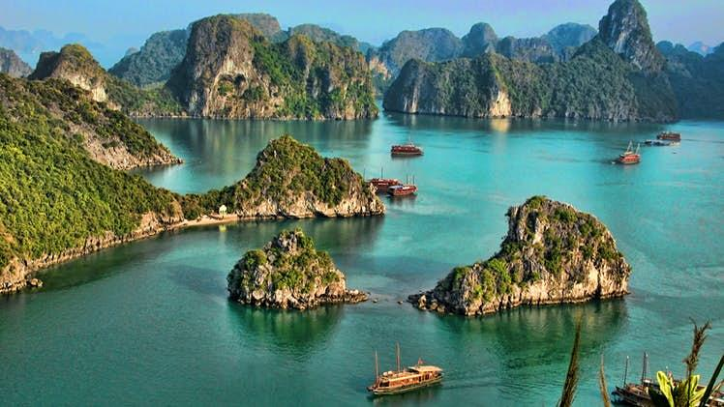  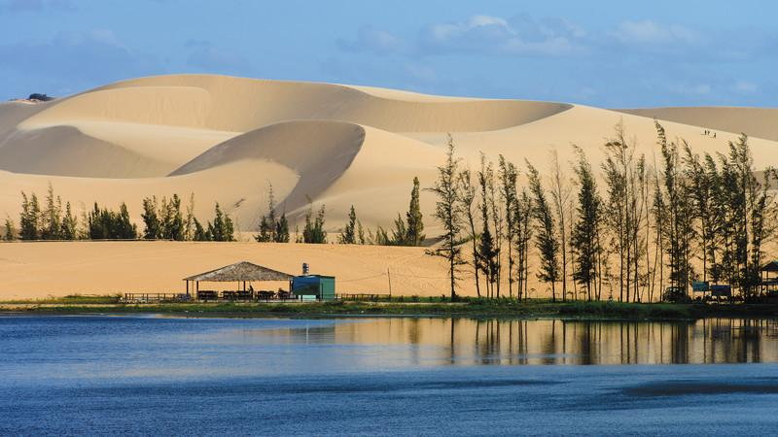
3. While - reading:
a. Aims: Help Ss read for general and specific information about some landscapes and answer the questions.
b. Content: General and specific information about some landscapes.
c. Product: Ss can understand the text.
d. Organisation: Whole class, individual work, pairwork.
- Teacher askes students to do Exercise 2 individually, in 3 minutes.  - After 3 minutes, teacher lets students swap their answers with their partner.  - Check the answers.  - T has Ss answer the questions by playing game: Lucky number. Class is divided into 2 groups.  - Teacher prepares 7 numbers which includes 5 questions about their school, and 2 lucky numbers.  - Each team takes turns and chooses a number and answers the question behind the number. If the team answers the question correctly, they will get 1 point. If the team chooses the lucky number, they get 1 point without answering the question and may choose another number. | Task 2. Complete the sentences, using the words from the box. (p. 54)  - Ss work individually  1. islands  2. wonder  3. desert  4. Remember  5. visit  Task 3: Read the text and answer the following questions. (p. 54)  - Ss work in two teams:  - Ha Long Bay is in Quang Ninh.  - You can enjoy great seafood and join in exciting activities.  - No, there isn’t. It’s like a desert, not a real desert.  - You can have a picnic in Mui Ne by the beach.  5. The best time to visit the Mui Ne Sand Dunes is early morning or late afternoon.
4. Post - reading: Speaking
a. Aims: Help Ss talk about famous / interesting places.
b. Content: Talk about famous / interesting places.
c. Product: Ss’ speaking.
d. Organisation: Individual work and groupwork.
- Teacher asks students to work in groups of 3 and make notes about one place in the reading.  - Compare the notes with other groups.  Teacher asks students to tell their partner about the place by looking at the notes.  - Students share their ideas with the whole class.  - Teacher asks students to work in groups of 5.  + Leader?  + Idea thinkers?  + Presenters?  + Drawers?  - Teacher asks students to choose a famous place in their city or area.  - Teacher asks students to discuss and make notes of the information they want to share with the class.  - Teacher asks students to refer to the questions as suggestions for their notes or they can do it in their own way. | Task 4: Work in pairs. Make notes about one of the places in the reading. You can add your own ideas. (p. 54)  * Example:  Ha Long Bay has a lot of interesting islands. It also has many caves and beautiful beaches. You can enjoy great seafood here and take part in exciting activities.  Task 5: Some foreign visitors are visiting your city/ town/ area. You are their tour guide. Tell them some interesting things about the place as well as what they must and mustn’t do there.  + Where is it?  + What does it have?  + Are there any interesting things here?  + What must they do or mustn’t do there?  * Example:  - You must wear sun scream when you're in My Khe beach  - You must go to the My Khe beach in late afternoon  - You mustn't litter on the beach.  - You mustn't swim alone.
  Ha Long Bay | Mui Ne
  - interesting island  - many islands and caves  - beautiful beaches  - great seafood  - exciting activities | - a beautiful place  - amazing landscapes  - different colour  - like a desert  - many activities
* Homework:
- Prepare: Unit 5: Skills 2.
- Learn by heart all the new words.
- Do Ex D1, 2 (WB).
Prepare: .../.../2022
Teach: .../.../2022
UNIT 5: NATURAL WONDERS OF VIET NAM.
Period 39: Skills 2.
I. OBJECTIVES:
By the end of the lesson, students will be able to:
+ Listening for specific information about a natural wonder;
+ Writing a paragraph about a natural wonder.
1. Knowledge:
+ Vocabulary: words related to the topic “things in nature” and “travel items”
+ Grammar: Making suggestions.
2. Ability:
Listening and writing skill.
3. Quality:
- Ss have positive attitude in English language learning so that they actively participate in all classroom activities.
- Ss know more about natural wonders in Viet Nam.
- Ss love our coutry and have good attitude to preserve the nature.
II. MATERIALS:
1. Teacher: Textbooks, plan, computer or phone with internet.
2. Students: Text book, workbook, notebook, computer or phone with internet.
III. TEACHING PROCEDURES:
1. Warm - up:
a. Aims: Check the old lesson, warm up the class and lead in the lesson.
b. Content: Name the places in the pictures.
c. Product: Ss’ Answer.
d. Organisation: Whole class, individual work.
Teacher’s Activities | Students’ Activities
* Greeting:  - Greet Ss and check their attendance.  - Check the date.  * Game: Look at the pictures and name the places in the pictures  - Teacher encourages students to complete the task individually.  - Teacher asks students to name the places in the pictures.  - Teacher shows the answer and check.  Lead in:  - T shows a picture on the screen and asks Guess the name of the destination.  Today we are going to listen to a talk about a famous natural wonder of Viet Nam. It’s Phu Quoc Island. | - Greetings.  - Monitor: ………………………….  - Ss work in two teams:  * Game: Look at the pictures and name the places in the pictures    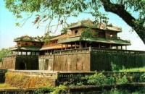  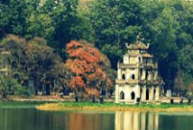  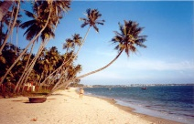  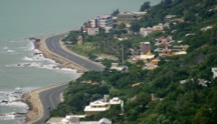  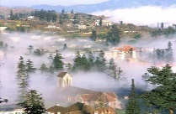  * Answer key:  1. Ha Long Bay 2. Hue 3. Ha Noi  4. Mui Ne 5. Vung tau 6. Sa Pa  Phu Quoc Island  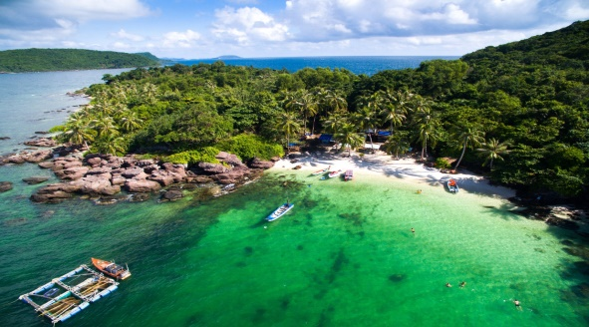
2. Pre - listening:
a. Aims: To prepare students for the listening text.
b. Content: Discuss and answer the question.
c. Product: Students’ predictions.
d. Organisation: Whole class, individual work.
- Teacher asks students to work in groups of four to answer the question:  “What do you know about Phu Quoc Island?”  - Teacher asks students to talk in Vietnamese (sometimes) if they do not have enough vocabulary in English.  - Teacher asks students to share what they have discussed to see what they know about Phu Quoc Island.  - Play the recording one or two times for Ss to check their answers. | Task 1: Work in groups. Discuss and answer the question. (p. 55)  “What do you know about Phu Quoc Island?”  * Suggested answers:  - a beautiful island in Viet Nam.  - the night market,  - The food is delicious  - In Kien Giang province  * Listen to the talk and check your answers
3. While - listening:
a. Aims: Help students listen and understand the talk.
b. Content: Listen and understand the talk.
c. Product: Ss can listen to the tape and do the tasks.
d. Organisation: Whole class, individual work.
- Teacher plays the recording once or twice.  - Teacher asks students to listen and tick the answers.  - Teacher calls on some students to read aloud their answers and correct the false one(s).  - Teacher checks students’ answers as a class. | Task 2: Listen and tick True or False.  * True – False prediction:  Answer key:  1. T  2. F (It has beautiful beaches and green forest.)  3. T  4. F (Sailing and fishing are popular water sports.)  5. T
4. Post - listening: Writing
a. Aims: Help students write a paragraph about a famous place.
b. Content: Write a paragraph about a famous place.
c. Product: Ss’s writing.
d. Organisation: Individual work.
- Teacher models the task by summarizing the information of the talk with a student using the questions in the network below:  - Teacher asks students to choose a travel attraction they know and individually brainstorm about that place using the network in Task 3.  - Teacher asks students to work in groups of four to introduce about their chosen places using the filled network.  - Teacher asks 1-2 students to stand up and talk about their chosen place then gives them comments.  - Teacher shows the picture in Task 4 and explains to students that they should begin the paragraph with a topic sentence for  - Teacher asks students to use ideas they have brainstormed to write a paragraph about 50 words about a travel attraction they know. | 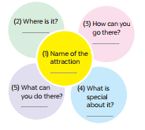  Task 3: Fill each blank in the network with the information about a travel attraction you know.  * Suggested answers:  T: What is the name of the attraction?  Ss: It’s Phu Quoc island  T: Where is it?  Ss: It’s in Kien Giang  T: How can you go there?  Ss: You can fly to the island because it has an international airport.  T: What can you do there?  Ss: I can visit the fishing villages, the national parks, beautiful beaches, temples, pagodas, etc. I can enjoy some water sports like Sailing and fishing or buy interesting things at the night market.  T: What is special about it?  Ss: It’s one of the most famous natural wonders of Viet Nam and thousands of tourists visit it every year.  Task 4: Write a paragraph about 50 words about a travel attraction you know. Use the information in Task 3.  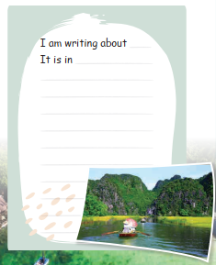  * Example:  I am writing about Ly Son island. It is a beautiful island in Quang Ngai province. And it’s not far from here. You can go there by ship . It is a pristine island with exotic seafood. Ly Son island is famous for its friendliness, long beautiful beaches, and being “the kingdom of garlic.” There you can enjoy great Vietnamese seafood; Especially King crab. You can go diving and swimming. You can join exciting activities. I think, you should have a visit to Ly Son.
* Homework:
- Rewrite the paragraph.
- Prepare: Unit 5: Looking back & Project.
- Do exercises: E1, 2 (WB).

Prepare: .../.../2022
Teach: .../.../2022
UNIT 5: NATURAL WONDERS OF VIET NAM.
Period 40: Looking back & Project.
I. OBJECTIVES:
By the end of the lesson, students can:
- Review the vocabulary and grammar of Unit 5.
- Apply what they have learnt (vocabulary and grammar) into practice through a project.
1. Knowledge:
+ Vocabulary: Lexical items related to topic: “things in nature” and “travel items”
+ Grammar: Revise the use of must /mustn't and countable and uncountable nouns.
2. Ability:
- Reading, speaking and writing skills.
3. Quanlity:
- Ss have positive attitude in English language learning so that they actively participate in all classroom activities.
- Ss know more about natural wonders in Viet Nam.
- Ss love our coutry and have good attitude to preserve the nature.
II. MATERIALS:
1. Teacher: Textbooks, plan, computer or phone with internet.
2. Students: Text book, workbook, notebook, computer or phone with internet.
III. TEACHING PROCEDURES:
1. Warm - up:
a. Aims: Warm up the class and lead in the lesson.
b. Content: Brainstormings.
c. Product: Ss’ answers.
d. Organisation: Whole class, team work
Teacher’s Activities | Students’ Activities
* Greeting:  - Greet Ss and check their attendance.  - Check the date.  * Brainstormings:  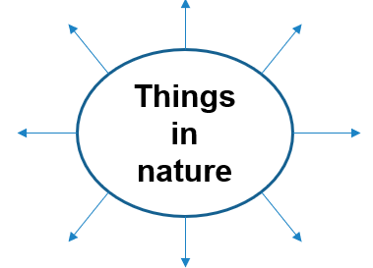  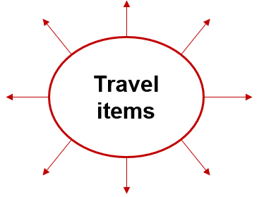 | - Greetings  - Monitor: …………………  - Ss work in two teams:  + Things in nature: desert, forest, mountain, lake, river, valley, cave, island, beach,…  + Travel items: lighter, scissors, sleeping bag, compass, plastic, backpack,….
2. Practice:
a. Aims: Help students review the vocabulary, the grammar related to the topic.
b. Content: The vocabulary, the grammar related to the topic.
c. Product: Ss can do the tasks.
d. Organisation: Whole class, individual work, pairwork.
Task 1:  - Teacher encourages students to complete the task individually.  - Teacher shows the answer and check  Task 2:  - Teacher asks students to work individually.  - Teacher checks the answers with the whole class.  Task 3:  - Teacher asks students to do this exercise individually.  - Teacher lets students compare their answers in pairs before checking as a class.  - Task 4:  Teacher asks students to work independently.  - Teacher asks students to read the sentences carefully and correct the mistakes.  - Students complete the task and discuss about the answers.  - Teacher gives feedback as a class discussion.  Task5:  - Teacher lets students to work individually complete the activity.  - Teacher asks students to make a role play.  - Teacher checks the answers with the whole class. | Task 1: Write the name for each picture.  - Ss work individually  1. waterfall 2. cave 3. desert  4. lake 5. beach 6. island  Task 2: Match the name of a natural wonder on column A with a word indicating it in column B.  - Ss work individually  1. d 2. c 3. a  4. e 5. f 6. b  Task 3: Write the words under the pictures.  Answer key:  1. scissors  2. sleeping bag  3. compass  4. backpack  5. plaster  Task 4: Find the mistake in each sentence and correct it. (p. 56)  * ANSWER KEY:  1. is / are  2. are / is  3. instrument /instruments  4. are / is  5. luggages / luggage  Task 5: Complete the dialogue, using must / mustn’t. (p. 56)  * Answer key:  1. must  2. must  3. mustn’t  4. must  5. mustn’t
3. Production:
a. Aims: Help Ss further practice on using countable and uncountable nouns, must / mustn’t.
b. Content: Further practice on using countable and uncountable nouns, must / mustn’t.
c. Product: Ss’ sentences.
d. Organisation: Individual work.
- T asks students work indepently.  - Ss rewrite the sentences using the words in brackets.  - Ss complete the sentences in the book.  - Teacher invites some students to give out the answers.  - T comments and gives marks. | * Rewrite the sentences using the words in brackets.  1. There are some chairs and a table in the kitchen.  We have…………………………………. .  2. Not many people can understand his lecture.  Only…………………………………….  ( some / a few people can understand his lecture)  3. It is wrong of us to throw rubbish.  We mustn’t …………………………..  4. It is necessary for us to be present at the class discussion on Saturday.  We must ……………………………..  5.The tour guide tells us not to throw rubbish.  The tour guide says that we………………
* Homework:
- Review the lesson.
- Do the project.
- Prepare: Unit 6: Getting started

