Teaching date: 07/9/2022
Period 2 UNIT 1: FREE TIME
Lesson 1.1 - Vocabulary and Reading (Page 4)

I. OBJECTIVES
By the end of the lesson, Ss will be able to:
1.1. Language knowledge and skills
- talk about their hobbies, using words: build models, bake cakes, make vlogs, read comics, play online games, collect soccer stickers.
- practice reading and understanding general and specific information about a teen’s hobby.
- use the Present Simple for talking about habits.
1.2. Competences
- improve communication, collaboration, analytical and critical thinking skills.
1.3. Attributes
- take up a useful hobby and spend a suitable amount of time on this hobby.
- build good habits for themselves and ditch bad ones.
II. TEACHING AIDS AND LEARNING MATERIALS
1. Teacher’s aids: Student book and Teacher’s book, class CDs, Digital Book (DCR phần mềm tương tác SB, DHA (từ vựng/ cấu trúc) phần mềm trò chơi tương tác), projector/interactive whiteboard / TV (if any), PowerPoint slides.
2. Students’ aids: Student’s book, Workbook, Notebook.
III. ASSESSMENT EVIDENCE
Performance Tasks | Performance Products | Assessment Tools
- Activate the free time activities that Ss may know.  - Match the words with the pictures in a.  - Listen and repeat.  - Compare Ss’ hobbies to Kate, or a classmate.  - Talk about Ss’ hobbies and what cool things they can make | - Ss’ answers in notebooks.  - Ss’ answers.  - Ss’ practice.  - Ss’ performance.  - Ss’ answers/ presentation. | - T’s feedback.  - T’s observation/ DCR.  - T’s observation.  - T’s feedback/Peers’ feedback.  - T’s feedback/Peers’ feedback.
IV. PROCEDURES
A. Warm up: (5’)
a. Objective: Introduce the new lesson and set the scene for Ss to acquire new language; get students' attention at the beginning of the class by enjoyable and short activities as well as to engage them in the follow-up steps.
b. Content: Introduce words about hobbies.
c. Expected outcomes: Ss have general ideas about the topic “free time activities”.
d. Organization of the activity:
TEACHER’S ACTIVITIES | STUDENTS’ ACTIVITIES
- Give greetings.  - Check attendance.  Option 1: Number the pictures.  - Use the “New words” part a.– page 4 for the warm-up activity.  - Show pictures and words (using DCR), have Ss number the pictures (in pairs).  - Call Ss to give answers.  - Give feedback and show correct answers (using DCR).  - Lead to the new lesson.  - Play the audio (CD1 – Track 02), have Ss listen and repeat.  - Correct Ss’ pronunciation if necessary.  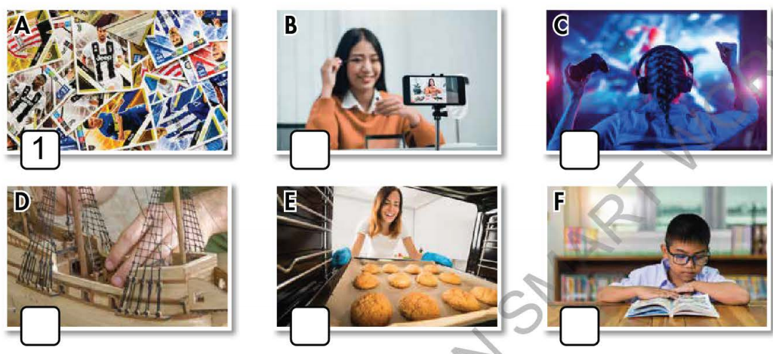  Option 2: Chatting.  - Ask Ss some questions about their free time activities:  Eg: - What do you often do in your free time?  - How much time do you spend doing it?  - Do you find it useful?  - Lead to the new lesson: Free time. | - Greet T.  - Work in pairs to number the pictures.  - Give answers.  - Listen.  Answer keys: A1 B4 C6 D2 E3 F5  - Answer the questions.  - Listen.
B. New lesson (35’)
Activity 1: Pre-Reading (Vocabulary) (12’)
a. Objective: Ss know words about free time activities.
b. Content:
- Vocabulary study (build models, bake cakes, make vlogs, read comics, play online games, collect soccer stickers).
- Speaking: Note more than 3 hobbies you know and discuss if you like them.
c. Expected outcomes: Ss know how to pronounce the new words correctly and use them in appropriate situations.
d. Organization of the activity:
TEACHER’S ACTIVITIES | STUDENTS’ ACTIVITIES
Task a. Number the pictures. Listen and repeat.  Option 1 (If the teacher hasn’t used this part for the Warm-up activity)  - Demonstrate the activity, using the example (using DCR).  - Have Ss number the pictures.  - Divide class into pairs and have them check their answers with their partners.  - Call Ss to give answers (read or write).  - Check answers as a whole class.  - Play audio (CD1 – Track 02) (using DCR). Have Ss listen and repeat.  - Correct Ss’ pronunciation.  Option 2: Matching. (If the teacher has used part a. for the Warm-up activity)  - Have Ss review the words they have known in the warm-up activity by matching words with pictures (T uses different pictures from those in the textbook).  - Call Ss to give answers (read or write).  - Check answers as a whole class.  - Call some Ss to read the words again.  - Correct Ss’ pronunciation if necessary.  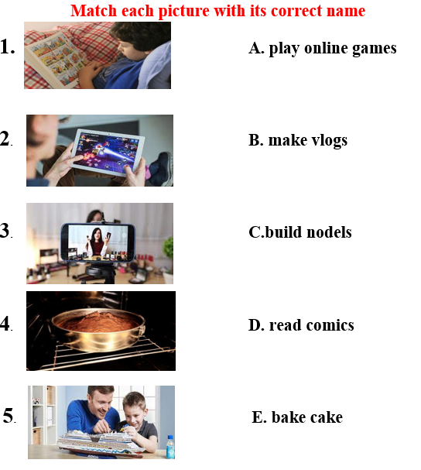  - For more practice and options, have Ss play a vocabulary game using DHA.  Task b. Note three more hobbies you know. Discuss if you like them.  Option 1:  - Have Ss talk in pairs about their hobbies using the new words and three other hobbies they know.  - Remind Ss to use the structure:  Do you like +V.ing …?  - Have Ss share their ideas in front of the class.  - Give feedback and evaluation.  Option 2: (for class with better students)  - Give Ss an extra activity: Have Ss work in groups to have a free talk about their hobbies. Encourage students to use their own ideas. Remind students to state whether they like these hobbies and whether these hobbies are useful or not.  - Call some groups to present their conversation with the class.  - Give feedback and evaluation. | - Look and listen.  - Work individually.  - Work in pairs.  - Give answers.  - Listen and repeat.  Answer keys:  A1 B4 C6 D2 E3 F5  - Work in pairs.  - Give answers.  - Read.  Answer keys  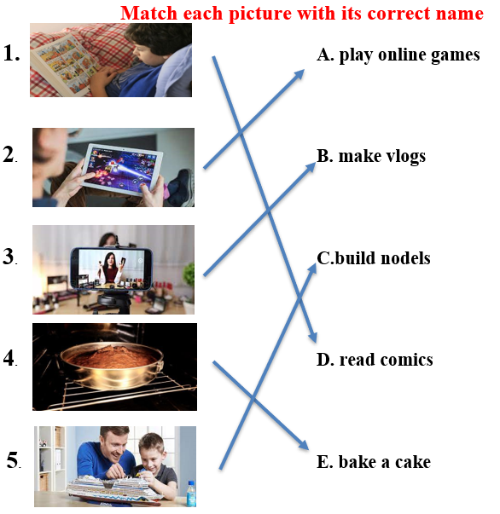  - Watch and play.  - Work in pairs.  - Present.  Suggested three more hobbies: playing sports, arranging flowers, making origami, …  - Work in groups.  - Present.  Suggested conversation  A: My hobby is playing online games. Do you like it?  B: Yes, I like it too  C: I think playing online games is relaxing, but it’s rather time-consuming.  A: Oh really? So what do you often do in your free time?  C: I collect old correction pen. I find this hobby not really challenging but relaxing
Activity 2: While - Reading
a. Objective: Students can develop their reading skills.
b. Content: Reading a teen blogger and choosing the best title, then circling the correct answer.
c. Expected outcomes: Students can read and understand general and specific information about a teen’s hobby.
d. Organization of the activity:
TEACHER’S ACTIVITIES | STUDENTS’ ACTIVITIES
Task a. Read Kate’s blog post and choose the best title.  Option 1:  - Ask Ss to read two options and find out key words.  - Show the task using DCR. Have Ss read the blog individually.  - Have Ss work in pairs to read the blog again.  - Have Ss circle the correct answers.  - Have some Ss share their answers with the class (read), explain for their answers.  - Give feedback.  - Give feedback and correct Ss’ answers if necessary.  Option 2:  - Have students look at the picture in part Reading a (using DCR) and ask them some questions about Kate:  What is her name?  What is her hobby?  What is the title of the blog?  - Retell students what a blog is  - Lead to the reading text.  - Have Ss read the questions and guess the answers.  - Have Ss read the blog and circle the correct answers – underline the supporting ideas.  - Have Ss check answers with their partners.  - Call Ss to give answers, explain.  - Give feedback and evaluation.  Task b. Now, read and circle the correct answers.  - Use DCR to show the task. Have Ss read the questions, underline key words and guess the answers.  - Have Ss read the blog again and circle the correct answers – underline or highlight the supporting ideas.  - Have Ss check answers with their partners.  - Call Ss to give answers, explain.  - Give feedback and evaluation. | -Work individually.  - Work in pairs.  - Circle the correct answers.  - Read answers, explain.  - Check answers.  Answer keys  1.My Model Collection  - Look and give answers.  - Listen.  - Read and do the task.  - Work in pairs.  - Give answers, explain.  Answer key: No  1. My Model Collection  - Read and underline.  - Do the task.  - Check answers.  - Give answers, explain.  Answer keys  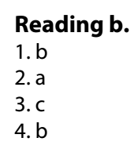
Activity 3: Post - Reading (6’)
a. Objective: Students can use the vocabulary and the sample text to develop their speaking skills.
b. Content: Speaking: What cool things can you make?
c. Expected outcomes: Students can have a free-talk about a cool thing they can make (What is it? How do you make it? What is it used for? Who helped you to make it…)
d. Organization of the activity:
TEACHER’S ACTIVITIES | STUDENTS’ ACTIVITIES
Task c. What cool things can you make?  - Have Students work in groups to talk about what cool things they can make.  -If there is enough time, ask Students to choose a cool thing to draw it (each group draws a picture).  -Have students hang the pictures on the board, ask the whole class to vote for the best picture.  -Make comments and announce the best picture. | - Work in groups to discuss and then draw.  - Take part in the class activities.
C. Consolidation and homework assignments (4’)
* Words about free time activities: build models, bake cakes, make vlogs, read comics, play online games, collect soccer stickers.
* Homework:
- Learn the new words by heart.
- Practice talking about your hobby.
- Do the exercises in Workbook: Lesson 1 - New words (page 2).
- Prepare: Lesson 1.2 – Grammar (page 5 – SB).
- Do the vocabulary exercise in Tiếng Anh 7 i-Learn Smart World Notebook (page 4).
****************************************************************
Teaching date: 09/9/2022
Period 3 UNIT 1: FREE TIME
Lesson 1.2 - Grammar (Page 5)
I. OBJECTIVES
By the end of the lesson, Ss will be able to:
1.1. Language knowledge and skills
- listen to 2 people asking and answering about a free time activity.
- talk about habits or things that happen regularly.
- use the Present Simple correctly.
- write simple sentences about habits.
1.2. Competences
- improve speaking, listening and writing skills.
- improve the use of English.
1.3. Attributes
- take up a useful hobby and spend a suitable amount of time on this hobby.
- build good habits for themselves and kick bad ones.
II. TEACHING AIDS AND LEARNING MATERIALS
1. Teacher’s aids: Student book and Teacher’s book, class CDs, Digital Book (DCR phần mềm tương tác SB, DHA (từ vựng/ cấu trúc) phần mềm trò chơi tương tác), projector/interactive whiteboard / TV (if any), PowerPoint slides, handouts.
2. Students’ aids: Student’s book, Workbook, Notebook.
III. ASSESSMENT EVIDENCE
Performance Tasks | Performance Products | Assessment Tools
- Listen and repeat.  - Fill in the blanks with the correct form of the verbs.  - Write sentences about habits using the pictures and prompts.  - Ask your partner about what they do and don’t do in their free time. | - Ss’ performance.  - Ss’ answers.  - Ss’ answers.  - Ss’ answers/ presentation. | - T’s feedback.  - T’s feedback/Peers’ feedback.  - T’s feedback/Peers’ feedback.  - T’s observation, T’s feedback/Peers’ feedback.
IV. PROCEDURES
A. Warm up: (5’)
a. Objective: Introduce the new lesson and set the scene for Ss to acquire new language; get students' attention at the beginning of the class by enjoyable and short activities as well as to engage them in the follow-up steps.
b. Content: Jumbled word or rearranging words to make a meaningful sentence.
c. Expected outcomes: Ss review words about hobbies or Ss have general ideas about the grammar point they are going to study in the new lesson.
d. Organization of the activity:
TEACHER’S ACTIVITIES | STUDENTS’ ACTIVITIES
- Give greetings.  - Check attendance.  Option 1: Game “JUMBLED WORD”  - Have Ss rearrange letters to make a meaningful word.  - Call Ss to give answers.  - Check Ss’ answers, give feedback and lead to the new lesson.  1. bbohy 2. deloms 3. Moiccs  4. lonnie 5. bouYutre  - Have Ss make sentences, using the words they have just made.  - For more vocabulary games, use DHA.  - Lead to the new lesson.  Option 2: REARRANGING  - Have Ss rearrange the words to make a meaningful English sentence.  1. do / do / free time / What / you / your / in?  2. play / you / Do / soccer?  3. reading / like / comics / I  4. online / He / on / plays / games / Sundays  5. We / on / like / movies / the / watching / weekends.  - Have Ss read their answers.  - Tell Ss about the grammar point they are going to study in the new lesson.  - Lead to the new lesson. | - Greet T.  - Take part in the game.  - Give answers (write on the board).  Answers keys  1. hobby 2. models 3. comics  4. online 5. Youtuber  - Read sentences.  - Work in pairs.  Answers keys  1. What do you do in your free time?  2. Do you play soccer?  3. I like reading comics.  4. He plays online games on Sundays.  5. We like watching movies on the weekends.  - Give answers.  - Listen.
B. New lesson (35’)
Activity 1: Presentation (10’)
a. Objective: Help Ss review Present Simple (form, usage).
b. Content:
- Listen and repeat.
- Review the form and usage of the Present Simple.
c. Expected outcomes: Ss remember the Present Simple and use it in some exercises that follow.
d. Organization of the activity:
TEACHER’S ACTIVITIES | STUDENTS’ ACTIVITIES
Task a. Listen and repeat.  - Have Ss look at the picture (using DCR).  - Play audio (CD1 – Track 03) and have Ss listen and read the speech bubbles.  - Play the audio again and have Ss listen and repeat.  Grammar box:  Option 1:  - Have Ss look at the grammar explanation (using DCR).  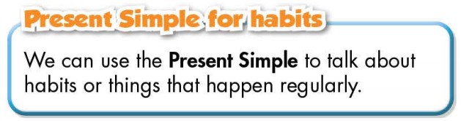  - Have Ss look at the box and read examples of different forms.  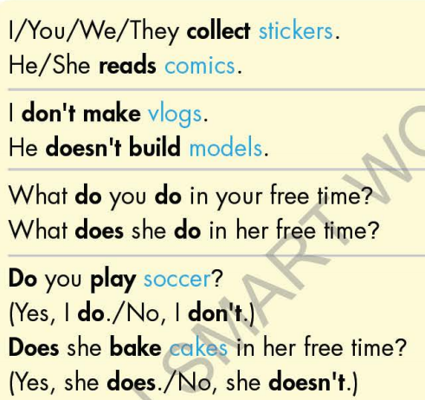  - Explain more about the form and the usage of the Present Simple, have Ss pay attention to the negative and the question form.  Form:  Be: (+) S + am / is / are + …  (-) S + am / is / are + not + …  (?) Am / Is / Are + S + …  Normal verb: (+) S + V _{s/es}  (-) S + don’t / doesn’t + V _{bare infinitive}  (?)Do / Does + S + V _{bare infinitive}  Usage: to talk about habits or things that happen regularly.  - Have some Ss read aloud the sentences in the Grammar Box aloud.  - Ask Ss to give more examples using the Present Simple.  Option 2:  - Have Ss close books.  - Give some model sentences, ask Ss to indicate which tense is being used, then have Ss retell form of the Present Simple.  *Suggested model sentences:  1. I always watch TV after I finish my exercises.  2. We go to the library every Saturday.  3. My father often has a cup of coffee every morning.  - Call Ss to give answers, comment on Ss’ answers  - Ask Ss: What are these sentences about?  - Then have Ss open the books and read the grammar box.  - Have Ss give more examples of the Present Simple,  encourage them to make sentences with their own ideas.  - Give feedback and evaluation. | - Look.  - Listen, then read.  - Listen and repeat.  - Look and read.  - Read.  - Listen and take notes.  - Read.  - Give examples.  - Close all books.  - Look and answer.  Expected answer: The sentences are about habits or activities that happen regularly.  - Read.  - Give examples.  - Listen.
Activity 2: Practice (19’)
a. Objective: Students can use the “Present Simple for habits” to do the given exercises.
b. Content:
- Filling in the blanks.
- Writing sentences about habits, using the pictures and prompts.
c. Expected outcomes: Students can get used to the use of Present Simple and use it correctly.
d. Organization of the activity:
TEACHER’S ACTIVITIES | STUDENTS’ ACTIVITIES
Task b. Fill in the blanks with the correct form of the verbs.  - Demonstrate the activity, using the example (using DCR).  - Have Ss fill in the blanks with the correct form of the verbs.  - Have Ss work in pairs to check each other’s work.  - Have some Ss share their answers with the whole class.  - Give feedback, correct Ss’ answers if necessary.  Task c. Write sentences about habits, using the pictures and prompts.  Option 1:  - Demonstrate the activity, using the example (using DCR).  - Have Ss write sentences about habits, using the pictures and prompts, remind Ss to pay attention to the form (negative, affirmative, or interrogative)  - Have Ss check answers with their partners.  - Call Ss to write answers.  - Check Ss’ answers, give feedback.  Option 2:  - Help Ss remember the activities in the pictures given in the exercise first (using DCR).  - Have Ss work in pairs to give names of activities in the pictures.  Eg: Picture 1: collect soccer stickers  - Have Ss write sentences about habits, using the pictures and prompts, remind Ss to use the verb phrases they have reviewed and pay attention to the form (negative, affirmative, or interrogative).  - Have Ss check answers with their partners.  - Call Ss to give answers by reading them aloud.  - Give feedback and show correct answers (using DCR). | - Look and listen.  - Work individually.  - Work in pairs.  - Read answers.  Answer keys  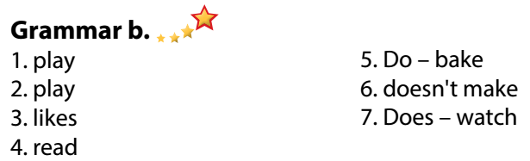  - Look and listen.  - Work individually.  - Work in pairs.  - Write answers.  Answer keys (use DCR)  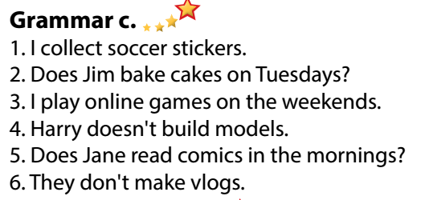  - Listen and memorize.  - Work in pairs.  Expected answers:  Picture 2: bake cakes / bake a cake  Picture 3: play online games  Picture 4: build models  Picture 5: read comics  Picture 6: make vlogs  - Work individually.  - Work in pairs.  - Give answers.  Answer keys
Activity 3: Production (6’)
a. Objective: Students master the grammar point they study in the lesson.
b. Content: Speaking: Asking and answering about what they do and don’t do in their free time.
c. Expected outcomes: Ss produce the new language successfully, and they can apply the Present Simple in everyday speaking and writing.
d. Organization of the activity:
TEACHER’S ACTIVITIES | STUDENTS’ ACTIVITIES
Task d. Ask your partner about what they do and don’t do in their free time.  - Divide class into pairs.  - Have Ss ask their partner about what they do and don’t do in their free time.  - Have some pairs demonstrate the activity in front of the class.  - Give feedback and evaluation.  - For more practice, have Ss play grammar games with DHA. | - Have conversation in pairs.  - Present.  - Listen.
C. Consolidation and homework assignments (5’)
*Consolidation:
- Form and usage of the Present Simple:
Form: Be: (+) S + am / is / are + …
(-) S + am / is / are + not + …
(?) Am / Is / Are + S + …
Normal verb: (+) S + V _{s/es}
(-) S + don’t / doesn’t + V _{bare infinitive}
(?)Do / Does + S + V _{bare infinitive}
Usage: to talk about habits or things that happen regularly.
*Homework:
- Make 3 sentences, use the Present Simple to talk about your habits.
- Do the exercises in WB: Lesson 1 - Grammar (page 5).
- Prepare: Lesson 1 – Pronunciation and Speaking (page 6 – SB).
- Complete the grammar notes in Tiếng Anh 7 I-Learn Smart World Notebook (page 5).
- Play consolation games in Tiếng Anh 7 i-Learn Smart World DHA App on
*******************************************************************
Teaching date: 13/9/2022
Period 4 UNIT 1: FREE TIME
Lesson 1.3 – Pronunciation and Speaking (Page 6)
I. OBJECTIVES
By the end of the lesson, Ss will be able to:
1.1. Language knowledge and skills
- pronounce the sound /eɪ/ correctly.
- ask and answer about free time activities, using time expressions of the Simple Present.
- conduct a survey about hobbies.
1.2. Competences
- improve listening and speaking skills.
1.3. Attributes
- take up a useful hobby and spend a suitable amount of time on this hobby.
- build good habits for themselves and ditch bad ones.
II. TEACHING AIDS AND LEARNING MATERIALS
1. Teacher’s aids: Student book and Teacher’s book, class CDs, Digital Book (DCR phần mềm tương tác SB, DHA (từ vựng/ cấu trúc) phần mềm trò chơi tương tác), projector/interactive whiteboard / TV (if any), PowerPoint slides, handouts.
2. Students’ aids: Student’s book, Workbook, Notebook.
III. ASSESSMENT EVIDENCE
Performance Tasks | Performance Products | Assessment Tools
- Listen to the words with the sound /eɪ/.  - Listen and cross out the word that doesn’t contain the sound /eɪ/.  - Read the words with the sound /eɪ/.  - Ask and answer about free time activities, using time expressions of the Simple Present.  - Complete the survey for themselves, then ask 3 more friends to have more information about hobbies, then fill in the table. | - Ss’ performance.  - Ss’ answers.  - Ss’ performance.  - Ss’ performance.  - Ss’ performance /  Presentation. | - T’s observation.  - T’s feedback/Peers’ feedback.  - T’s feedback/Peers’ feedback.  - T’s feedback/Peers’ feedback.  - T’s observation, T’s feedback/Peers’ feedback.
IV. PROCEDURES
A. Warm up: (5’)
a) Objective: Introduce the new lesson and set the scene for Ss to acquire new language; get students' attention at the beginning of the class by enjoyable and short activities as well as to engage them in the follow-up steps.
b) Content: Review vocabulary about hobbies.
c) Expected outcomes: Ss remember old words and use them in other speaking activities.
d) Organization of the activity:
TEACHER’S ACTIVITIES | STUDENTS’ ACTIVITIES
- Give greetings.  - Check attendance.  Option 1: MATCHING  - Have Ss work in pairs, do the matching exercises.  - Call Ss to read answers.  - Give feedback and lead to the new lesson.  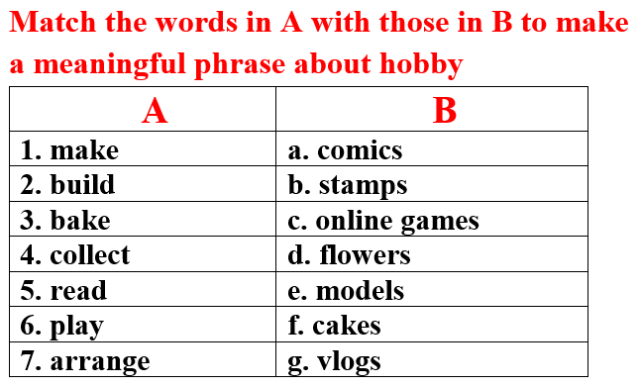  - Lead to the new lesson.  Option 2:  - Give a sample sentence:  David makes eight cakes for his classmates on Sunday.  - Have Ss practice reading this sentence fluently.  - Ask Ss to find as many as possible words that contain the same sound in this sentence.  - Introduce the sound /eɪ/ and lead to the new lesson. | - Greet T.  - Work in pairs, then give answers.  Answer keys  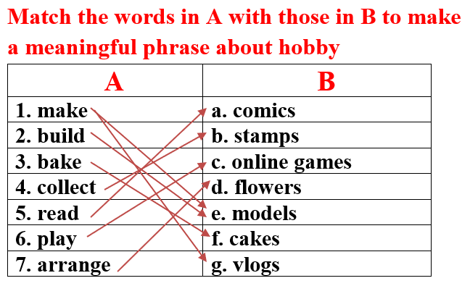  -Read.  - Practice reading out loud.  - Give answers.  Answer keys: David, makes, eight, cakes, classmates, Sunday
B. New lesson (35’)
Activity 1: Pre-Speaking: Pronunciation (10’)
a) Objective: Introduce the sound /eɪ/ and how to pronounce it.
b) Content:
- recognize the sound /eɪ/.
- listen and check, find mistakes.
- practice.
c) Expected outcomes: Ss distinguish and pronounce the sound /eɪ/ correctly in their speaking.
d) Organization of the activity:
TEACHER’S ACTIVITIES | STUDENTS’ ACTIVITIES
Task a + b. Listen to the sentences and focus on the /eɪ/ sound.  - Play the recording (CD1, track 04) using DCR.  - Ask Ss to listen and pay attention to the /eɪ/ sound.  - Have Ss make comments on the sound of the underlined words.  - Play the recording again, have Ss listen and repeat with a focus on the pronunciation feature.  Task c + d. Listen and cross out the word that doesn’t have /eɪ/ sound, then read the words with the sound noted: /eɪ/  - Play the recording (CD 1 – Track 05) using DCR, have Ss listen and cross out the option that doesn’t use the noted sound.  - Call Ss to give answers.  - Play the recording again and check answers as a whole class.  - Then have Ss practice reading the words with a partner, using the noted sound.  - Call some Ss to read in front of the class.  - Ask Ss to find more words containing the /eɪ/ sound. | - Listen.  - Comment.  - Listen again and repeat.  - Listen and cross out.  - Give answers.  - Listen again and check.  - Work in pairs.  - Present.  - Give answers.
Activity 2: While-speaking (20’)
a) Objective: Students can talk about their hobbies and their friends’ hobbies.
b) Content:
- asking and answer about free time activities, using time expressions of the Simple Present.
- conducting a survey about hobbies, filling in the table.
c) Expected outcomes: Ss produce the new language successfully.
d) Organization of the activity:
TEACHER’S ACTIVITIES | STUDENTS’ ACTIVITIES
PRACTICE  Task a. Ask and answer.  - Use DCR to show the task.  - Demonstrate the activity by asking and answering with a student.  - Have pairs ask and answer, using the pictures.  - Remind Ss to use the time expressions of the Present Simple.  - Have some pairs demonstrate the activity in front of the class.  b. Practice with your own ideas.  - Have pairs practice the conversation with their own ideas, then swap roles.  - Call some pairs to demonstrate the activity in front of the class.  - Give feedback and evaluation.  SPEAKING: Top Teen Hobbies.  Task a. You’re asking your classmates about their hobbies. In groups of 4, complete the survey for yourself, then ask 3 more friends. Fill in the table.  - Use DCR to show the task. Demonstrate the activity by practicing role-play with a student.  - Have Ss work in groups, ask and answer, then complete the table with information about their hobbies  - Observe, give help if necessary. | - Observe, listen.  - Work in pairs.  - Present.  - Work in pairs.  - Present.  Suggested conversation  - What do you do in your free time?  - I arrange flowers  - How often do you arrange flowers?  - I arrange flowers on the weekends or on some special occasions such as my family members’ birthday, Tet holiday or Christmas.  - Observe and listen.  - Work in groups.
Activity 3: Production (5’)
a) Objective: Students report to the class about the survey results of their group.
b) Content: Answering: What is the most popular hobby in your group?
c) Expected outcomes: Ss produce the new language successfully in everyday speaking and writing.
d) Organization of the activity:
TEACHER’S ACTIVITIES | STUDENTS’ ACTIVITIES
SPEAKING: Top Teen Hobbies.  Task b. Answer the question: What is the most popular hobby in your group?  - Have some Ss share their findings with the class.  - Give feedback and evaluation.  -Ask Ss some more questions:  1.What is the most popular hobby in your class?  2.Can you list top 3 most popular hobbies in your group / class?  3. In your group, is there any easy or difficult hobby? | - Present.  - Listen.  - Give answers.

C. Consolidation and homework assignments (5’)
* Consolidation:
- Words with the sound /eɪ/: make, play, place, bake, game, say, day, …
- Time expressions in the Simple Present: once a week, every day, a few times a month, on the weekends, …
* Homework:
- Make 2 sentences containing some words with the sound /eɪ/, then practice reading them.
- Complete the survey for those who haven’t finished it in class.
- Prepare: Lesson 2 – New words and Listening (page 7 – SB).
- Review the vocabulary and grammar notes in Tiếng Anh 7 i-Learn Smart World Notebook
(pages 4 & 5).
- Play consolation games in Tiếng Anh 7 i-Learn Smart World DHA App on www.eduhome.com.vn
*********************************************************************
Teaching date: 14/9/2022
Period 5 UNIT 1: FREE TIME
Lesson 2.1 – New words and Listening (Page 7)
I. OBJECTIVES
By the end of the lesson, Ss will be able to:
1.1. Language knowledge and skills
- talk about their free time activities, using words about places of entertainment: sports center, bowling alley, theater, ice rink, water park, market, fair.
- practice listening to 2 students having a phone call to make plans to meet each other (for general and specific details).
- know how to start a friendly conversation and practice using it.
1.2. Competences
- improve communication, collaboration, and critical thinking skills.
1.3. Attributes
- entertain themselves after study hard.
- know how to make plans for an informal meeting.
II. TEACHING AIDS AND LEARNING MATERIALS
1. Teacher’s aids: Student book and Teacher’s book, class CDs, Digital Book (DCR phần mềm tương tác SB, DHA (từ vựng/ cấu trúc) phần mềm trò chơi tương tác), projector/interactive whiteboard / TV (if any), PowerPoint slides.
2. Students’ aids: Student’s book, Workbook, Notebook.
III. ASSESSMENT EVIDENCE
Performance Tasks | Performance Products | Assessment Tools
- Activate some places of entertainment that Ss may know.  - Match the words with the pictures in a.  - Listen and repeat.  - Talk about activities students can do in these places of entertainment.  - Listen to 2 students having a phone call to make plans to meet each other, then circle the right answer.  - Speak: Where do you like to meet friends? What do you do there? | - Ss’ answers.  - Ss’ answers.  - Ss’ performance.  - Ss’ answers/ presentation.  - Ss’ answers.  - Ss’ answers/ presentation | - T’s feedback.  - T’s observation/ DCR.  - T’s observation.  - T’s feedback/Peers’ feedback.  - T’s feedback/Peers’ feedback.  - T’s feedback/Peers’ feedback.
IV. PROCEDURES
A. Warm up: (5’)
a) Objective: Introduce the new lesson and set the scene for Ss to acquire new language; get students' attention at the beginning of the class by enjoyable and short activities as well as to engage them in the follow-up steps.
b) Content: Introduce words about places of entertainment.
c) Expected outcomes: Ss get to know some new words they are going to study in the lesson.
d) Organization of the activity:
TEACHER’S ACTIVITIES | STUDENTS’ ACTIVITIES
- Give greetings.  - Check attendance.  Option 1: Match the words with the pictures  - Use the “New words” part a.– page 7 for the warm-up activity (using DCR).  - Show pictures and words, have Ss match the words with the pictures (in pairs).  - Call Ss to give answers.  - Give feedback and show correct answers.  - Lead to the new lesson.  - Play the audio (CD1 – Track 06), have Ss listen and repeat.  - Correct Ss’ pronunciation if necessary.  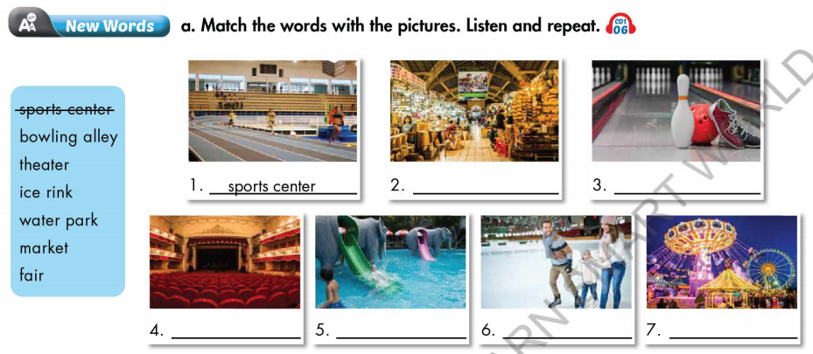  Option 2: Fill in the blanks  - Have Ss work in pairs to fill in the blanks.  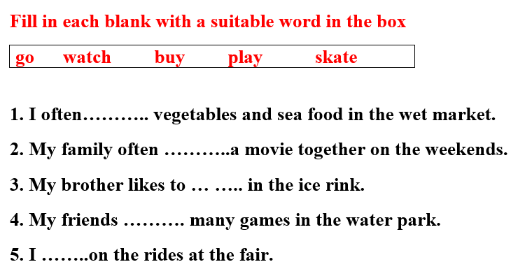  - Call Ss to give answers.  - Lead to the new lesson. | - Greet T.  - Work in pairs.  - Give answers.  - Listen.  - Listen and repeat.  Answer keys  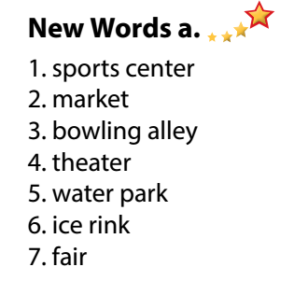  - Work in pairs.  - Give answers.  - Listen.  Answer keys  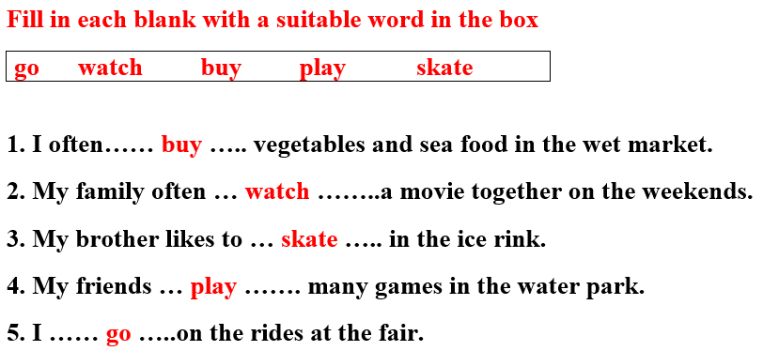
B. New lesson (35’)
Activity 1: Pre-Listening (Vocabulary) (12’)
a) Objective: Ss get to know words about places of entertainment.
b) Content:
- Vocabulary study (sports center, bowling alley, theater, ice rink, water park, market, fair).
- Speaking: Say what activities you can do at each place using the verbs in the box (page 7).
c) Expected outcomes: Ss know how to pronounce the new words correctly and use them in appropriate situations.
d) Organization of the activity:
TEACHER’S ACTIVITIES | STUDENTS’ ACTIVITIES
Task a. Match the words with the pictures. Listen and repeat.  Option 1 (If the teacher hasn’t used this part for the Warm-up activity.)  - Demonstrate the activity (using DCR), using the example  - Have Ss number the pictures.  - Divide class into pairs and have them check their answers with their partners.  - Call Ss to give answers (read or write).  - Check answers as a whole class.  - Play audio (CD1 – Track 06). Have Ss listen and repeat.  - Correct Ss’ pronunciation.  Option 2: Matching (If the teacher has used part a. for the Warm-up activity.)  - Have Ss review the words they have known in the warm-up activity by filling in the blanks (T uses different pictures from those in the textbook).  - Call Ss to give answers (read or write).  - Check answers as a whole class.  - Call some Ss to read the words again.  - Correct Ss’ pronunciation if necessary.  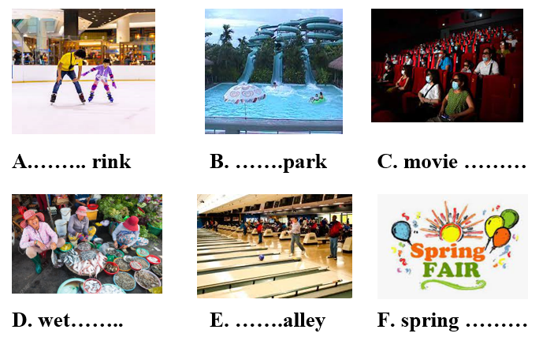  Task b. Say what activities you can do at each place using the verbs in the box.  - Use DCR to show the task.  - Have Ss work in pairs to talk about activities they can do at each place using the verbs in the box.  - Have some pairs share their ideas with the class.  - Give feedback and evaluation. | - Look and listen.  - Work individually.  - Work in pairs.  - Give answers.  - Listen and repeat.  Answer keys  - Work in pairs.  - Give answers.  - Read.  Answer keys  A. ice  B. water  C. theater  D. market  E. bowling  F. fair  - Work in pairs.  - Present.  Suggested ideas  - I watch movies in a movie theater.  - I play sports in the sports center.  - I play bowling in the bowling alley  - I skate in the ice rink.  …
Activity 2: While - Listening (17’)
a) Objective: Students can develop their listening skill.
b) Content: Listening to 2 students having a phone call to make plans to meet each other (for general and specific details).
c) Expected outcomes: Students can listen and understand general and specific information about making plans for an informal meeting with friends.
d) Organization of the activity:
TEACHER’S ACTIVITIES | STUDENTS’ ACTIVITIES
Task a. Listen to Becky calling Toby to make plans to meet. Which place will they visit together?  - Use DCR to show the task.  - Have Ss read the question.  - Play audio (Track 1.07).  - Have Ss listen and answer the question.  - Check answer as a whole class.  Task b. Now, listen and circle  - Use DCR to show the task.  - Have Ss read the questions, underline key words and guess the answers.  - Play the audio again (Track 1.07).  - Have Ss listen and circle the correct answer.  - Have Ss check answers with their partners.  - Call Ss to give answers.  - Give feedback and show correct answers. | - Work individually.  - Circle the correct answers.  Answer keys  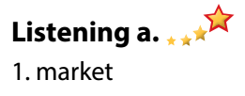  - Read and underline.  - Do the task.  - Check answers.  Answer keys  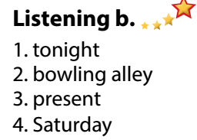
Activity 3: Post - Listening (6’)
a) Objective: Students can use the vocabulary and the content in listening part to develop their speaking skill.
b) Content: Speaking: Where do you like to meet you friends? What do you do there?
c) Expected outcomes: Students can have a free-talk about things to do when hanging out with friends.
d) Organization of the activity:
TEACHER’S ACTIVITIES | STUDENTS’ ACTIVITIES
Conversation skill  - Use DCR to show the task.  - Have Ss look at the Conversation box and read.  - Play audio (Track 08), have Ss listen and repeat.  - Ask Ss to find more ways to start a friendly conversation.  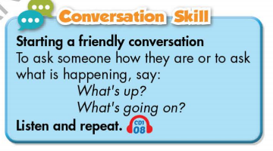  Task c. Where do you like to meet you friends? What do you do there?  - Have Ss work in pairs to discuss.  - Observe and give help if necessary.  - Call some pairs to share their ideas with the class.  - Give feedback and evaluation.  - For more practice, have Ss play vocabulary games with DHA. | - Look and read.  - Listen and repeat.  - Give answers.  - Work in pairs.  - Present.
C. Consolidation and homework assignments (4’)
* Consolidation:
- Words about places of entertainment: sports center, bowling alley, theater, ice rink, water park, market, fair.
- Language to start a friendly conversation: What’s up? / What’s going on? / Hi there! / Hey! …
*Homework
- Learn the new words by heart.
- Practice making a plan.
- Do the exercises in WB: New words and Listening (pages 4,5).
- Do the vocabulary exercise in Tiếng Anh 7 i-Learn Smart World Notebook (page 6).
- Play consolation games in Tiếng Anh 7 i-Learn Smart World DHA App on
- Prepare: Lesson 1 – Grammar (page 8 – SB).
*********************************************************************
Teaching date: 16/9/2022
Period 6 UNIT 1: FREE TIME
Lesson 2.2 - Grammar (Page 8)
I. OBJECTIVES
By the end of the lesson, Ss will be able to:
1.1. Language knowledge and skills
- listen to 2 people asking and answering about a plan.
- talk about future plans.
- use the Present Continuous and prepositions of place correctly.
- write questions about next week’s plan, then answer them.
1.2. Competences
- improve speaking, listening and writing skills
- improve the use of English.
1.3. Attributes
- make plans for themselves.
- be well-organized and disciplined.
II. TEACHING AIDS AND LEARNING MATERIALS
1. Teacher’s aids: Student book and Teacher’s book, class CDs, Digital Book (DCR phần mềm tương tác SB, DHA (từ vựng/ cấu trúc) phần mềm trò chơi tương tác), projector/interactive whiteboard / TV (if any), PowerPoint slides, handouts.
2. Students’ aids: Student’s book, Workbook, Notebook.
III. ASSESSMENT EVIDENCE
Performance Tasks | Performance Products | Assessment Tools
- Listen and repeat.  - Circle the correct word.  - Write questions using the prompts in the next week’s plan, then answer them.  - Work with your partner to make a plan to go out with your friend. | - Ss’ performance.  - Ss’ answers.  - Ss’ answers.  - Ss’ answers/ presentation. | - T’s feedback.  - T’s feedback/Peers’ feedback.  - T’s feedback/Peers’ feedback.  - T’s feedback/Peers’ feedback.
IV. PROCEDURES
A. Warm up: (5’)
a) Objective: Introduce the new lesson and set the scene for Ss to acquire new language; get students' attention at the beginning of the class by enjoyable and short activities as well as to engage them in the follow-up steps.
b) Content: Jumbled word or rearranging words to make a meaningful sentence.
c) Expected outcomes: Ss review words about hobbies or Ss have general ideas about the grammar point they are going to study in the new lesson.
d) Organization of the activity:
TEACHER’S ACTIVITIES | STUDENTS’ ACTIVITIES
- Give greetings.  - Check attendance.  Option 1: Review: Prepositions of place.  - Have Ss review some prepositions of place by doing the matching activity:  - Call Ss to give answers.  - Check Ss’ answers, give feedback and lead to the new lesson.  Near / under / next to / on / in front of / behind  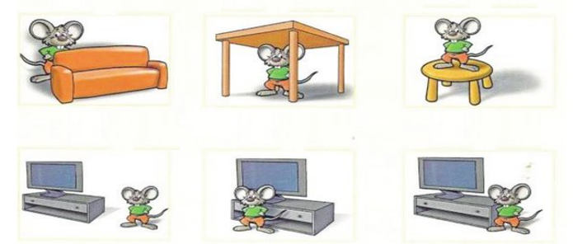  - Have Ss make sentences, using the prepositions of places.  - Lead to the new lesson.  Option 2: Fill in the blank  - Have Ss close all books and notebooks.  - Show some sentences with pictures, have Ss use the pictures to think of a word/phrase to fill in each blanks.  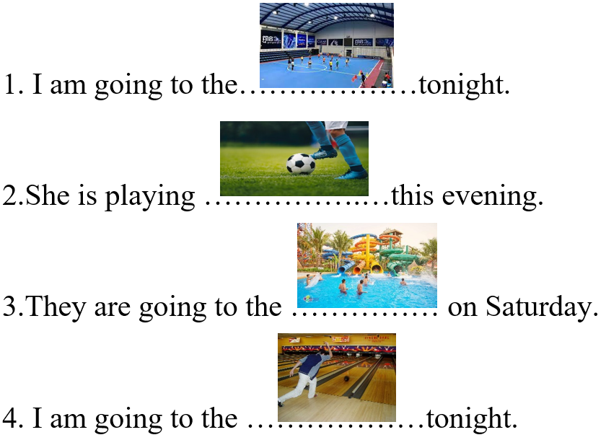  - Have Ss read their answers.  - Tell Ss about the grammar point they are going to study in the new lesson.  - Lead to the new lesson. | - Greet T.  - Work in pairs.  - Give answers.  Answers keys  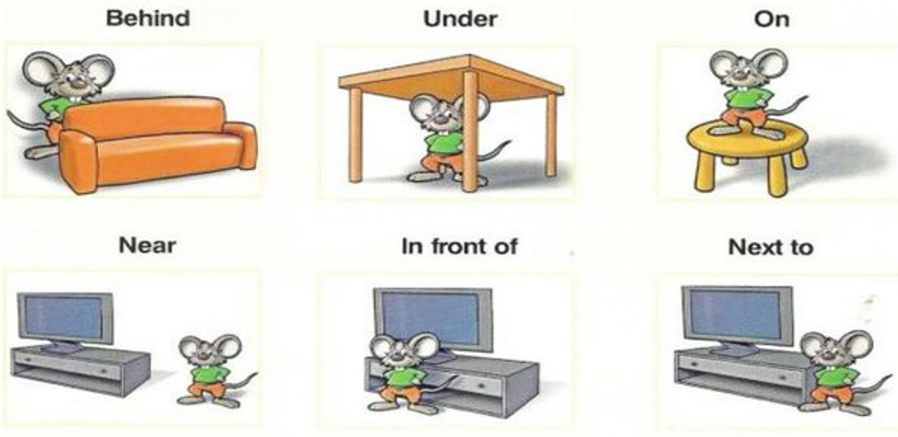  - Read sentences.  - Close books and notebooks, then work in pairs.  - Give answers.  Answers keys  1. sport center 2. soccer  3. water park 4. bowling alley  - Listen
B. New lesson (35’)
Activity 1: Presentation (10’)
a) Objective: Help Ss review Present Continuous tense (form, usage).
b) Content:
- Listen and repeat
- Review the form and usage of the Present Continuous.
- Review: Prepositions of place.
c) Expected outcomes: Ss remember the Present Continuous, prepositions of place and use them in some exercises that follow.
d) Organization of the activity:
TEACHER’S ACTIVITIES | STUDENTS’ ACTIVITIES
Task a. Listen and repeat  - Have Ss look at the picture (using DCR).  - Play audio (CD1 – Track 09) and have Ss listen and read the speech bubbles.  - Play the audio again and have Ss listen and repeat.  Grammar box  Option 1:  - Have Ss look at the grammar explanation (using DCR).  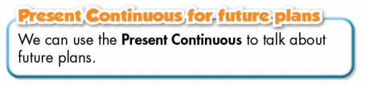  - Have Ss look at the box and read examples of different forms.  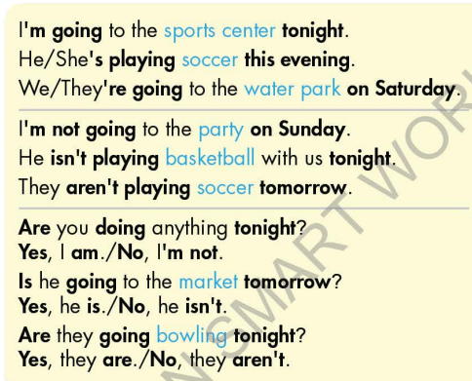  - Explain more about the form and the usage of the Present Simple, have Ss pay attention to the negative and the question form.  Form:  (+) S + am / is / are + V-ing …  (-) S + am / is / are + not + …  (?) Am / Is / Are + S + V-ing …  Usage: to talk about future plans.  - Have some Ss read aloud the sentences in the Grammar Box aloud.  - Ask Ss to give more examples using the Present Continuous.  - Have Ss look at the Prepositions of Place box, remind them that Prepositions of Place are used to talk about where something or someone is located.  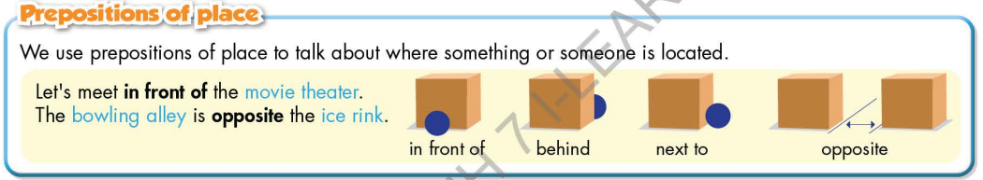  Option 2:  - Have Ss close books.  - Give some model sentences (T can use the sentences form the warm-up activity), ask Ss to indicate which tense is being used, then have Ss retell form of the Present Continuous.  *Suggested model sentences:  1. I am going to the sports center tonight.  2.She is playing soccer this evening.  3.They are going to the water park on Saturday.  4. I am going to the bowling alley tonight.  - Call Ss to give answers, comment on Ss’ answers.  - Ask Ss: What are these sentences about?  - Then have Ss open the books and read the grammar box.  - Have Ss give more examples of the Present Continuous, encourage them to make sentences with their own ideas.  - Give feedback and evaluation.  * Prepositions of Place: If T has used it in the warm-up activity, there’s no need to carry out this grammar part again. | - Look.  - Listen, then read.  - Listen and repeat.  - Look and read.  - Read.  - Listen and take notes.  - Read.  - Give examples.  - Close all books.  - Look and answer.  Expected answer: The sentences are about future plans.  - Read.  - Give examples.  - Listen.
Activity 2: Practice (19’)
a) Objective: Students can use the “Present Continuous for future plans” and “Prepositions of Place” to do the given exercises.
b) Content:
- Circling the correct words.
- Writing questions using the prompts in the next week’s plan, then answer them.
c) Expected outcomes: Students can get used to the use of the “Present Continuous for future plans”. and Prepositions of Place and use it correctly.
d) Organization of the activity:
TEACHER’S ACTIVITIES | STUDENTS’ ACTIVITIES
Task b. Circle the correct words.  - Use DCR to show the task.  - Demonstrate the activity, using the example.  - Have Ss read the sentences and circle the correct words.  - Have Ss work in pairs to check each other’s work.  - Have some Ss share their answers with the whole class.  - Give feedback, correct Ss’ answers if necessary  Task c. Look at the next week’s plan. Write questions using the prompts, then answer the questions.  - Use DCR to show the task.  - Demonstrate the activity, using the example.  - Have Ss write questions using the prompts, then answer the questions.  - Have Ss check answers with their partners.  - Call Ss to write answers.  - Check Ss’ answers, give feedback. | - Look and listen.  - Work individually.  - Work in pairs.  - Read answers.  Answer keys  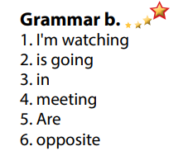  - Look and listen.  - Work individually.  - Work in pairs.  - Write answers.  Answer keys  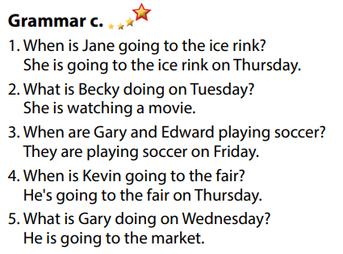
Activity 3: Production (6’)
a) Objective: Students master the grammar point they study in the lesson.
b) Content: Speaking: Making a plan to go out with your friend.
c) Expected outcomes: Ss produce the new language successfully, and they can apply the Present Continuous in speaking and writing.
d) Organization of the activity:
TEACHER’S ACTIVITIES | STUDENTS’ ACTIVITIES
Task d. In pairs: Make a plan to go out with your friend.  *Remind Ss some useful structures to make plan:  - How about / What about + V-ing  - Let’s + V _{B.I}  - Why don’t we / Shall we + V _{B.I}  - Divide class into pairs.  - Have Ss discuss their plan to go out.  - Have some pairs demonstrate the activity in front of the class.  - Give feedback and evaluation.  - For more practice, have Ss play grammar games with DHA. | -Listen and take notes.  - Have conversation in pairs.  - Present.  - Listen.
C. Consolidation and homework assignments (5’)
*Consolidation
- Present Continuous
Form:
(+) S + am / is / are + V-ing …
(-) S + am / is / are + not + …
(?) Am / Is / Are + S + V-ing …
Usage: to talk about future plans.
- Prepositions of place: in front of, behind, next to, opposite, on, under, .
*Homework:
- Make 2 sentences, use the Present Continuous to talk about your future plans.
- Make 2 sentences with prepositions of place.
- Do the exercises in WB: Grammar & Writing (page 5).
- Complete the grammar notes in Tiếng Anh 7 i-Learn Smart World Notebook (page 7).
- Play consolation games in Tiếng Anh 7 i-Learn Smart World DHA App on
- Prepare: Lesson 2 – Pronunciation and Speaking (page 9 – SB).
********************************************************************
Teaching date: 20/9/2022
Period 7 UNIT 1: FREE TIME
Lesson 2.3 – Pronunciation and Speaking (Page 9)

I. OBJECTIVES
By the end of the lesson, Ss will be able to:
1.1. Language knowledge and skills
- use intonation for Yes / No questions.
- ask and answer about future plan, using the Present Continuous and prepositions of places.
- discuss a plan to join in a free time activity.
- start a friendly conversation.
1.2. Competences
- improve listening and speaking skills.
1.3. Attributes
- make plans for themselves.
- be well-organized and disciplined.
II. TEACHING AIDS AND LEARNING MATERIALS
1. Teacher’s aids: Student book and Teacher’s book, class CDs, digital book (DCR phần mềm tương tác SB, DHA (từ vựng/ cấu trúc) phần mềm trò chơi tương tác), projector/interactive whiteboard / TV (if any), PowerPoint slides, handouts.
2. Students’ aids: Student’s book, workbook, notebook, handouts.
III. ASSESSMENT EVIDENCE
Performance Tasks | Performance Products | Assessment Tools
- Listen to the questions and notice how the intonation rises.  - Listen and cross out the sentence doesn’t follow the note: intonation for Yes / No questions rises.  - Read the questions with the rising intonation to a partner.  - Ask and answer about making plan, using the Present continuous and prepositions of place.  - Invite your friend to join you in a free time activity, discuss the plan and complete the table. | - Ss’ performance and answers.  - Ss’ answers.  - Ss’ performance.  - Ss’ performance.  - Ss’ performance /  Presentation. | - T’s observation.  - T’s feedback/Peers’ feedback.  - T’s feedback/Peers’ feedback.  - T’s feedback/Peers’ feedback.  - T’s observation, T’s feedback/Peers’ feedback.
IV. PROCEDURES
A. Warm up: (5’)
a) Objective: Introduce the new lesson and set the scene for Ss to acquire new language; get students' attention at the beginning of the class by enjoyable and short activities as well as to engage them in the follow-up steps.
b) Content: Review vocabulary about hobbies.
c) Expected outcomes: Ss remember old words and use them in other speaking activities.
d) Organization of the activity:
TEACHER’S ACTIVITIES | STUDENTS’ ACTIVITIES
- Give greetings.  - Check attendance.  Option 1:  - Give Ss a set of questions.  - Have Ss work in pairs to divide the questions given into 2 groups: Yes/No questions and Wh-questions.  - Call Ss to read answers.  - Give feedback and lead to the new lesson: intonation for Yes/No questions.  *Suggested questions  1.Can you talk now?  2. Are you going to the fair tonight?  3.Where should we meet?  4. Is she coming with us?  5. What are you doing tonight?  6. Do you like bowling?  Option 2: Rising or Falling?  - Let Ss play a game: T reads some questions with rising tone and falling tone.  - For each question with rising tone, Ss stand up. For each question with falling tone, Ss sit down.  - Ask 2 Ss to stand in front of the class to observe.  - Any Ss who do not follow the game rules will be sent out of the game.  - T may have the losers sing a song or do any fun activities in front of the class.  - Introduce the new lesson: intonation for Yes/No questions. | - Greet T.  - Work in pairs, divide the questions into 2 groups.  - Give answers.  Answer keys  * Yes/No questions  1.Can you talk now?  2. Are you going to the fair tonight?  4. Is she coming with us?  6. Do you like bowling?  * Wh-questions  3.Where should we meet?  5. What are you doing tonight?  - Listen.  - Take part in the class activity.
B. New lesson (35’)
Activity 1: Pre-Speaking: Pronunciation (10’)
a) Objective: Introduce intonation for Yes/No questions.
b) Content:
- recognize the intonation for Yes/No questions.
- listen and check, find mistakes.
- practice.
c) Expected outcomes: Ss distinguish and use intonation for Yes/No questions correctly in their speaking.
d) Organization of the activity:
TEACHER’S ACTIVITIES | STUDENTS’ ACTIVITIES
Task a + b. Listen to the question and notice how the intonation rises.  - Use DCR to show the task.  - Play the recording (CD1, track 10).  - Ask Ss to listen and notice how the intonation rises.  - Play the recording again, have Ss listen and repeat with a focus on the pronunciation feature.  Task c + d. Listen and cross out the sentence that doesn’t follow the sound feature, then read the questions with the rising intonation to a partner.  - Use DCR to show the task.  - Play the recording (CD 1 – Track 11), have Ss listen and cross out the option that doesn’t follow the sound feature in “a”.  - Call Ss to give answers.  - Play the recording again and check answers as a whole class.  - Then have Ss practice saying the examples with a partner, using the pronunciation feature.  - Call some Ss to read questions in front of the class.  - Ask Ss to make some more Yes/ No questions and practice reading them with rising tone. | - Listen.  - Listen again and repeat.  - Listen and cross out.  - Give answers.  - Listen again and check.  - Work in pairs.  - Present.  - Give answers.
Activity 2: While-speaking (19’)
a) Objective: Students can make plans.
b) Content:
- asking and answering about making plan for tonight, using the Present Continuous and Prepositions of place.
- inviting a friend to join a free time activity, discussing time and place to meet, then completing in the table.
c) Expected outcomes: Ss produce the new language successfully.
d) Organization of the activity:
TEACHER’S ACTIVITIES | STUDENTS’ ACTIVITIES
PRACTICE  Task a. Practice the conversation. Swap the roles and repeat.  - Use DCR to show the task.  - Demonstrate the activity by practicing the role-play with a student.  - Have pairs practice the conversation.  - Remind Ss to use the prepositions of place and the Present Continuous.  - Have Ss swap roles and repeat, using the ideas on the right.  - Have some pairs demonstrate the activity in front of the class.  - Give feedback and evaluation.  Task b. Practice with your own ideas.  - Have pairs practice the conversation with their own ideas, then swap roles.  - Remind Ss to use some words to start a friendly conversation.  - Call some pairs to demonstrate the activity in front of the class.  - Give feedback and evaluation.  SPEAKING: Let’s Go Out!  Task a. You’re inviting your friend to join you in a free time activity. Student B goes to page 118, file 1. Student A writes activities and places in the table, then invite student B. If he/she can come, discuss where and when to meet and complete the table.  - Use DCR to show the task.  - Demonstrate the activity by practicing role-play with a student.  - Have student A look at the schedule on the bottom of the page and student B turn to page 118, file 1.  - Ask Ss to fill in the table with their own ideas.  - Have Ss take turns to invite each other to complete the table.  - Observe, give help if necessary. | - Observe, listen.  - Work in pairs to practice the conversation.  - Swap roles and continue the task.  - Present.  - Work in pairs to practice the conversation, then swap roles.  - Present.  - Observe and listen.  - Work in pairs to make plan.
Activity 3: Production (6’)
a) Objective: Students can make plans.
b) Content: Asking your partner what they arranged to do with their friend, when and where they will meet them.
c) Expected outcomes: Ss produce the new language successfully in everyday speaking and writing.
d) Organization of the activity:
TEACHER’S ACTIVITIES | STUDENTS’ ACTIVITIES
SPEAKING: Let’s Go Out!  Task b. Make a new pair. Ask your partner what they arranged to do with their friend, when and where they will meet them.  - Pair each student with a new partner.  - Have Ss ask their partners about what they arranged to do with their friends, where they arranged to meet, and at what time.  - Have some Ss share their answers with the class  - Give feedback and evaluation. | - Make a new pair.  - Work with new partner.  - Give answers.

C. Consolidation and homework assignments (5’)
* Consolidation:
- Intonation for Yes / No questions: rising.
*Homework:
- Make 2 Yes / No questions, then practice reading them.
- Complete the table for those who haven’t finished it in class.
- Prepare: Lesson 3 – Listening and Reading (page 10– SB).
- Review the vocabulary and grammar notes in Tiếng Anh 7 i-Learn Smart World Notebook
(pages 6 & 7).
- Play consolation games in Tiếng Anh 7 i-Learn Smart World DHA App on
********************************************************************
Teaching date: 21/9/2022
UNIT 1: FREE TIME
Lesson 3.1 - Listening and Reading (Page 10)
I. OBJECTIVES
By the end of the lesson, Ss will be able to:
1.1. Language knowledge and skills
- talk about extreme sports.
- practice listening and understanding general and specific information about extreme sports.
- read an invitation email for gist and detail.
1.2. Competences
- improve communication, collaboration, analytical and critical thinking skills.
1.3. Attributes
- take up a sport and practice it regularly.
- be careful when trying extreme sports.
II. TEACHING AIDS AND LEARNING MATERIALS
1. Teacher’s aids: Student book and Teacher’s book, class CDs, Digital Book (DCR phần mềm tương tác SB, DHA (từ vựng/ cấu trúc) phần mềm trò chơi tương tác), projector/interactive whiteboard / TV (if any), PowerPoint slides.
2. Students’ aids: Student’s book, workbook, notebook.
III. ASSESSMENT EVIDENCE
Performance Tasks | Performance Products | Assessment Tools
- Activate the extreme sports that Ss may know.  - Match the extreme sports to the pictures. Name 3 other extreme sports.  - Listen to a talk about extreme sports. How does the speaker feel about them?  - Listen again and circle.  - Read Mark’s email. What is the email about?  -Read again and answer the questions.  -Speaking: Which extreme sports would you like to try? Why? | - Ss’ answers.  - Ss’ answers.  - Ss’ answers.  - Ss’ answers.  - Ss’ answers.  - Ss’ answers / presentation.  - Ss’ answers / presentation. | - T’s feedback.  - T’s feedback.  - T’s feedback/Peers’ feedback.  - T’s feedback/Peers’ feedback.  - T’s observation/ DCR and T’s feedback.  - T’s observation/ DCR and T’s feedback.
IV. PROCEDURES
A. Warm up: (5’)
a) Objective: Introduce the new lesson and set the scene for Ss to acquire new language; get students' attention at the beginning of the class by giving enjoyable and short activities as well as to engage them in the follow-up steps.
b) Content: Name of some extreme sports.
c) Expected outcomes: Ss have general ideas about extreme sports, which they are going to listen and read in the new lesson.
d) Organization of the activity:
TEACHER’S ACTIVITIES | STUDENTS’ ACTIVITIES
Option 1: Let’s talk!  - Use the “Let’s talk!” part in the textbook– page 10 for warm-up activity.  - Show pictures and words (using DCR), have Ss match the name of extreme sports to the pictures (in pairs).  - Call Ss to give answers.  - Give feedback and show correct answers.  - Have Ss discuss the questions.  - Elicit answers from some students.  - Lead to the new lesson.  Option 2:  - Have Ss watch a clip about extreme sports: Best of Extreme Sports Compilation 2019.  - Link: https://www.youtube.com/watch?v=wsg8k-2HYXA  - Ask Ss whether they know any names of the sports in the clip.  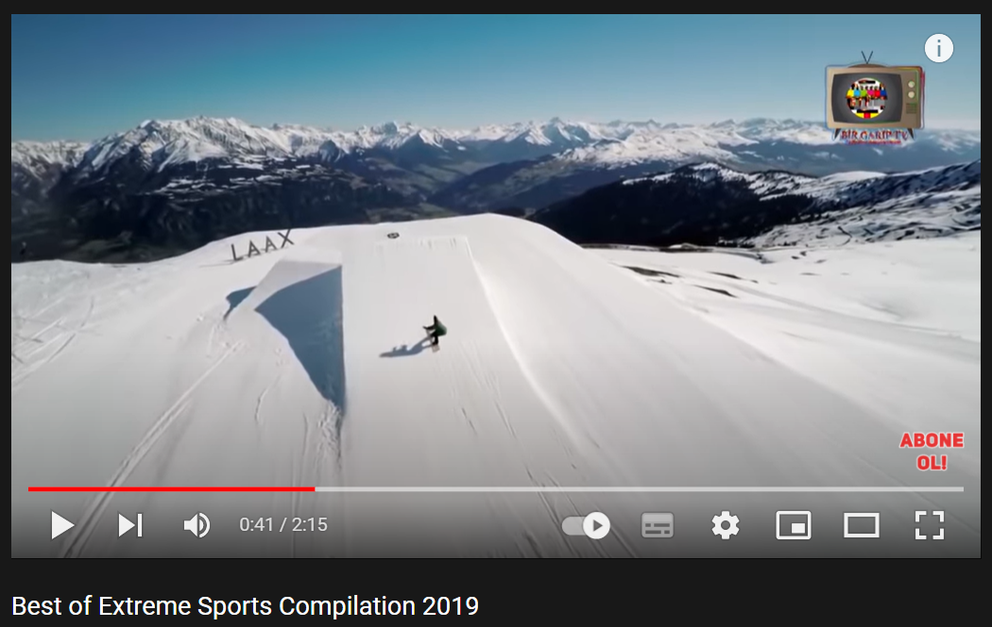  - Lead to the new lesson: Extreme sports. | - Work in pairs to match the name of extreme sports to the pictures.  - Give answers.  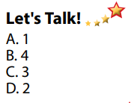  Answer keys  - Discuss the questions, then give answers.  Suggested some other extreme sports: waterskiing, scuba diving, bungee jumping, parasailing, ice climbing, slacklining,…  - Listen  - Watch and try to give names of some extreme sports in the clip.  - Listen.

B. New lesson (35’)
Activity 1: Pre-Listening (Vocabulary) (5’)
a) Objective: Ss know names of some extreme sports.
b) Content:
- Vocabulary study (skateboarding, surfing, rock climbing, zorbing, …)
- Speaking: Would you like to try any of the extreme sports in the pictures? Name 3 others extreme sports.
c) Expected outcomes: Ss know how to pronounce the new words correctly, understand the meaning and have good preparation for the listening part.
d) Organization of the activity:
TEACHER’S ACTIVITIES | STUDENTS’ ACTIVITIES
Let’s Talk!: Match the name of extreme sports to the pictures. Would you like to try any of them? Can you name three other extreme sports?  Option 1 (If the teacher hasn’t used this part for the Warm-up activity.)  - Use DCR to show the task.  - Have Ss match the name of extreme sports to the pictures (in pairs).  - Call Ss to give answers.  - Give feedback and show correct answers.  - Have Ss discuss the questions.  - Elicit answers from some students.  Option 2: Matching (If the teacher has used the Let’s Talk! part for the Warm-up activity)  - T reads names of some extreme sports that Ss have learnt as a model.  - Have Ss practice reading the names of some extreme sports again.  - Call some Ss to read again.  - Correct Ss’ pronunciation if necessary. | - Work in pairs to do the matching activity.  - Give answers.  Answer keys  - Discuss in pairs, then give answers.  - Listen.  - Listen.  - Practice reading the names of some extreme sports again.  - Read.
Activity 2: While - Listening (10’)
a) Objective: Students can develop their listening skill.
b) Content: Listening to a talk about extreme sports.
c) Expected outcomes: Students can practice listening and understanding general + specific information about extreme sports.
d) Organization of the activity:
TEACHER’S ACTIVITIES | STUDENTS’ ACTIVITIES
Task a. Listen to a talk about extreme sports. How does the speaker feel about them?  - Use DCR to show the task.  - Have Ss read the questions and guess the answers.  - Play audio (CD1 - Track 12).  - Have Ss listen and choose the correct answers.  - Call Ss to give answer, explain.  - Check answers as a whole class using DCR.  Task b. Now, listen and circle.  - Use DCR to show the task.  - Have Ss read the sentences first.  - Play the audio again (CD1 - Track 12).  - Have Ss listen and circle the correct answers.  - Have Ss check answers with their partners.  - Call Ss to give answers, explain.  - Check answers as a whole class using DCR. | - Read.  - Listen and choose the correct answers.  Answer keys  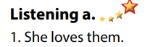  - Read.  - Listen and circle the correct answers.  - Exchange answers.  - Give answers.  Answer keys  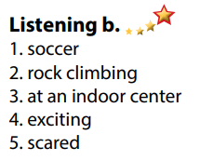
Activity 3: Reading (20’)
a) Objective: Students can develop their reading skill.
b) Content: Reading an invitation email, choosing the main idea of the email, then answering comprehension questions.
c) Expected outcomes: Students can read an invitation email for gist and detail, and they can talk about the extreme sport they would like to try.
d) Organization of the activity:
TEACHER’S ACTIVITIES | STUDENTS’ ACTIVITIES
Task a. Read Mark’s email quickly. What is the email about?  - Use DCR to show the task.  - Have Ss read the question and guess the answer.  - Ask Ss to read the email quickly and circle the correct answer.  - Call 1 S to give answer.  - Check answers as a whole class using DCR.  Task b. Now, read and answer the questions.  - Use DCR to show the task.  - Have Ss read the questions and underline the key words.  - Have Ss read the email again and answer the questions.  - Have Ss check their answers with a partner.  - Call Ss to give answers (read or write on the board).  - Check answers as a whole class using DCR.  Task c. Speaking: In pairs: Which extreme sport would you like to try? Why?  - Have Ss discuss the questions in pairs.  - Call Ss some s to share their answers with the whole class.  - Give feedback and evaluation. | - Read and guess.  - Scan the email for general idea.  - Give answer.  Answer keys  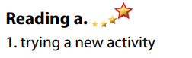  - Read and underline the key words.  - Read the email again for detail.  - Exchange answers.  - Give answers.  Answer keys  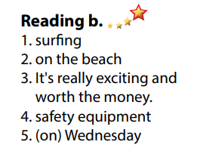  - Discuss in pairs.  - Present.
C. Consolidation and homework assignments (5’)
*Consolidation:
- Vocabularies: Name of some extreme sports: skateboarding, surfing, rock climbing, zorbing, waterskiing, scuba diving, bungee jumping, parasailing, ice climbing, slacklining …
*Homework
- Learn by heart the new vocabularies.
- Practice talking about the extreme sport you like.
- Do the exercises in WB: Lesson 3 – Listening and Reading (page 6).
- Do the vocabulary exercise in Tiếng Anh 7 i-Learn Smart World Notebook (page 8).
- Play consolation games in Tiếng Anh 7 i-Learn Smart World DHA App on www.eduhome.com.vn
- Prepare: Lesson 3 – Writing (page 11 – SB).
****************************************************************
Teaching date: 23/9/2022
Period 9 UNIT 1: FREE TIME
Lesson 3.2 – Speaking and Writing (Page 11)
I. OBJECTIVES
By the end of the lesson, Ss will be able to:
1.1. Language knowledge and skills
- use some adjectives to talk about extreme sports (exciting, dangerous, fascinating, challenging, adventurous).
- invite a friend to join an activity.
- write an invitation email to ask a friend to join an activity.
1.2. Competences
- improve communication, collaboration, writing and critical thinking skills.
1.3. Attributes
- take up a sport and practice it regularly.
- be careful when trying extreme sports.
II. TEACHING AIDS AND LEARNING MATERIALS
1. Teacher’s aids: Student book and Teacher’s book, class CDs, Digital Book (DCR phần mềm tương tác SB, DHA (từ vựng/ cấu trúc) phần mềm trò chơi tương tác), projector/interactive whiteboard / TV (if any), PowerPoint slides.
2. Students’ aids: Student’s book, workbook, notebook.
III. ASSESSMENT EVIDENCE
Performance Tasks | Performance Products | Assessment Tools
- Speaking: Discuss what you think the activities in the pictures are like.  - Choose one of the extreme sports or choose your own activity. Then, take turns asking and answering the questions below.  - Writing: Read about writing invitation emails and number the parts.  - Reorder the parts of the email. Use the skill box.  - Write an invitation email to ask a friend to join you for an activity. | - Ss’ answers.  - Ss’ performance.  - Ss’ answers.  - Ss’ answers.  - Ss’ answers/ presentation. | - T’s feedback.  - T’s observation/ DCR.  - T’s observation.  - T’s feedback/Peers’ feedback.  - T’s feedback/Peers’ feedback.  - T’s observation and feedback.
IV. PROCEDURES
A. Warm up: (5’)
a) Objective: Introduce the new lesson and set the scene for Ss to acquire new language; get students' attention at the beginning of the class by enjoyable and short activities as well as to engage them in the follow-up steps.
b) Content: Review names of some extreme sports.
c) Expected outcomes: Ss remember names of some extreme sports that they are going to talk about in the lesson.
d) Organization of the activity:
TEACHER’S ACTIVITIES | STUDENTS’ ACTIVITIES
Option 1: Jigsaw puzzle  - Divide class into groups.  - Give each group a set of many pieces of paper, have them use these pieces to make a right picture about an extreme sport, then give the name of the extreme sport.  - The group which has a correct picture and give the right name of that extreme sport in the shortest time will be the winner.  - Give a small present to the winner and the runner-up.  - Ask Ss extra question: What do you think about this extreme sport?  - Have Ss give answers.  - Give feedback and evaluation.  - Lead to the new lesson.  (T can use same activity for the picture: windsurfing.)    Option 2:  - Give Ss icons of some extreme sports.  - Have Ss give the right name of each icon.  - Call Ss to give answers.  - Give feedback.  àLead to the new lesson.   | - Take part the games in groups.  - Give answers.  - Listen.  Answer keys    Name of the extreme sport: mountain biking  - Work in pairs.  - Look and give answers  - Listen.  Answer keys  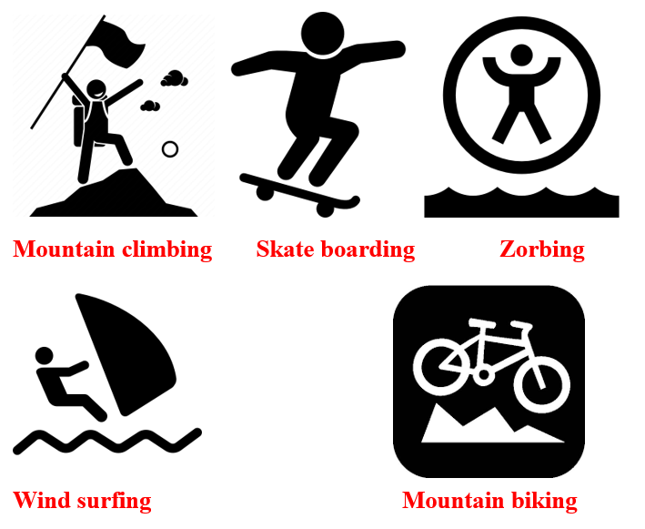
B. New lesson (35’)
Activity 1: Pre-Writing (Speaking) (10’)
a) Objective: Ss prepare for what they are going to write about.
b) Content:
- Speaking: Discuss what you think the activities in the pictures are like.
- Asking and answering the questions about planning for joining an extreme sport activity.
c) Expected outcomes: Ss can use some adjectives to talk about extreme sports and they can apply the language from speaking to their writing.
d) Organization of the activity:

TEACHER’S ACTIVITIES | STUDENTS’ ACTIVITIES
Task a. Look at the pictures in the lesson. Discuss what you think the activities are like.  - Have Ss observe the pictures (using DCR), then work in pairs to discuss what they think the activities are like.  - Remind Ss to use more adjectives to describe (exciting, dangerous, fascinating, challenging, adventurous)  - Have some Ss share their ideas with the class.  - Give feedback and evaluation.  Task b. Choose one of the extreme sports or choose your own activity. Then, take turns asking and answering the questions below and note your ideas.  - Have Ss choose an extreme sport (from the pictures in the books or their own).  - Have Ss take turns asking and answering the questions, then note their ideas in the table.  - Have some pairs share their ideas with the class  - Give feedback and evaluation. | - Look and discuss.  - Give answers.  - Work in pairs: Choose an extreme sport, asking and answering the questions, then note discussed ideas in the table.  - Present.
Activity 2: While - Writing (20’)
a) Objective: Students can develop their writing skill.
b) Content:
- Numbering the parts of an invitation email.
- Reordering the parts of an invitation email.
- Writing an invitation email to ask a friend to join you for an activity.
c) Expected outcomes: Students can write an invitation email, using the Present Continuous, prepositions of place and structures of suggestion.
d) Organization of the activity:
TEACHER’S ACTIVITIES | STUDENTS’ ACTIVITIES
Task a. Read about writing invitation emails. Then, read Mark’s email again and number the parts.  - Briefly explain the Writing skill box (using DCR).  - Have Ss read the Writing skill box and Mark’s email again (page 10), then number the pars of his email.  - Have Ss check their answers with a partner.  - Call Ss to give answers.  - Check answer as a whole class.  Task b. Reorder the parts of the email. Use the skill box to help you.  - Use DCR to show the task.  - Have Ss read the email and reorder the parts.  - Have Ss check their answers with a partner.  - Call Ss to give answers.  - Check answer as a whole class.  *Let’s Write: Now, write an invitation email to ask a friend to join you for an activity. Use the feedback form to help you.  - Draw Ss’ attention to the feedback form (using DCR).  - Have Ss use their notes in speaking part and the form of the invitation email to write an invitation email to ask a friend to join them for an activity.  - Have some Ss write their emails in front of the class. | - Listen.  -Work in pairs.  - Exchange their answers with a partner.  - Give answers.  Answer keys  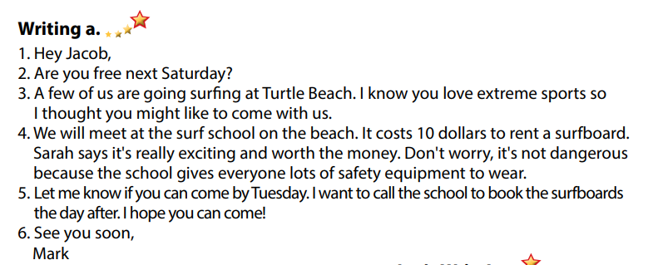  - Read and reorder the parts.  - Exchange answers.  - Give answers.  Answer keys  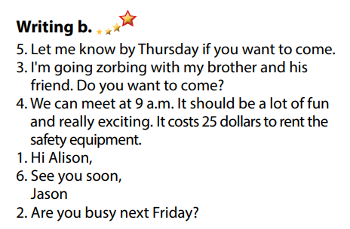  - Look and listen.  - Do the writing part.  -Write.  Sample answer  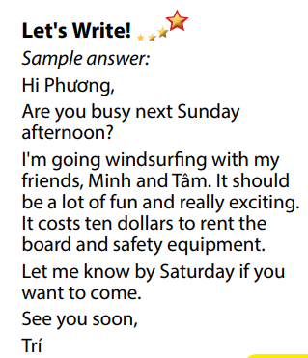
Activity 3: Post - Writing (5’)
a) Objective: Help Ss realize their mistakes in writing and correct them.
b) Content: Correcting Ss’ writings.
c) Expected outcomes: Students know whether their emails follow the model and uses the correct structures, whether their writings are interesting and understandable or not.
d) Organization of the activity:
TEACHER’S ACTIVITIES | STUDENTS’ ACTIVITIES
Conversation skill  - Give feedback, correct Ss’ mistakes.  - Use the feedback form to give evaluation. Focus on:  + the format, the structures.  + the understandability.  + the coherence and cohesion. | - Look, listen and correct mistakes.
C. Consolidation and homework assignments (5’)
* Consolidation:
- Adjectives to describe extreme sports: exciting, dangerous, fascinating, challenging, adventurous, …
- Format of an invitation email:
1. Start with a greeting
2. Check their availability
3. Write the invitation
4. Give more details
5. Ask for a reply
6. Sign off
*Homework
- Remember how to write an invitation letter.
- Finish the writing part.
- Do the exercises in WB: Writing (page 7).
- Complete the grammar notes in Tiếng Anh 7 i-Learn Smart World Notebook (page 9).
- Play consolation games in Tiếng Anh 7 i-Learn Smart World DHA App on www.eduhome.com.vn
- Prepare: Unit 1 – Review (page 84).
Teaching date: 27/9/2022
Period 10 UNIT 1: FREE TIME
Lesson 4 – Review (Page 84)
I. OBJECTIVES
By the end of the lesson, Ss will be able to:
1.1. Language knowledge and skills
- review words about free time activities (play badminton, bake cakes, make vlogs, play online games, play volleyball, take photos, build models).
- review words about places of entertainment (sports center, ice rink, market, fair, water park).
- review grammar: prepositions of place, the Present Continuous.
- pronoun some sounds correctly: /ɒ/, /ɪ/, /aɪ/, / eɪ/.
1.2. Competences
- improve speaking, listening, reading and writing skills.
- improve the use of English.
1.3. Attributes
- have positive attitude in English language learning so that they actively participate in all classroom activities.
- review the old lesson and have good preparation for any assessment.
II. TEACHING AIDS AND LEARNING MATERIALS
1. Teacher’s aids: Student book and Teacher’s book, class CDs, Digital Book (DCR phần mềm tương tác SB, DHA (từ vựng/ cấu trúc) phần mềm trò chơi tương tác), projector/interactive whiteboard / TV (if any), PowerPoint slides, handouts.
2. Students’ aids: Student’s book, workbook, notebook.
III. ASSESSMENT EVIDENCE
Performance Tasks | Performance Products | Assessment Tools
- Listening: Listen to John talking to his mom about his friend’s free time activities. Which activity does each person do? For each question, write letter A-H next to each person.  - Reading: Read about 3 people and choose the correct answer.  - Vocabulary: Fill in the blanks with the words from the box.  - Grammar: Unscramble the sentences + Circle the correct words.  - Pronunciation: sound and stress. | - Ss’ answers.  - Ss’ answers.  - Ss’ answers.  - Ss’ answers.  - Ss’ answers/ presentation. | - T’s feedback/Peers’ feedback.  - T’s feedback/Peers’ feedback.  - T’s feedback/Peers’ feedback.  - T’s feedback/Peers’ feedback.  - T’s observation, T’s feedback/Peers’ feedback.
IV. PROCEDURES
A. Warm up: (5’)
a) Objective: Introduce the new lesson and set the scene for Ss to acquire new language; get students' attention at the beginning of the class by enjoyable and short activities as well as to engage them in the steps that followed.
b) Content: Reviewing vocabulary.
c) Expected outcomes: Ss are ready for the new lesson.
d) Organization of the activity:
TEACHER’S ACTIVITIES | STUDENTS’ ACTIVITIES
Option 1: Word Dictation  - Choose 7 words from Vocabulary tasks (pages 4 to 11), find mp3 sound.  - Play the mp3 sound of each word (or T reads the words out loud), have Ss listen and write the word down on the board.  - Check and correct Ss’ answers.  - Give feedback.  - Lead to the new lesson.  Option 2: Game: LEAVE ME OUT  - Give Ss some words with wrong spelling (There is 1 extra letter in each word).  - Have Ss find the extra letter to leave it out to make a right English word.  - Have Ss read their answers.  - Give feedback.  - Lead to the new lesson.  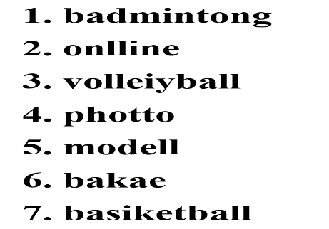 | - Listen and write the words you can hear.  Answer Keys  1. badminton  2. online  3. volleyball  4. photo  5. model  6. bake  7. basketball  - Take part in the class activity.  - Give answers.  Answers keys  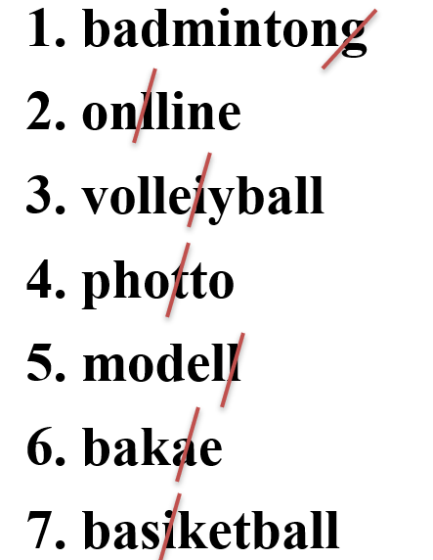
B. New lesson (35’)
Activity 1: Listening (7’)
a) Objective: Help Ss improve their listening skill.
b) Content:
- Listening and writing letter A-H next to each person.
c) Expected outcomes: Ss listen in details and get familiar with the listening test format.
d) Organization of the activity:
TEACHER’S ACTIVITIES | STUDENTS’ ACTIVITIES
You will hear John talking to his mom about his friends’ free time activities. Which activity does each person do? For each question, write a letter (A-H) next to each person.  - Use DCR to show the task.  - Have Ss read through the listening part.  - Demonstrate the activity by using the example.  - Play the audio (CD 2 – Track 34).  - Have Ss check answers with pairs and then give answers.  - Check answers as a whole class. | - Read in silence.  - Listen and then give answers.  Answer keys  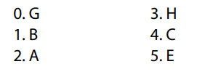
Activity 2: Reading (7’)
a) Objective: Students can improve their reading skill.
b) Content:
- Reading a text and choose the correct answer.
c) Expected outcomes: Ss read for comprehension and get familiar with the reading test format.
d) Organization of the activity:
TEACHER’S ACTIVITIES | STUDENTS’ ACTIVITIES
Read about three people. Choose the correct answer (A, B or C).  - Use DCR to show the task.  - Demonstrate the activity by using the example.  - Have Ss read the text about three people and choose the correct answer.  - Call Ss to give answers, explain.  - Give feedback and evaluation. | - Observe and listen.  - Work individually.  - Give answers, explain.  Answer keys 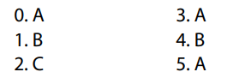
Activity 3: Vocabulary (7’)
a) Objective: Ss can review vocabulary about places of entertainment.
b) Content: Filling in the blanks with the correct words from the box.
c) Expected outcomes: Ss produce the new language successfully, and they can use these words in speaking and writing.
d) Organization of the activity:
TEACHER’S ACTIVITIES | STUDENTS’ ACTIVITIES
Fill in the blanks with the words from the box  - Use DCR to show the task.  - Have Ss read the sentences.  - Ask Ss to work in pairs to fill in the blanks with the words from the box.  - Have Ss give answers, tell the meaning of the words again.  - Check answers as a whole class. | - Read the sentences.  - Work in pairs.  - Give answers.  Answer keys  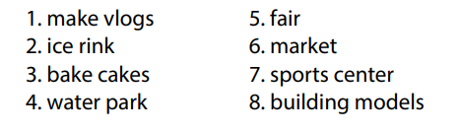
Activity 4: Grammar (10’)
a) Objective: Ss can review the use of English: The Present Continuous and prepositions of place.
b) Content:
- Unscrambling the sentences.
- Circling the correct words (using the map).
c) Expected outcomes: Ss produce the new language successfully, and they can use the grammar points in speaking and writing.
d) Organization of the activity:
TEACHER’S ACTIVITIES | STUDENTS’ ACTIVITIES
Task a. Unscramble the sentences.  - Use DCR to show the task.  - Have Ss read the sentences and unscramble the words to make a meaningful sentence.  - Ask Ss to work in pairs to check each other’s work.  - Have Ss write answers on the board.  - Check Ss’ answers, give feedback.  Task b. Look at the map and circle the correct words.  - Use DCR to show the task.  - Ask Ss to work individually to circle the correct answer.  - Have Ss work in pairs to check each other’s work.  - Call Ss to give answers, explain for their choice.  - Check answers as a whole class. | - Do the task.  - Exchange answers.  - Write answers on the board.  Answer keys  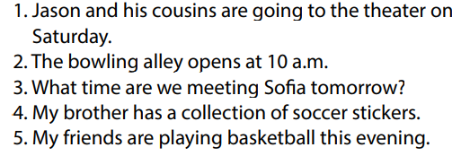  - Work individually.  - Work in pairs.  - Give answers.  Answer keys  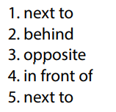
Activity 5: Pronunciation (4’)
a) Objective: Ss can review the word stress and vowels.
b) Content:
- Circling the word that has the underlined part pronounces differently from the others.
- Circling the word that has different stress from the rest.
c) Expected outcomes: Ss produce the new language successfully.
d) Organization of the activity:
TEACHER’S ACTIVITIES | STUDENTS’ ACTIVITIES
Task a. Circle the word that has the underlined part pronounced differently from the others.  - Use DCR to show the task.  - Have Ss distinguish the sound /i/ and / ai/, /ɒ/ and /eɪ/.  - Ask Ss to work individually to circle the answer.  - Have Ss work in pairs to check each other’s work.  - Call Ss to give answers, pronounce the words again.  - Give feedback, correct Ss’ pronunciation if necessary.  Task b. Circle the word that differs from the other three in the position of primary stress in each of the following questions.  - Use DCR to show the task.  - Remind Ss some basic rules of putting stress on words with 2 or 3 syllables.  - Ask Ss to work individually.  - Have Ss work in pairs to check each other’s work.  - Call Ss to give answers, pronounce the words again.  - Give feedback, correct Ss’ pronunciation if necessary. | - Listen.  - Work individually.  - Work in pairs.  - Give answers.  Answer keys  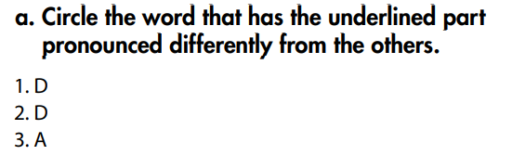  - Listen.  - Work individually.  - Work in pairs.  - Give answers.  Answer keys  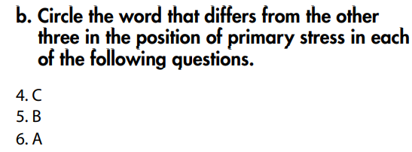
C. Consolidation and homework assignments (5’)
*Consolidation:
*Grammar of Unit 1: The Present Continuous and prepositions of place.
*Vocabulary of Unit 1: Vocabulary about free time activities and places of entertainment.
*Homework:
- Review vocabulary, grammar of unit 1.
- Do the exercises in WB: Review of Unit 1 (page 62).
- Prepare: Unit 2 – New words and Reading (page 12 – SB).
****************************************************************

