Date of teaching:
UNIT 2: MY HOUSE.
Period 9: Getting Started.
I. OBJECTIVES:
- By the end of the lesson, students will be able to:
+ Use the lexical items related to the topic ‘My house’
+ Ask and answer about where someone lives.
1. Knowledge:
a. Vocabulary: town house (n), country house (n), flat (n),….
b. Grammar: possessive case and prepositions of place
2. Ability: Reading, listening and speaking skill.
3. Qualities: Ss will know more about types of houses and love their house.
II. MATERIALS:
1. Teacher: Textbooks, plan, computer.
2. Students: Text book, workbook, notebook.
III. TEACHING PROCEDURE:
1.Warm up:
a. Aims: Attracts students’attention to the lesson.
b. Content: Crossword puzzle.
c. Product: Ss can do the task.
d. Organization: T - WC
Teacher’s Activities | Students’ Activities
- Greetings.  - Check attendances and the date.  * Crossword puzzle:  1. Where does Mi live?  She lives in an A……………..  2.They have a small house in the c………..  3. Which room is it?  It is a k……….  4. What word is it? NOTW  ………………………..  5. What is it?  It is a r………….  6. Tomatoes are in the fr…………… | - Greetings.  - Monitor answers: ………………  - Work in two teams:
  1 | A | P | A | R | T | M | E | N | T
  C | O | U | N | T | R | Y | 2
  3 |  | K | I | T | C | H | E | N
   |  |  | 4 |  | T | O | W | N
   |  |  | R | O | O | M | 5
   | F | R | I | D | G | E
2. Presentation:
a. Aims: Help students understand the dialogue, explain the meanings of words and phrasals in the dialogue.
b. Content: - The dialouge
- Vocabularies related to the topic ‘My house”.
c. Product: Ss can practise the dialouge.
d. Organization: Group work and individual work
Teacher’s Activities | Students’ Activities
* Pre teach vocabulary  - Teacher use different techniques to teach vocab (pictures, situation, realia)  - Follow the seven steps of teaching vacab.  * Checking vocab: < matching>  * Listen and read:  * Set the sence:  * Set the sences: T-Ss  - Teacher draws students’ attention to the pictures in the textbook and asks them some questions about the pictures.  * Now we are going to listen a conversation between Nick and Mi  - Teacher plays the recording, asks students to underline the words related to the topic My house. (Teacher may check the meaning of some words if necessary.)  - Teacher can play the recording more than once.  - Teacher can invite some pairs of students to read aloud.  - Then, teacher confirms the correct answer: | I. Vocabulary:  - flat (n): căn hộ  - country house (phr. n): nhà ở quê  - town house (phr. n): nhà ở phố  - behind (prep): Ở đằng sau  - cousin (n): anh, chị, em họ  - move (v): di chuyển  - Repeat in chorus and individually  - Copy all the words  II. Listen and read:  * Chatting  - What are Nick and Mi doing?  - What might they talk about?  Suggested answers:  - They are talking to / discussing with each other through the Internet.  (Students’answers)  * Listen and read.  + They are talking about their houses.  + Mi is describing their new flat which her family was moving to.  - Students listen and read.
3. Practice:
a. Aims: Ss can practise the dialogue and more vocabularies about houses.
b. Content: The dialogue and vocabularies about houses.
c. Product: Ss can complete exercises.
d. Organization: Team work, pair work and individual work

Teacher’s Activities | Students’ Activities
- Teacher asks students “Which family members does Mi talk about?” without reading the conversation again.  - Then, teacher tells them to read it again individually and check their answers.  - Teacher allows students to share their answers before discussing as a class and encourages them to give evidence.  - Teacher calls some students to check.  - Teacher asks students to work independently to fill each blank with the word from the conversation.  - Teacher allows students to share their answers before discussing as a class.  - Teacher calls some students to check. Teacher confirms the right answers and writes on the board.  - Teacher divides the class into two teams, then writes the topic “Types of house” on the board and gives them two minutes to discuss.  - After that time, a student from each team one by one runs to the board and writes one word.  - The team which has more correct answers is the winner. | III. Practice:  Task 2: Tick the correct answers.  “Which family members does Mi talk about?”  Answer key:  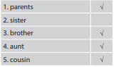  Task 3: Complete the sentences.  * Answer key:  1. sister  2. TV  3. town  4. country  5. three  Task 4: Complete the word web: Types of house.  * Game: Net working  Types of houses  Town house
4. Production:
a. Aims: Ss can ask and answer about where they live.
b. Content: Ask and answer about where they live.
c. Product: Ss can do the task.
d. Organization: Group work
Teacher’s Activities | Students’ Activities
- Teacher asks students to work in groups of 4 or 6 to take turns to ask and answer about where they live.  - Teacher can model with one student.  - Teacher moves around to observe and offer help when needed.  - By the end of the activity, one student from each group can stand up and report to the class. | - Task 5: Ask your friends where they live. Then report their answer:  A: Where do you live?  B: I live in a flat.  A: In my group, Linh lives in a flat, Lan and Huong live in a country house, etc….
* Homework:
- Learn by heart Vocabulary.
- Practice the dialog
- Prepare “Unit 2: A closer look 1”
…………………………………………………………

Date of teaching: ..../..../2022
UNIT 2: MY HOUSE.
Period 10: A closer look 1.
I. OBJECTIVES:
By the end of the lesson, students will be able to:
+ Use the lexical items related to the topic ‘My house’
+ Use the vocabulary and structures to talk about the names of rooms and furniture pieces in the house;
+ Pronounce and recognize the sounds /s/ and /z/.
1. Knowledge:
a. Vocabulary: House lexical items
b. Grammar: The present simple tense.
c. Pronunciation: Practise pronouncing the sounds /s/ and /z/ in isolation in context.
2. Ability: Reading, listening and speaking skill.
3. Qualities:
- Ss will know more about types of houses and love their house.
II. MATERIALS:
1. Teacher: Textbooks, plan, computer.
2. Students: Text book, workbook, notebook and computer or phone with internet.
III. TEACHING PROCEDURE:
1.Warm up:
a. Aims: Attracts students’attention to the lesson.
b. Content: Net work.
c. Product: Ss can do the task.
d. Organization: Individual work and pair work.
Teacher’s Activities | Students’ Activities
- Greetings.  - Check attendances and the date.  * Network:  Types of rooms | - Greetings.  - Monitor: ………………………  - Ss work in two teams:
2. Presentation:
a. Aims: Students can know to use some new words about rooms and furniture.
b. Content: Vocabularies about rooms and furniture.
c. Product: Ss can understand and use the vocabulary.
d. Organization: Individual work and team work.
Teacher’s Activities | Students’ Activities
* Pre teach vocabulary:  - Teacher use different techniques to teach vocab (pictures, situation, realia)  - Follow the seven steps of teaching vocab.  - Check Vo by matching. | A. Vocabulary:  - hall (n): hội trường, phòng lớn  - chest of drawers (n): ngăn kéo tủ  - sink (n): bồn rửa  - dishwasher (n): máy rửa chén  - cupboard (n): tư đựng bình ly  - poster (n): tấm áp phích  - ceiling fan (n) : quạt trần  - light (n): đèn diện  - Repeat in chorus and individually  - Copy all the words
3. Practice:
a. Aims: Ss can know how to use words about house and pronounce correctly the sounds /s/ and /z/ in isolation and in context.
b. Content: Vocabularies about house; sounds /s/ and /z/
c. Product: Ss can complete exercises
d. Organization: Individual work.
A. Vocabulary:  Task 1: Name the things in each room in Ex. 1.  - Teacher asks students to work in pairs to do this activity.  - Teacher writes the names of the rooms on the board in different places, then calls on students from different pairs to go to the board and write the name of the furniture under these rooms.  - Remind students that one piece of furniture can belong to more than one room.  - Teacher asks other students to comment and asks them if they can add some more things to each room.  Task 2: Guessing game  - Teacher models this activity with a student.  - Teacher asks students to work in pairs: one student thinks of a room in his / her house; the other asks questions to guess the room.  - Teacher calls some pairs to practise in front of the class.  - Teacher comments on their performance.  B. Pronunciation:  - Teacher introduces 2 sounds s/ and /z/ to students and lets them listen and repeat the words in Ex. 4 (p. 18).  - Teacher has students comment on how to pronounce these two sounds at the end of the words.  - Teacher quickly explains the rules:  - Teacher asks students to give some words they know containing these sounds.  - Task 3: Listen and write the words in the correct column. Then listen and repeat.  - Teacher asks students to read and listen again the words, then put them in the correct column.  - Students work individually.  - Teacher plays the recording for students to listen, repeat and check their answers.  Task 4: Listen to the conversation. Underline the final “s” in the words and put them into the correct column. (p. 18)  - Have students quickly read the conversation and underline the final “s” in the words. Now play the recording for students to listen to the conversation and write /s/ or /z/ under each “s” that they have underlined.  - Tell them to put the words with the final “s” in the correct column according to the sound of “s”.  - Check students’ answers. Ask them to explain their answers.  - Play the recording again for students to repeat each line of the conversation.  - Ask students to work in pairs to practice the conversation. | Task 1: Name the things in each room in Ex. 1.  Suggested answers:  - Bedroom: lamp, picture, chest of drawers  - Living room: lamp, sofa, picture  - Hall: picture  - Kitchen: fridge, cupboard, dishwasher, sink  - Bathroom: shower, sink, toilet  Other words: chair, fan, air conditioner, cooker, etc.  Task 2: Guessing game  Example:  Ss 1: What’s in your room?  Ss 2: A lamp and a chest of drawers.  Ss 1: Is it the bedroom?  Ss 2: Yes.  B. Pronunciation:  * Rules:  + Final –s is pronounced /s/ after voiceless sounds (/t/, /p/, /k/, /f/, /θ/).  + Final –s is pronounced /z/ after voiced sounds (/b/, /d/, /g/, /n/, /m/, /l/, etc.) and any vowel sounds.  Suggested answers:  - /s/: cats, lamps, books, months  - /z/: beds, dogs, cans, rooms, videos, cookers, bees  - Task 3: Listen and write the words in the correct column. Then listen and repeat.  Answer key:  Task 4: Listen to the conversation. Underline the final “s” in the words and put them into the correct column. (p. 18)  Answer key:  /s/: chopsticks, lamps  /z/: bowls, things, homes  - Ss work in pairs to compare their answers.  - Work in pairs to practice the conversation.
  /s/ | /z/
  lamps, sinks, flats, toilets, | cupboards, sofas, kitchens, rooms
4. Production:
a. Aims: Ss can review what they have leart in the lesson.
b. Content: Game: Whispering (say the full sentence)
c. Product: Ss can play the game.
d. Organization: Group work
Teacher’s Activities | Students’ Activities
- Teacher divides the class into 4 big groups and asks students to stand in four lines.  - The member in the last place will make a sentence containing at least a word and a sound they have learnt; then, whisper the sentence to the next member of the group. They will continue until the member in the first place and this member will say the sentence aloud.  - The fastest group will win the game. | * Game: Whispering  * Suggested sentences:  - There are two bedrooms in my house.  - My living room has a TV, two lamps, some pictures and a sofa.  3. The toilets in my school are clean.
* Homework:
- Learn by heart all the new words.
- Do exercise A1, 2 in work boo
- Prepare: Unit 2: A closer look 2.
………………………………………………………………….

Date of teaching: ....../...../2022
UNIT 2: MY HOUSE.
Period 11: A closer look 2.
I. OBJECTIVES:
- By the end of the lesson, students will be able to know how to use the possessive case and prepositions of place correctly.
1. Knowledge:
+ Vocabulary: House lexical items.
+ Grammar: Possessive case and prepositions of place
2. Ability:
- Reading, speaking and writing skill.
3. Quality:
- Ss will know more about types of houses and love their house.
II. MATERIALS:
1. Teacher: Textbooks, plan, computer.
2. Students: Text book, workbook, notebook.
III. TEACHING PROCEDURES:
1. Warm - up:
a. Aims: Review the old lesson, warm up the class and lead in the lesson.
b. Content: Game: Memory game
c. Product: Ss’ sentences.
d. Organisation: Whole class, group.
Teacher’s Activities | Students’ Activities
- Greetings.  - Check attendances.  * Warm up:  - Teacher divides the class into 4 groups.  - Teacher tells students the rules of the game:  + Students have to study the picture of 3 people (Jack, Polly and Greg) and try to remember the things belonging to each person in 30 seconds without writing down in their notebooks.  + After 30 seconds, teacher shows the things of Jack, Polly and Greg and a member of each team has to answer quickly the question “Whose is it?”  + The group with more correct sentences will be the winner. | - Greetings.  - Monitor……………………………….  - Work in groups.  Game: Memory game    Answer keys:  1. Whose ball is it?  - It’s Jack’s ball.  2. Whose T-shirt is it?  – It’s Greg‘s T-shirt.  3. Whose bike is it?  - It’s Greg’s bike  4. Whose sock is it?  – It’s Polly’s sock.
2. Presentation:
a. Aims: Help Ss know how to use possessive case and prepositions of place correctly.
b. Content: Possessive case and prepositions of place
c. Product: Ss understand the grammar.
d. Organisation: Whole class.
1. Possessive case:  - Teacher draws students’ attention to the words in the answers from the Warm-up “Greg’s T- shirt, Jack’s ball, Polly’s sock” and asks them whether they know the meanings of these words.  - Teacher provides or confirms the answers and lead in the grammar focus of the lesson:  - Teacher writes the form of the possessive case on the board:  2. Prepositions of place:  - Teacher asks students what prepositions of place they know. Encourage students to say as many as possible  - Have them look at the Remember box to see if the prepositions they have mentioned are the same.  Teacher confirms how to use prepositions of place | 1. The possessive case  ( Dạng sở hữu cách)  We use “’s ” to show possession.  name’s + noun  Ex: Polly’s sock.  singular noun’s + noun  - Ex: teacher’s book.  2. Prepositions of place  (Giới từ chỉ nơi chốn)  We use prepositions of place to describe where people or things are.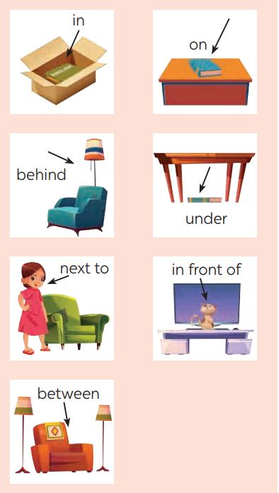
3. Practice:
a. Aims: Help Ss use possessive case and prepositions of place and do some exercises.
b. Content: Possessive case and prepositions of place
c. Product: Ss can do the tasks.
d. Organisation: Whole class, individual work, pairwork, groupwork.
Teacher’s Activities | Students’ Activities
Task 1: Choose the correct answer.  - Teacher asks students to do the exercise individually and then compare their answers with a classmate.  - Check the answers as a class.  Teacher confirms the correct answers  Task 2: Complete the sentences with the correct possessive forms.  - Teacher has students do this exercise individually and calls on two students to write their answers on the board.  - Teacher draws all students’ attention to the board and checks the answers together.  - Teacher confirms the correct answers.  Task 3: Write the correct preposition in the box under each picture.  - Teacher divides the class into 2 teams.  - Each team chooses the number they like, then tries to make the sentencecorrectly.  - The team which chooses a lucky number will get two points without answering any questions.  - The team which has more points will be the winner.  Task 4: Decide True or False statements.  - Teacher has students look at the picture of the room and asks them to describe the room briefly, then has them read each sentence, look at the picture and decide if each sentence is true or false. If it is false, ask them to correct it.  - Teacher has students do this exercise individually before they share their answers with a partner.  - Ask some students to read out their answers.  - Teacher confirms the correct ones. | Task 1: Choose the correct answer.  1. grandmother’s  2. sister’s 3. cousin’s  4. Nam’s 5. An’s  Task 2: Complete the sentences with the correct possessive forms.  1. Mi’s 2. teacher’s  3. Nick’s 4. father’s  5. brother’s  Task 3: Write the correct preposition in the box under each picture.  + Game: Lucky number  1. on 2. next to  3. behind 4. in  5. in front of 6. between  7. under  1. The dog is on the chair.  2. The dog is next to the armchair.  3. The cat is behind the TV.  4. The cat is in the wardrobe.  5. The dog is in front of the kennel / doghouse.  6. The cat is between the lamp and the armchair.  7. The cat is under the table.  Task 4: Decide True or False statements.  1. T  2. F (The school bag is under the table.)  3. F (The clock is between the two pictures.)  4. T  5. F (The cap is on the pillow.)
4. Production:
a. Aims: Ss can ask and answer questions about the position of things.
b. Content: The position of things.
c. Product: Ss can do the task.
d. Organisation: Individual work, pair work.
- Teacher has students work in pairs to play the game Memory challenge.  - Students look at the picture in Exercise 4 for 30 seconds and then cover it.  - They ask and answer questions about the position of the things in the picture.  - Teacher invites some pairs to perform in front of the class. | * Memory challenge  Example:  A: Where are the books?  B: They’re on the table.
* Homework:
- Prepare: Unit 2: Communication.
- Do exercise B4, 5, 6 (WB).

Date of teaching: .../.../2022
UNIT 2: MY HOUSE.
Period 12: Communication.
I. OBJECTIVES:
- By the end of the lesson, students will be able to:
+ Learn how to give suggestions;
+ Practise using some grammar points and vocabulary related to the topic.
1. Knowledge:
a. Vocabulary: House lexical items.
b. Grammar: Giving suggestions: How about + V-ing?
Let’s + V
2. Ability:
Reading, speaking and listening skill.
3. Quality:
- Ss will know more about types of houses and love their house.
II. MATERIALS:
1. Teacher: Textbooks, plan, computer.
2. Students: Text book, workbook, notebook.
III. TEACHING PROCEDURES:
1. Warm - up:
a. Aims: To warm up the class and lead in the lesson.
b. Content: Picture describing.
c. Product: Ss’ answers.
d. Organisation: Whole class, individual work.
Teacher’s Activities | Students’ Activities
- Greetings.  - Check attendances.  * Picture describing:  - Teacher shows the picture of Nam’s house and asks students to describe as many things in the picture as possible.  - Students give their answers.  - Teacher checks the answers. | - Greetings.  - Monitor……………………………….  - Work individually  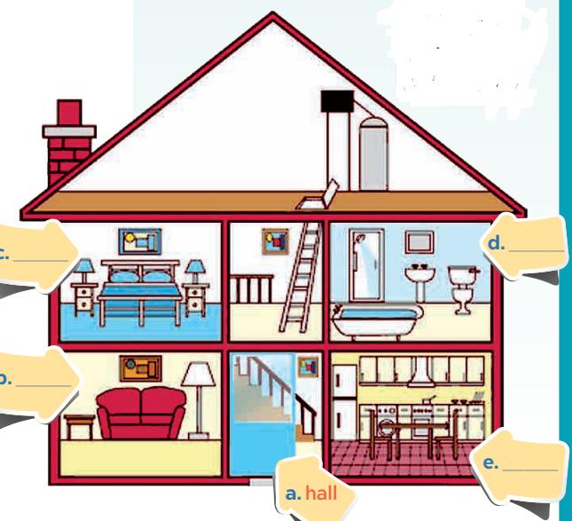  * Suggested answers:  - This is Nam’s house.  - There are 4 rooms in his house.  - In the living room, there is a lamp, a picture, a table and a sofa.  - In the kitchen, there is a fridge, a dishwasher and a sink.
2. Presentation:
a. Aims: Help Ss know and use some suggestions.
b. Content: Giving suggestions.
c. Product: Ss’understandings.
d. Organisation: Whole class, individual work.
Pre structure  - Teacher plays the recording for students to listen and read the dialogue between Elena and her mum at the same time.  - Teacher asks students to pay attention to the highlighted sentences.  - Teacher elicits the structures to give suggestions from students.  - - Teacher has students practise the dialogue in pairs. Call some pairs to practise the dialogue in front of the class. | Task 1: Listen and read a dialogue.  * Giving suggestions:  + Structure:  How about + V-ing?  Let’s + V.  Audio script:  Elena: My bedroom isn't nice.  Mum: How about putting apicture on the wall?  Elena: Great idea, Mum.  Mum: Let's go to the department store to buy one.
3. Practice:
a. Aims: Help students practise doing tasks about giving suggestions and describing houses.
b. Content: Giving suggestions and describing houses.
c. Product: Ss can do the tasks.
d. Organisation: Whole class, individual work, pairwork, groupwork.
Task 2: Make similar dialogues.  - Teacher give students some situations to practice:  Situation 1: You want to clean something in your home.  Situation 2: You want to do some activities at the weekend with your friend.  Situation 3: You want to buy some new school things  - Teacher asks students to work in pairs.  - Teacher moves around to observe and provide help.  Teacher calls some pairs to practise in front of the class, then comments on their performance.  Task 3: Complete the sentences.  - Teacher has students look at the picture and try describing Mi’s grandparents’ country house.  - Teacher encourages students to say full sentences.  - Then ask students to work in pairs to complete the given sentences.  - Teacher moves around to observe and provide help.  - After that, teacher invites students to share their answers.  - Teacher confirms the correct answers.  Task 4: Find the differences between the two houses.  - Have Ss work in pairs to find the differences betwen the two houses.  - Before Ss do this activity, model the way to do this with a student.  - T (look at Nick's house):  - Student (look at Mi's house):  After some minutes, the pair which has the most differences will be the winner.  - Ask some pairs to act out the conversation. Other pairs listen and add more differences if there are any. | Task 2: Make similar dialogues.  * Suggested answers:  1/ A: The kitchen is dirty and messy.  B: How about cleaning it and rearranging things?  A: Great idea, Elena.  B: Let’s do it right now.  2/ A: I am so bored.  B: How about going to the cinema this weekend?  A: Great idea!  Task 3: Complete the sentences.  - 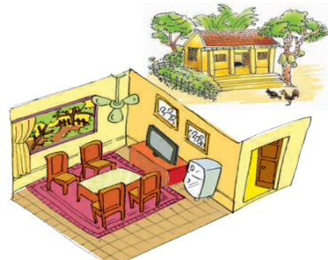  Answer key:  1. country 2. are 3. Is 4. chairs 5. On  Task 4: Find the differences between the two houses.  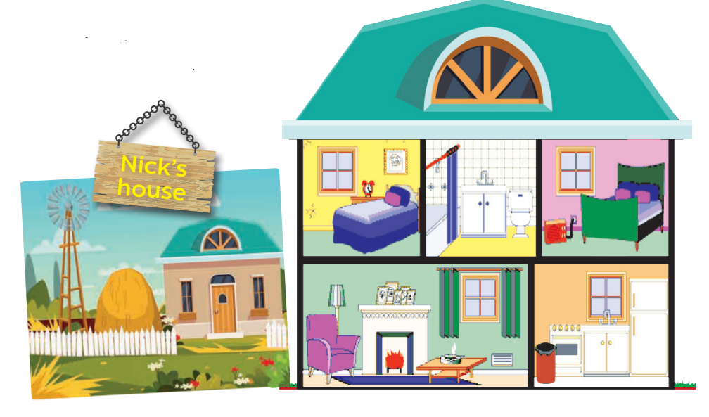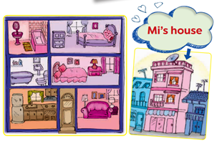  T: Nick lives in a country house. Where does Mi live?  S s: : She lives in a town house.  T: How many rooms are there in Mi's house?  Ss: There are six rooms.  What about in Nick's house?  How many rooms are there? etc.
4. Production:
a. Aims: To help students practise describing their house
b. Content: Draw a simple picture of your house.
c. Product: Students’ drawing and description
d. Organisation: Individual work.
- Teacher gives students 5 – 7 minutes to draw a simple picture of their house, then asks students work in pairs to tell each other about their house. If time allows, teacher can ask them to note down the differences between their houses.  - Teacher calls some students to describe their friend’s house to the class.  - Students may also present the differences between their house and their friend’s. Other students and teacher listen and give comments. The group with higher scores will win the game. | Task 5: Drawing a simple picture of your house. Tell your partner about it.    This is my house. It is a small house in the country. There are 5 rooms in my house such as living room, bathroom, dining room, my room and my parent’s room. There is a sofa, a coffee table and two stools in the living room. There are six chairs and a table, and a fridge in the dining room. The kitchen is big and fully equipped. There is a bed, a table, a chair and a bookshelf in the bedroom. There is a sink and a toilet in the bathroom….. I love my house..
* Homework:
- Prepare: Unit 2: Skills 1.
- Learn by heart all the new words
- Do Ex C1, 2 (WB).
…………………………………………………………..

Date of teaching: ...../..../2022
UNIT 2: MY HOUSE.
Period 13: Skills 1
I. OBJECTIVES:
By the end of the lesson, Ss can: understand the description of a room at the Crazy House Hotel in Da Lat, describe one room (in their imagination) in that hotel.
1. Knowledge:
+ Vocabulary: strange, shape, crazy, an ant….
+ Grammar: The present simple.
2. Ability:
Reading and speaking skill.
3. Quality:
- Ss will know more about types of houses and love their house.
II. MATERIALS:
1. Teacher: Textbooks, plan, computer.
2. Students: Text book, workbook, notebook, computer or phone with internet.
III. TEACHING PROCEDURES:
1. Warm - up:
a. Aims: To warm up the class and lead in the lesson.
b. Content: House.
c. Product: Ss’ answers.
d. Organisation: Whole class, individual work.
Teacher’s Activities | Students’ Activities
- Greetings.  - Check attendances.  * Chatting:  - T gets a student to describe their house to the class.  - T gives comments | - Greetings.  - Monitor: …………………….  * Chatting:  - Work individually  - Others listen and give comments.
2. Pre - reading:
a. Aims: Help Ss understand some words related to a house and predict the content of the text.
b. Content: Some words related to house, the content of the text
c. Product: Ss’ vocabulary and prediction
d. Organisation: Whole class, individual work, pairwork.
- Pre teach vocabulary  - Teacher use different techniques to teach vocab (pictures, situation, realia)  * Prediction:  - Ask Ss to look at the pictures on the textbook, look at the title then make prediction about the reading.  - Ask Ss to read the study skills box. Ss quickly look at the text and answer the questions. | - * vocabulary:  - strange (adj) = crazy : kì lạ, lạ thường  - shape (n) : hình dạng  - Repeat in chorus and individually  - Copy all the words  * Prediction:  Answer key:  1. It’s an email.  2. The text is about Nick’s room at the Crazy House Hotel.
3. While - reading:
a. Aims: Help Ss read for general and specific information about a room at the crazy house hotel in Da Lat and answer the questions.
b. Content: A room at the crazy house hotel in Da Lat
c. Product: Ss can understand the text.
d. Organisation: Whole class, individual work, pairwork.
Task 2:T –Ss : Ss- Ss  - Teacher lets students look at Ex. 2 on p. 22  and tells them how to do this kind of exercise:  + Read the questions.  + Underline the key words.  + Locate the key words in the text.  + Read that part and answering the questions.  - Teacher has students read the text in detail to answer the questions and tells them to underline parts of the email that help them with the answers.  - Teacher tells them to compare their answers in pairs before giving the answers to teacher.  - Teacher asks them to give evidence when giving the answers  Task 3: T - Ss, Ss – Ss  - Teacher asks students to read through the words given and then locate them in the text. If they find a similar word in the text, they should circle it in the list.  - Teacher has students compare their answers.  - Teacher checks and confirms the correct answers | Task 2: Read the text and answer the questions. (Ex. 2, p. 22)  - Ss work individually  1. He’s in Da Lat with his parents.  2. There are ten rooms.  3. Because there’s a big tiger on the wall.  4. It’s under the bed.  Task 3: Circle the things in the Tiger Room.  (Ex. 3, p. 22)  .  * Answer key:  a window  a lamp  a wardrobe  a desk
4. Post - reading:
a. Aims: Help Ss talk about a room in the crazy house hotel.
b. Content: A room in the crazy house hotel.
c. Product: Ss can talk about a room in the crazy house hotel.
d. Organisation: Individual work and groupwork.
- Teacher tells each student to create a new room for the hotel and draw a plan for the room.  - Teacher sets a time limit for students to do it.  - Teacher asks students to give the room a name and bear in mind the organisation of the room including the things in the room and their position.  - Have them note down quickly these ideas  - Have students work in pairs and show the plan to their partner. Ask students to take turns to describe their rooms.  - Remind them to focus on the three points on the board. Move around to observe and offer help.  - Call on some students to show their plan to the whole class and describe it. Other students and the teacher listen and vote for the best plan | Task 4: Create a new room for the hotel. Draw a plan for the room. (Ex. 4, p.22)  - Why is the room called the … room?  (Dog / Cat / Horse / Dolphin (cá heo)/  - Where is your bed?  (under the window / next to the door / in the corner / in the middle of the room / …)  - What are there in your room?  (a TV / a fridge / air-conditioner / a piano, …)  - How is your room?  (big / bright with a lot of windows / cool / clean / dirty / messy / tidy / nice / …  Task 5: Describe your plan. (Ex. 5, p. 22)  - 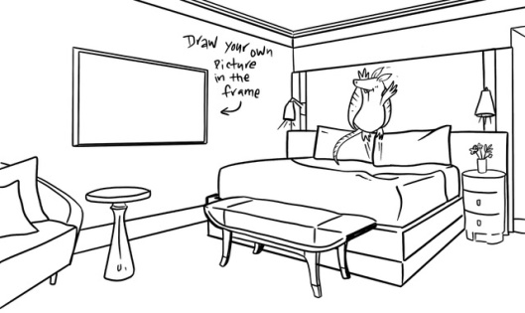    Eg:  This is the Dolphin Room. There’s a big Dolphin at the door. There’s a table and a sofa in the middle of the room ...
* Homework:
- Prepare: Unit 2: Skills 2.
- Learn by heart all the new words
- Do Ex D1, 2 (WB).
……………………………………………………………………
Date of teaching: .../.../2022
UNIT 2: MY HOUSE.
Period 14: Skills 2
I. OBJECTIVES:
By the end of the lesson, students will be able to listen to get information about rooms and houses and write an e - mail to a friend.
1. Knowledge:
+ Vocabulary: Newwords related to the lesson.
+ Grammar: The present simple.
2. Ability:
Listening and writing skill.
3. Quality:
- Ss will know more about types of houses and love their house.
II. MATERIALS:
1. Teacher: Textbooks, plan, computer.
2. Students: Text book, workbook, notebook.
III. TEACHING PROCEDURES:
1. Warm - up:
a. Aims: Check the old lesson, warm up the class and lead in the lesson.
b. Content: Rooms and houses.
c. Product: Ss’ Answer.
d. Organisation: Whole class, individual work.
Teacher’s Activities | Students’ Activities
* Greeting:  - Greet Ss and check their attendance.  - Check the date.  * Oral:  - Teacher gets one student to describe Nick’s room in the hotel.  - Teacher makes comments | - Greetings.  - Monitor: ………………………….  - Work individually  - Others listen and give comments.
2. Pre - listening:
a. Aims: To prepare students for the listening text.
b. Content: Name the pieces of furniture.
c. Product: Students to read the correct words out loud.
d. Organisation: Whole class, pairwork.
- Ask students to look at the pieces of furniture and parts of the house and name them.  - Call on some students to read the words out loud.  - Ask some students to write the words on the board.  - Have students guess if these things are mentioned in the listening text. If they say yes for a thing, put a tick next to the word.  - Play the recording once for students to check their guesses.  - Teacher confirms the correct answers for their prediction. | Task 1: Name the pieces of furniture.  * Answer key:  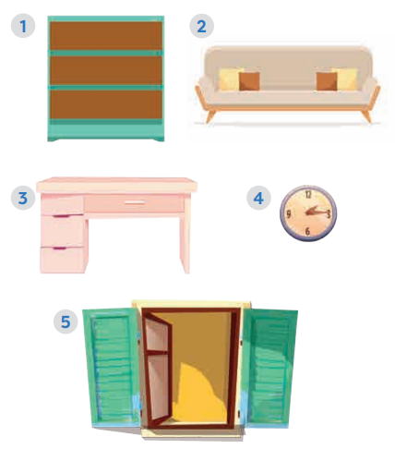  1. bookshelf  2. sofa  3. desk  4. clock  5. window  *Answer key:  Things mentioned in the listening text: bookshelf, desk, clock, window.
3. While - listening:
a. Aims: Help students listen for specific and detailed information about Mai’s house.
b. Content: Mai’s house.
c. Product: Ss can listen to the tape and do the tasks.
d. Organisation: Whole class, individual work, pairwork.
- Have students look at the sentences in this activity. Ask them how to do it. Give them some strategies to do the exercise (e.g. reading the sentences, underlining the key words, listening to the text paying attention to the key words, deciding if each sentence is true or false).  - Play the recording twice for students to do Exercise 2. For a better class, ask students to take notes of the information to explain why a sentence is false.  - Have students share their answers in pairs.  - Invite some pairs to give their answers and confirm the correct ones.  - Play the recording again if needed, stopping at the place where students find it difficult to hear.  - For a better class, ask students to correct the false sentences. | - Task 2: True or False statements. (Ex. 2, p. 23)  - Ss work in pairs:  * *Answer key:  1. F (There are three people.)  2. F (There are six rooms.)  3. T  4. T  5. F (She reads books.)  * Audio script:  My name’s Mai. I live in a town house in Ha Noi.  I live with my parents. There are six rooms in our  house: a living room, a kitchen, two bedrooms, and two bathrooms.  I love our living room best because it’s bright.  It’s next to the kitchen.  I have my own bedroom. It’s small but beautiful. There’s a bed, a desk, a chair, and a bookshelf. It also has a big window and a clock on the wall.  I often read books in my bedroom.
4. Post - listening:
a. Aims: Help students write an email to a friend to describe about their house.
b. Content: An email to a friend to describe about their house.
c. Product: Ss’s writing.
d. Organisation: Individual work.
- T shows a sample email on the slide / on the board or give each student a handout with this sample.  - Ask them several questions:  1. How many parts are there in the email?  2. What is the subject of the email? Where can you find it?  3. What does An write about in the first paragraph of the email?  4. What does An write about in the second paragraph?  - T guides Ss how to write an email, Ss listen and copy down  - Tell students that now they are going to focus on the body of the email only.  - Tell them that answering the guiding questions is one way to help them brainstorm as well as organize ideas for their writing.  - Have students answer the questions individually, encouraging them to write the answers in full sentences.  - Move around to offer help.  - Invite some students to share their answers to the class. Comment on their answers.  - Ask students to write the body of their email individually.  - Ask one or two students to write their email on the board.  - Ask Ss to look at the email and comment.  - T feedbacks and gives mark. | * Necessary parts of an email  - Ss look at the sample and answer:  1. (5 parts)  2.(My house – We can find it in the “Subject line”)  3. (The introduction)  4. (The subject(s) of the email)  * How to write email to friend?  1. In the subject line, write briefly, what the email is about.  2. Begin the email with a greeting (Dear/Hi/Hello).  3. The introduction is the first paragraph. Ask about his/her health, thank him/her for the previous email or write the reasons for the email, etc.  4. In the body, write the subject(s) of the email. Write each subject in a new paragraph.  5. The conclusion is the last paragraph. Say goodbye, ask your friend to write back, etc.  Task 3: Answer the questions. (Ex. 3, p. 23)  - Ss work individually  - 1. I live in a small house in the countryside  2. There are 5 rooms in my house. Living room, two bedrooms,….  3. I like the living room best because I can watch TV with my parents and my younger sister.  Task 4: Write an email to Mira………  * Sample email:  From: Huong@fastmail.com  To: Mira@quickmail.com  Subject: My house.  Hi Mira,  Thank for your email. Now, I’ll tell you about my house.  I live with my parents and younger brother in a town house.  It's big. There are six rooms: a living room, a kitchen, two bedrooms and two bathrooms. I like the living room best because I can watch TV with my parents and younger brother together.  What about you? Where do you live?  Tell me in your next e-mail.  Best wishes,
* Homework:
- Rewrite the email.
- Prepare: Unit 2: Looking back & Project.
- Do exercises: E1, 2 (WB).
……………………………………………………

Date of teaching: ..../..../2022
UNIT 2: MY HOUSE.
Period 15: Looking back & Project.
I. OBJECTIVES:
By the end of the lesson, students can:
- Review the vocabulary and grammar of Unit 2
- Apply what they have learnt (vocabulary and grammar) into practice through a project.
1. Knowledge:
+ Vocabulary: House lexical items.
+ Grammar: The possessive case and Prepositions of place.
2. Ability:
- Reading, speaking and writing skills.
3. Quanlity:
- Ss will know more about types of houses and love their house.
II. MATERIALS:
1. Teacher: Textbooks, plan, computer
2. Students: Text book, workbook, notebook.
III. TEACHING PROCEDURES:
1. Warm - up:
a. Aims: Warm up the class and lead in the lesson.
b. Content: Brainstorming about houses and rooms
c. Product: Ss’ answers.
d. Organisation: Whole class, team work
Teacher’s Activities | Students’ Activities
* Greeting:  - Greet Ss and check their attendance.  - Check the date.  * Brainstorming:  - Have Ss work in 2 teams.  - Ss write as many words as possible | - Greetings  - Monitor: …………………  - Ss work in two teams:  HOUSES AND ROOMS
3. Practice:
a. Aims: Help students review the vocabulary, the grammar related to the topic.
b. Content: the vocabulary, the grammar related to the topic.
c. Product: Ss can do the tasks.
d. Organisation: Whole class, individual work, pairwork.
- Have Ss do this activity individually then compare their answers with their partners.  - Ask for Ss' answers or ask one student to write his/ her answer on the board.  - Confirm the correct answers.  - Have students say how to form the possessive form with proper names and singular nouns.  - Ask students to do the exercise individually and then exchange their answers with a classmate.  - Call on some students to write their answers on the board. Other Ss give comments.  - Confirm the correct answers.  - Ask students to say the prepositions of place they have learnt.  - Have students look at the pictures and do this exercise individually. Ask some students to write the sentences on the board.  - Check students’ answers.  + T can have Ss play a game: Lucky number | Task 1: Put the words into the correct group. Add a new word to each group.  Task 2: Complete the second sentence with the correct possessive form. (Ex. 2, p. 24)  Answer key:  1. teacher’s  2. brother’s  3. Elena’s  4. grandfather’s  5. Vy’s  Task 3: Make sentences using prepositions of place. (Ex. 3, p. 24)  * Answer key:  1. The cat is on the table.  2. The dog is in front of the kennel / doghouse.  3. The cat is between the bookshelf and the sofa.  4. The cat is behind the computer.  5. The girl is on the sofa.  6. The boy is next to the sofa.
  Types of house | Rooms | Furniture
  flat, town house,  country house | living room, bedroom, bathroom, kitchen, | chest of drawers, sink, fridge, dishwasher, cupboard,
4. Production:
a. Aims: Help Ss write three sentences to describe your favourite room in your house.
b. Content: Your favourite room in your house.
c. Product: Ss’ sentences.
d. Organisation: Individual work.
- Ask one student what room in the house is his / her favourite.  - Encourage him / her to say one or two sentences about it.  - Have students write three sentences to describe their favourite room.  - Remind students to use prepositions of place.  - Students share their sentences with their partners.  - Some students are asked to write their sentences on the board.  - Teacher and other students give feedback. | Task 4: Write three sentences to describe your favourite room. (Ex. 4, p. 24)  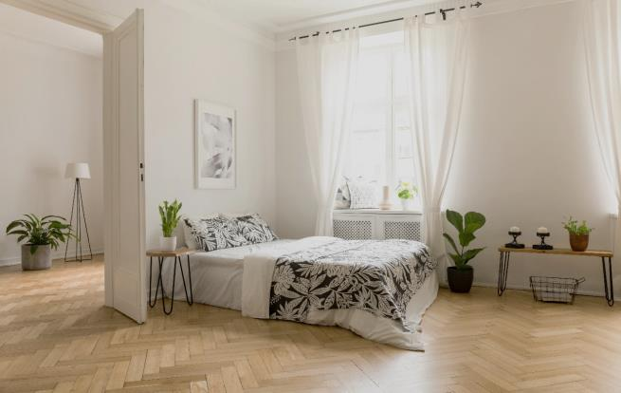  Ex:  - There’s a big bed next to the door.  - There is a clock on the wall.  - There are books on the bookshelf.
* Homework:
- Review the lesson.
- Do the project.
- Prepare: Unit 2: Getting started.

