Date of planning:  Date of teaching: | Period 26:  PREPARATION FOR THE 1S MID-  TERM TEST

I. OBJECTIVES:
1. Knowledge: By the end of the lesson, ss will be able to:
- Vocabulary: revise words related to cultural activities, clothes, accessories, personality adjectives.
- Grammar: review present simple and present continuous tense to describe people.
- Pronunciation: review the pronunciation of the following sounds: /æ/ and /e/, /i:/ and /ɪ/.
2. Competence: SS can revise the language they have learnt and the skills they have practiced in Units 1 – 2. Use the vocabulary of the units, and do the tasks assigned in the textbook. Participate in a guided conversation to give and respond to the news using the given information.
3. Quality/ behavior: Having a positive attitude towards the lesson and a good relationship with friends. The love of learning English. Hard-working; attentive; cooperative; sociable; good communication in class.
II. TEACHING AIDS:
- Teacher: Textbooks, laptop, loudspeaker, projector…
- Students: Grade 7 textbook, Unit 1&2 (SB p. 18&28), studying equipment….
- Method: T-WC; group works; individual ……
III. PROCEDURE:
1. WARM UP (7’)
ACTIVITY 1
* Aim:
- To create a positive classroom atmosphere to start a new lesson.
- To lead into the lesson.
* Content: Play game Who’s faster?
* Products: Students’ correct answers
* Organization of implementation:
Teacher’s & Student’s activities |  | Content
1. Who’s faster?  - T gives and checks instructions for the game.  - T corrects Ss’ pronunciation if any. |  | Game rules:  - Read the instructions carefully.  - Think and say the answers aloud.  - 1 correct answer = 1 point.
2. REVIEW VOCABULARY (22’)
ACTIVITY 2 - 5:
*Aim:
- To help students reviews topic words and word friends from the unit 1.
- To help students reviews topic words and word friends from the unit 2.
- To review vocabulary with critical thinking.
- To review vocabulary in context.
* Content: Vocabulary of unit 1 + 2.
* Outcome: get more information and understand the vocabulary in context,
do the exercises correctly.
* Organisation: Teacher’s instructions…...
Teacher’s & Student’s activities | Content
2. (5’) Activity 2:  - T tells students to open the Glossary box in the student book on page 18.  - T asks Ss to work in pairs: 1 student pronounces the word; 1 student writes it down. Then they swap their roles. Each student has 3 turns to do so. The Ss with more correct words is the winner.  - T corrects Ss’ pronunciation if any. | 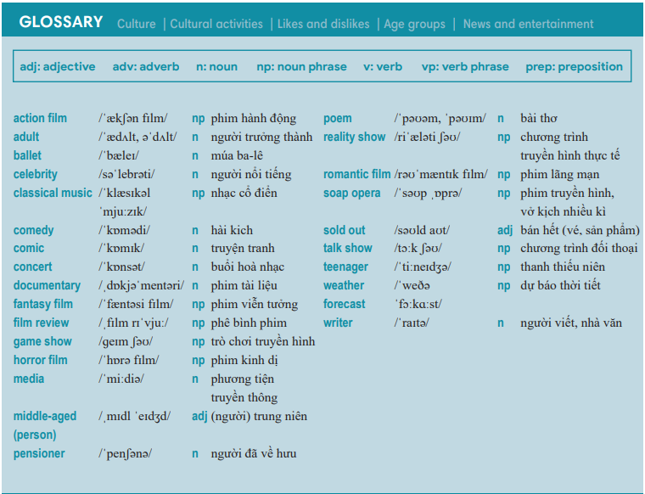
3. (5’) Activity 3:  - T tells students to open the Glossary box in the student book on page 28.  - T asks Ss to work in pairs: 1 student pronounces the word; 1 student writes it down. Then they swap their roles. Each student has 3 turns to do so. The Ss with more correct words is the winner.  - T corrects Ss’ pronunciation if any. | 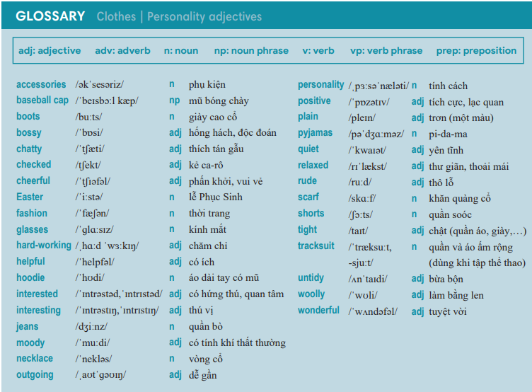
4. (5’) Circle the odd one out.  - T gives and checks the instruction.  - T set a time limit and asks Ss to work in pairs to read and then complete the activity.  - T encourages students to give the reason for their answers.  - T checks as the whole class. | Answer keys:  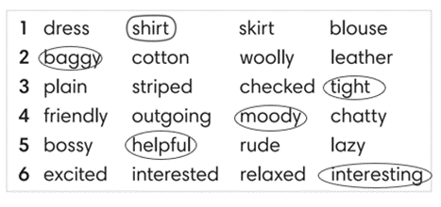
5. (7’) Fill in the blank with a personality adjective. In pairs, say if the sentences are true for you.  - T calls a student to read the instruction and then checks Ss’ understanding of it.  - T asks Ss to work in groups of four to read and then complete the activity.  - Ss work in groups to complete the task and compare the answers.  - T checks as the whole class.  Exercise 2 - Time to talk:  - T asks Ss to work in groups to share their facts.  - Ss work in groups to say which statements are true for them. | Answer keys:  2. cheerful / 3. chatty / 4. quiet / 5. Moody  Example:  Number 1 is true for me. I’m cheerful.  Number 4 is not true for me.
3. REVIEW GRAMMAR (7’)
ACTIVITY 6:
*Aim: To help students revise the form and use of the present simple, present
continuous.
* Content: Pac-man game (present simple, present continuous).
* Outcome: Give the correct answers.
* Organisation: Teacher’s instructions...

6. Pac-man game:  - T gives and checks instructions for the game.  - T corrects Ss if any. | Game rules:  - 2 teams take turns to answer questions.  - 1 correct answer = 10 points.  - The winning team = the team with a  higher point.
4. REVIEW PRONUNCIATION (6’)
ACTIVITY 7:
*Aim: To help students review the sounds: /æ/ and /e/, /i:/ and /ɪ/.
* Content: Words with sounds /æ/ and /e/, /i:/ and /ɪ/.
* Outcome: Discuss and choose the correct word.
* Organisation: Teacher’s instructions…...

7. Circle the word which has the underlined part pronounced differently.  - T asks Ss to work in pairs, discuss and give answers.  - Ss work in pairs to discuss and answer.  - T corrects Ss’ pronunciation if any. | Answer keys:  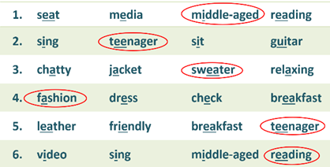
WRAP-UP & HOME WORK (3’)
- T asks Ss to talk about what they have learnt in the lesson.
- Review Unit 1 & 2 vocabulary and grammar.
- Review Unit 1 & 2 pronunciation.
HOME WORK
- Prepare for MID-TERM TEST 1.

