Date of planning: 25/9/22  Date of teaching: 1/10/22 | UNIT 1: CULTURE INTERESTS  Period 12: Lesson 1.6: Speaking
I. OBJECTIVES:
By the end of the lesson student will be able to:
- improve speaking skills by practicing say cinema expression to buy tickets.
1. Knowledge:
* Vocabulary: use vocabulary of types of films, time expression.
* Grammar: make dialogue in the Present Simple with cinema expressions.
2. Competence: Ss understand and use the vocabulary of types film and other related topics to the lesson content, do the tasks assigned in the textbook. Listen for comprehension and say cinema expression to buy tickets.
3. Quality/behavior: To teach Ss to be hard-working and attentive in class. Ss have a positive attitude to working in groups, individual work, pair work, cooperative learning and working.
II. TEACHING AIDS:
- Teacher: Grade 7 textbook, Unit 1 (SB p. 16, WB p.12), laptop/computer connected to the Internet, loudspeaker, projector/TV, PPT slides…
- Students: Text books, studying equipment…
- Method: Active teach, T-WC; group works; individual ……
III. PROCEDURE:
1. WARM UP + LEAD-IN (5’)
* Aim:
- To create a positive classroom atmosphere to start a new lesson.
- To review types of films
- To lead into the topic
* Content: Do mind-map for “Types of films”. Present their idea in front of the class.
* Outcome: Students share their knowledge about films, types of films…
* Organization of implementation: T- Ss …
Teacher’s & Student’s activities |  | Content
Extra activity 1: Mind-map  - T writes the words “TYPES OF FILMS” on board and asks students to work in pairs/small group.  - Students discuss and list out all words they remember from previous lesson.  - Students use a mind-map to present their ideas.  - Teacher encourages students to stand up and share their answers in front of the class.  - Teachers explains that students will use their knowledge about types of film to complete some tasks of the new lesson.  Unit 1 – Lesson 6: Speaking (At the cinema) |  | 
2. PRE-LISTENING (15’)
ACTIVITY 1 + 2:
* Aim:
- To activate Ss’ prior knowledge of the topic.
- To reinforce types of film
- To start a class discussion
- To listen and identify specific information to answer the questions
* Content: Some vocabularies related to films, and types of films. Listen to the conversation to answer the questions about Nam and Mai’s plan.
* Outcome: Knowledge about types of films. Understand the conversation.
* Organisation: Teacher’s instructions …

Teacher’s & Student’s activities |  |  | Content
1. (5’) Class vote  (SB p.16 – Ex 1)  - Set the scene: T tells Ss to look at the cinema program in Student book page 16. T asks some questions to elicit that the program tell students about the titles or the movies and when they start.  - Teacher introduces the Class Vote task in student book.  - T explains How-to-vote steps then checks instructions.  - Ss join in the survey in pairs or in small groups.  - T sets the transition for the next step of the lesson: “Now, let’s do a listening task to know Nam and Mai’s plan.” |  |  | How to vote:  - Read the program  - Say what types of films are on  - Answer the question for yourself “Which ones would you like to see”  - Use the given expression: “I think the … is a/an … film. I’d like to see it.”
2. (10’) Listen and answer the questions.  (SB p.16 – Ex 2)  - T asks students to look at the cinema program again and elicits some information about the program, tickets, seats and rows. (pre-teach the words if needed)  - T asks Ss to look at exercise 2.  - T calls a student to read the instruction then checks Ss’ understanding of it.  - T asks Ss to work in groups of three to listen for the first time  - Students works in pair to listen, answer, and compare their answers.  - T allows students to listen again, read the dialogue to double-check their answers.  - T calls groups to give answers to check with the whole class.  - T tells students to practice reading the dialogue again in a limited time. |  |  | Answer keys:  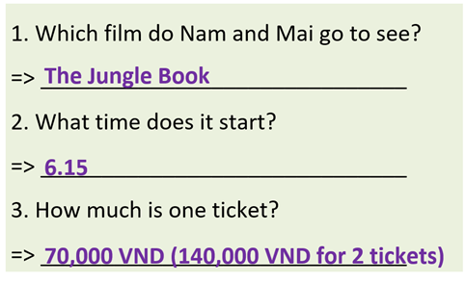
3. WHILE-SPEAKING (10’)
ACTIVITY 3:
* Aim:
- To reinforce the cinema expressions
- To practice the “buy ticket” dialogue
* Content: Complete the dialogue about buying tickets.
* Outcome: Understanding more about cinema expressions. Knowing the dialogue to buy movie tickets.
* Organisation: T_ Ss …
Teacher’s & Student’s activities |  |  |  | Content
3. Complete the dialogue below with one word in each gap. Listen again and check.  (SB p.16 - Exercise 3)  - T asks Ss to look at exercise 3.  - T goes through the Speaking box with students.  - T calls a student to read the instruction then checks Ss’ understanding of it  - Students find examples of the phrases in the dialogue.  - T asks Ss to work in pairs to read then complete the activity.  - T checks as the whole class.  - T sets a limit for students to work in pairs to practice the dialogue as a role play.  - T invites some pairs of students to act out the roleplay in front of the class.  - Ss work in pairs, practice the dialogue, then act out. |  |  |  | Answer keys:  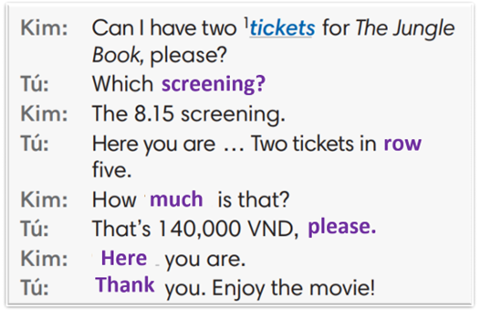
4. POST-SPEAKING ( 8’)
ACTIVITY 4:
*Aims: To help students applying the new language and skills related to the topic in communicating.
* Content: Ask and answer the questions to buy tickets for a film.
* Outcome: To practice speaking by asking and discussing the choices of films, and “buy ticket” related…
* Organisation: T_ Ss …

Teacher’s & Student’s activities | Content
4. In pairs, ask and answer to buy tickets for a film.  (Adaptation for Exercise 4 - SB p.16)  - T tells student to look at the speaking box in their student book again and prepare for the task.  - T gives students time to think about what they are going to say in their roleplays.  - T encourages stronger students to introduce a problem into their role play, e.g. the film is sold out, the only seats leaf are in the front row, there are two tickets left but they aren’t seated together.  - Students work in the same pairs from the last activity and practice their role plays, focus on using the correct intonation.  - Teacher invites pairs to act out their roleplays in front of the class. | 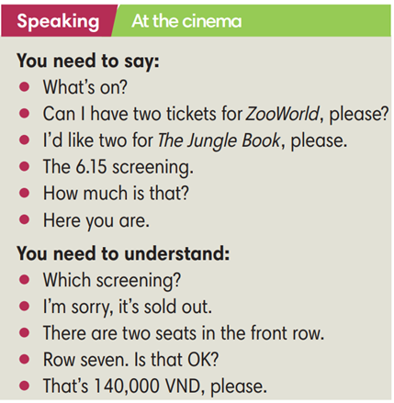
WRAP-UP & HOME WORK (2’)
- T asks Ss to talk about what they have learnt in the lesson.
Cinema expression
* HOME WORK
- Do exercises in the workbook page 12.
- Prepare for Lesson 1.7: Writing.
****************************************************************

