Preparing date: 5/3/2023
Teaching date: 8/3/2023

Period 73 – CLIL: 4 HISTORY

Objectives:
I. Content objectives: By the end of the lesson, students will be able to:
- read a text about mummies and define what a mummy is.
- identify why Ancient Egyptians created mummies and where they put the sarcophagus.
+ Language Objectives: By the end of the lesson, students will be able to:
- use words about history and mummies to make a presentation and in a writing
+ Target language:
- Vocabulary: bury, sarcophagus, spirit, tombs, afterlife
+ Anticipated problems:
- Students may find it hard to imagine how a real mummy looks like.
- Students might not have any ideas of any famous Egyptian mummies.
+ Proposed solutions
- T prepares a video about an Egyptian mummy for students to watch.
- T provides students with some pieces of information about
II. Assessment: Students will be assessed through two comprehension exercises:
- labelling pictures with the words
- true/ false activity
III. Teaching aids:
- Materials: textbooks, worksheet, PowerPoint slides, some Vietnamese poems
- Equipment: TV, projector, loudspeaker
VIII. Procedure:
- Checking: integrated into Warm-up activity
- New lesson:
Teacher’s and students’ activities | Contents
Warm-up
Aims: to get Ss to be ready and excited about the lesson
- The teacher lets students watch a video about the mummification process to answer the question “What is a mummy?” | https://www.youtube.com/watch?v=-MQ5dL9cQX0
Pre-reading
Pre-reading questions
Aims: to activate Ss’ prior knowledge about the topic.
- Students work in groups of 4 to discuss more questions about the mummy they’ve just watched:
- What materials did they use to make a mummy?
- Why did they do this?
Pre-teaching of vocabulary  - The teacher gives students a handout of the task: Match the words with their definitions/ explanations.  - The teacher checks Ss’ pronunciation of the words and checks the answers to the task.  - Students read through the whole text and underline the words they do not know.  - - Teacher explains the words if necessary. | 1. bury /ˈber.i/ (v): to put a dead body into the ground  2. sarcophagus /sɑːˈkɒf.ə.ɡəs/ (n): a stone coffin, often decorated, that was used in ancient times  3. spirit /ˈspɪr.ɪt/ (n) a particular way of thinking, feeling, or behaving, especially a way that is typical of a particular group of people, an activity, a time, or a place  4. tomb /tuːm/ (n) a large stone structure or  the underground room where someone, especially  an important person is buried  5. afterlife /ˈɑːf.tə.laɪf/ (n): the life, for example in  heaven, that some people believe begins after  death
While – reading
Task 1
Aims: to provide Ss with the main idea of the text and give them a reason/ motivation to read.
Activity 2 (Students’ Book page 116)  - Students read the text and complete the labels for photos A – D.  - Ask them to underline the words they found in the text  - Check the pronunciation of the words if necessary. | 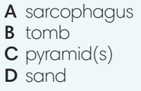
Task 2
Aims: to get Ss to practice their comprehensive reading skills and help them understand more deeply the content and structure of the poem.
Activity 3 (Students’ Book page 116)  - Students work in pairs.  - Students read the text again mark the sentences True (T) or False (F).  - Ask them to underline the information they found in the text.  * Mini game to check: 1 student reads a random statement and others stand up to mime the action spreading 2 arms as True or cross their arms as False.  The teacher invites some students to explain their answers. Encourage them to use the prompt “Number 1 is True/ False. I found it in paragraph___ line___”.  Graphic Organizer  - Give students a graphic organizer in the form of a mindmap with blanks to fill in.  - Students work in pairs to complete the task.  - Have Ss do group check after they finish. Ask them to use their own words to present the content.  - Invite some students to share their ideas. | 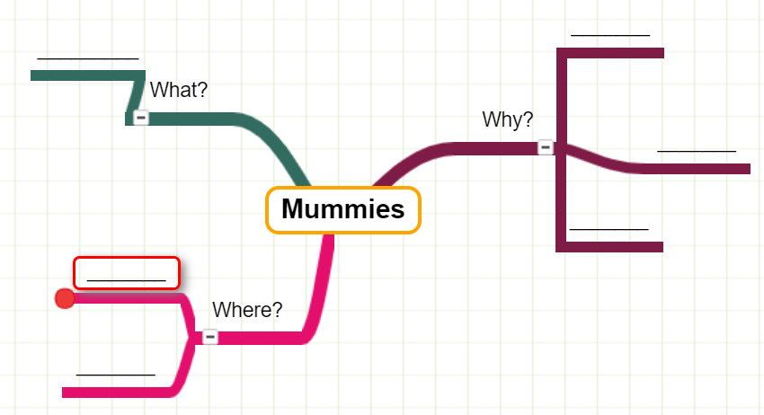
Post – reading
Aims: To help Ss reflect on what they’ve learnt and what they’ve known about mummies.
Activity 4 (Students’ Book page 116)  - Students work in groups of 4 to complete this task.  - Ask them to research a famous Egyptian mummy.  - Follow the instructions of the task.  - Give students some minutes to practice presenting their information.  - Invite some groups to present in front of the class.  - Give feedback and assessment after their presentation.  ***T should ask Ss to prepare this content in advance so their presentation can be better. | In case students didn’t have any tools to finish this activity, T needs to prepare some pieces of information in advance.  For example: “Tutankhamun. In 1922, British archaeologist Howard Carter discovered the mummy of pharaoh Tutankhamun in Egypt's Valley of the Kings. Despite several apparent grave robberies, the tomb was crammed with ancient treasures, including jewellery, gilded shrines and a solid gold funerary mask.”  Reference: https://www.thenationalnews.com/mena/egypt/seven-of-egypt-s-most-famous-mummies-and-their-incredible-histories-1.1195727
Activity 5 (Students’ Book page 116) (This one can be left as homework if time doesn’t allow.)
- The teacher asks students to write a paragraph about a mummy they know and add some illustrating pictures.
- Work in groups of 4 to share the writings with their friends.
- Guide students on how to take notes their friend’s writing based on the ideas given in Activity 4.
Wrap – up
- Students take note of the homework: Activity 5 (If they haven’t done it in class.)
- The teacher gives students homework.
- Guides for homework:
- Prepare Unit 8 Lesson 1.
***************************************************

