Preparing date: 16/4/2023
Teaching date: 19/4/2023

UNIT 9: GREETING AROUND
Period 90 - Lesson 9.7: Writing

I. Objectives: By the end of the lesson, Ss will be able to write an invitation email.
1. Knowledge:
Vocabulary: text languages, meeting arrangements
Grammar: past simple, be going to for plans, suggestions, present continuous for arrangements
2. Competences:
Groupwork and independent working, pair work, linguistic competence, cooperative learning, and communicative competence
II. Teaching aids:
Materials: textbooks, PowerPoint slides, Resource 113 Worksheets (Teacher’s resource book Unit 9_9)
Equipment: TV, projector, loudspeaker
III. Procedure:
Checking: integrated into Warm-up activity
New lesson:
Teacher’s and students’ activities | Contents
1. Warm-up
Aims: to recall words to describe people that they've learned in this unit.
Guessing Game  T divides the class into 2 groups and asks Ss to play a game.  T shows pictures of celebrations one by one and asks Ss to guess: What celebration is this?  Ss have to put their hands up to answer. The first group to put their hands up and to give the correct answer wins a point.  The winning group is the one that has won the most points. | Answer:  Birthday  New year  Halloween  Thanksgiving  Christmas
2. Set objectives
Aims: To introduce the objectives of the lesson with a can-do statement.
I can write an invitation email.
3. Pre-writing
Aims: To analyze the writing samples.
T checks that Ss understand the difference between celebrate (verb) and celebration (noun).  T sets a time limit for the pairs to discuss their story of the last good news and invites pairs to share their stories with the rest of the class. | Exercise 1:  - The answer may vary.
T asks students to read the email quickly and answer the questions in pairs.  T elicits the answers.  Think – Pair – Share  T asks Ss to look in the email again and find an example of something that happened in the past, a future plan, a suggestion, and text language.  T asks students to work in groups of 4 to share their ideas.  T calls some volunteers to share with the whole class. | Exercise 2: In pairs, read the email quickly and  answer the questions.  Eva  Max passed his audition.  Sol, Lily, and Max's dad.  At a quarter to six, on Friday.  A card.  In the past: Max passed his audition.  Future plan: I’m going to invite Lily and Max’s dad.  A suggestion: Let’s meet under the bus station clock.  Text language: BTW – which means by the way.
T asks Ss to find examples of phrases in Eva’s mail.  T elicits the answers.  Writing Race  T gives an unfinished table about the structure of an invitation email.  T divides the class into groups of six and asks Ss to complete the task.  The first group to have the correct answers wins the game. | Exercise 3: study the Writing box. Find examples of the phrases in Eva’s email.  Possible answer:
  Information | Tense/ Structure | Part
  To giving recent news | Past simple | Greeting/News
  To say what is happening now
  To talk about plans
  To talk about arrangements
  To make suggestions
  To invite
  Information | Tense/ Structure | Part
  To giving recent news | Past simple | Greeting/News
  To say what is happening now | Present continuous | Invitation
  To talk about plans | Be going to | Invitation/ Other plans
  To talk about arrangements | Present continuous | Meeting arrangements
  To make suggestions | Let’s | Meeting arrangements
  To invite | Would you like | Invitation
- While writing
Aims: to practice writing shorts sentences or a completed invitation email.
T shows the photo in Exercise 4 and discusses the photo with the class. T asks Ss if anyone has been karting.  T asks students to read the text quickly and complete the sentences.  T elicits the answers and checks that Ss understand the differences between minimum and maximum. | Exercise 4: Read the advert and complete the sentences. Write no more than three words in each gap.  Answers:  10 a.m  Thirteen  2.30  Food or drink  Minimum: used after amounts to show that the amount is the lowest possible  Maximum: used after amounts to show that the amount is the highest possible
T and Ss discuss the given sentences.  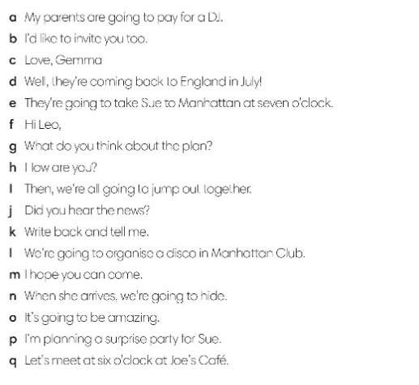  T guides Ss to complete the email within RESOURCE 113.  T and Ss check. | RESOURCE 113 Worksheet (Teacher’s resource book Unit 9_9)  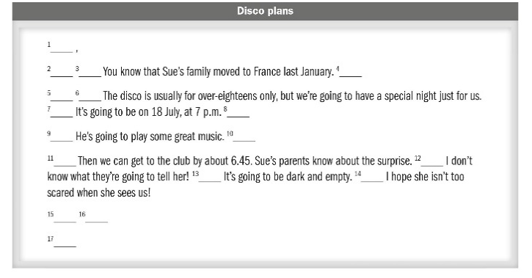
T elicits ideas for possible news that they could include at the start of their email.  T sets a time limit for Ss to write their email.  T puts Ss in pairs and asks them to swap emails. Ss should read their partner’s email and ask if it was written specifically to them.  The pairs take turns to thank each other and say whether they can come. | Exercise 5: You’re celebrating your birthday this Saturday. Write an email inviting a friend to come.
Post writing
Aims: to give comments for the writings.
T gives students the writing rubric to check their writings themselves, then give comments to partners. |  | Writing rubric:  Does your writing follow the right format of an invitation email?  Do you use correct punctuation?  Do you use the correct forms of the verbs?  Do you have a greeting and closing?
Guides for homework:
Do exercises on Workbook page 85.
Prepare Unit 9 Lesson 8 Pronunciation and Revision.
**************************************

