Date of planning:  Date of teaching: | UNIT 4: HEALTH AND FITNESS  Period 44-Lesson 6: Speaking
I. OBJECTIVES:
By the end of the lesson student will be able to:
- talk about illnesses and ask about how someone is feeling.
1. Knowledge:
* Vocabulary: use the phrases to describe symptoms of illnesses and to give advice.
* Grammar: make dialogue in the Present Simple, Present Continuous to talk about health problems and advice.
2. Competence: Ss understand and use the phrases of illnesses and advice, do the tasks assigned in the textbook. Listen and read a dialogue for comprehension. Then practice asking how a classmate is feeling and give some pieces of advice.
3. Quality/ behavior: To teach Ss to be hard-working and attentive in class. Ss have a positive attitude to working in groups, individual work, pair work, cooperative learning and working.
II. TEACHING AIDS:
- Teacher: Grade 7 textbook, Unit 4 (SB p. 46, WB p.39), laptop/computer connected to the Internet, loudspeaker, projector/TV, PPT slides…
- Students: Text books, studying equipment…
- Method: Active teach, T-WC; group works; individual ……
III. PROCEDURE:
1. WARM UP + LEAD-IN (5’)
* Aim:
- To create a positive classroom atmosphere to start a new lesson.
- To review words of illnesses.
- To lead into the topic.
* Content: Play Minion Games to recall the vocabulary in previous lessons.

* Outcome: Students talk about pets by using the vocabulary in previous lessons.
* Organization of implementation: T- Ss
Teacher’s & Student’s activities |  | Content
Extra activity 1: Minion Games  - T greets students and asks Ss what topic they learnt from last lesson.  - Students discuss and list out all words they remember from previous lesson.  - T introduces the Minion Games and How to play steps  - T uses the slides to lead the game.  - When Ss finish the game, T shows a slide of Unit 4 – Lesson 5 vocabulary and asks students to look at them quickly  - T tells Ss that, they are using the vocabulary to do some speaking tasks today.  - T writes the title of new lesson: Unit 4/ Lesson 6 - Speaking |  | How to play:  - Read the sentence carefully.  - Choose A or B to fill in the blank.  - 1 correct answer = 1 point.
2. PRE-SPEAKING (15’)
ACTIVITY 1 + 2 + 3:
* Aim:
- To activate Ss’ prior knowledge of the topic.
- To lead into the topic.
- To present phrases of talking about health problems and giving advice.
- To introduce the Speaking Box.
* Content: Listen to the conversation to answer the questions about Binh.
* Outcome: Know about asking what the problem is and giving advice. Understand the conversation.
* Organisation: Teacher’s instructions…
Teacher’s & Student’s activities |  | Content
1. (5’) In pairs, look at the photo. What do you think is happening?  (Exercise 1 – SB p.46)  Set the scene: See – think - wonder  - T tells Ss to look at the picture in their student book page 46.  - T encourages students to predict the information by answering the two questions:  1. What do you see in the picture?  2. What do you think is happening?  - Ss work in pairs to find the answer for the two questions.  - T calls some students to share their answers and checks as the whole class.  - T sets the transition for the next step of the lesson by showing the introduction: “This is Binh. He felt terrible so he went to see the school nurse. Let’s see what happened.” |  | Key answers:  - A boy and a nurse  - The boy has a health problem. / The boy is sick.
2. (5’) Listen and read. Why did Binh go to see the school nurse?  (Exercise 2 – SB p.46)  - T asks Ss to look at exercise 2.  - T calls a student to read the instruction then checks Ss’ understanding of it.  - T asks students to listen and read the dialogue to find the answer. T elicits some parts of the dialogue if needed.  - T asks the volunteer students to give the answer then checks as the whole class.  More tasks with Exercise 2  - T tell students to read the text again and answer the other two tasks:  1. What questions did the school nurse ask Binh?  2. Read again and finish the school nurse’s advice.  - Students work in pairs to continue reading and are allowed to give the answer massively.  - T listens to Ss’s answer and checks as the whole class.  - T explains to Ss that the school nurse in the dialogue did 2 main jobs: asking what the problem is and giving advice. |  | Answer key:  Because he felt terrible, and he had a really bad stomachache.  Answer keys for extra task:  1. When did you start feeling ill?  What did you have for lunch?  2. You should drink a lot of water  You should make an appointment with your doctor.
3. (5’) Underline the words and phrases from the dialogue.  (Exercise 3 – SB p.46)  - T asks Ss to look at exercise 3.  - T calls a student to read the instruction then checks Ss’ understanding of it.  - T goes through the Speaking box and asks students to find the phrases that are used in the dialogue.  - When they have finished, T asks them to work in pairs to create a short dialogue which includes at least one phrase from each section of the Speaking box.  - T encourages Ss to use their imagination and tell them to make sure that the advice given matches the illness that is described.  - T invites different pairs to act out their dialogues in front of the class. |  | 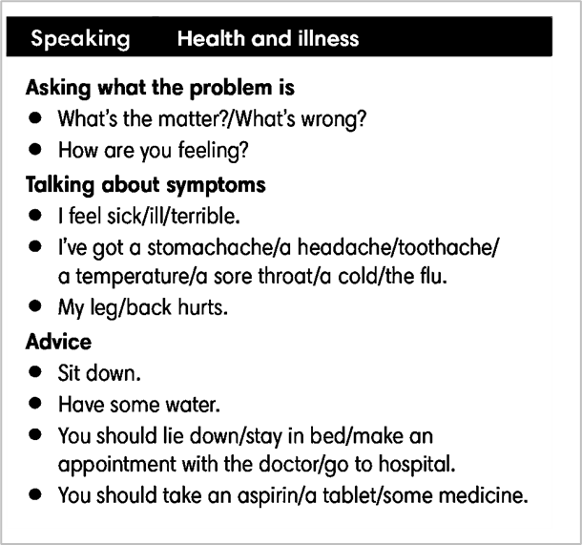
3. WHILE-SPEAKING (10’)
ACTIVITY 4 + 5:
* Aim:
- To reinforce the expressions of asking about health problem and giving advice
- To practice using the new expression in context
* Content: Complete the conversations to make an appointment to see the doctor.
* Outcome: Understand the use of making an appointment to communicate.
* Organisation: T, Ss ..….
Teacher’s & Student’s activities |  | Content
4. (5’) In pairs, complete the dialogues with one word in each gap. Listen and check.  (Exercise 4 - SB p.46)  - T asks students to work in pairs to complete the exercises.  - T plays the audio for students to check.  - When students have finished, T tells them to discuss each of the following: the last time they had a temperature and what they did; a time when they thought they had broken a bone and how it happened; the last time they made an appointment to see the doctor and why.  Pair work task 1  - T sets a limit for students to work in pairs to practice the 3 situations in Exercise 4 as a role play.  - T invites some pairs of students to act out the roleplay in front of the class.  Pair work task 2: Use the Speaking Box and replace another the response for each situation.  - Ss work in pair, practice the dialogue, then act out. |  | Answer keys:  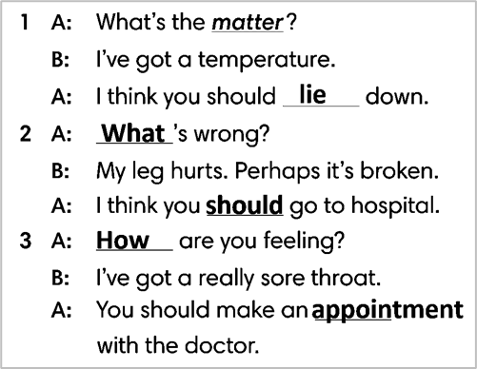
4. POST-SPEAKING (8’)
ACTIVITY 5:
*Aims: To help students applying the new language and skills related to the topic in communicating.
* Content: Describe symptoms of illnesses and to give advice.
* Outcome: To practice describing symptoms of illnesses and to give advice by create a new situation and act out.
* Organisation : T, Ss .…
Teacher’s & Student’s activities | Content
5. In pairs, follow the instructions. Use the Speaking box and Exercise 4 to help you.  (Exercise 5 - SB p.46)  - T tells students to look at the speaking box in their student book again and prepare for the task.  - T gives students time to think about what they are going to say in their roleplays.  - If students have difficulties thinking of true situations, T encourages them to use their imagination.  - T encourages stronger students to give some very first examples.  - Students work in the same pairs from the last activity and practice their role plays, focus on using the correct intonation.  - T tells students to do the activity with their books closed, so that their reactions can be natural, and they don’t just read from the Speaking box.  - Teacher invites pairs to act out their roleplays in front of the class. | 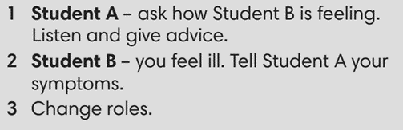
WRAP-UP & HOME WORK (2’)
- T asks Ss to talk about what they have learnt in the lesson.
- phrases to describe symptoms of illnesses and to give advice
* HOME WORK
- Do exercises in the workbook page 39.
- Prepare for Lesson 4.7: English In Use

