Date of planning:  Date of teaching: | UNIT 6: SCHOOLS  Period 69- Lesson 6: Speaking
I. OBJECTIVES:
By the end of the lesson, Ss will be able to:
- use vocabulary and phrases to talk about favorite subjects and activities at school.
1. Competence: Ss can use vocabulary and phrases to talk about their favorite subjects and activities at school, and do the tasks assigned in the textbook.
2. Quality/behavior: To teach Ss to be hard-working and attentive in class. Ss have a positive attitude to working in groups, individual work, pair work, cooperative learning and working.
II. TEACHING AIDS:
- Teacher: Grade 7 textbook, Unit 6 (SB p.66, WB p.57), laptop/computer connected to the Internet, loudspeaker, projector/TV, PPT slides…
- Students: Text books, studying equipment…
- Method: Active teach, T-WC; group works; individual ……
III. PROCEDURE:
1. WARM UP + LEAD-IN (5’)
* Aim:
- To create a positive classroom atmosphere to start a new lesson.
- To review words of subjects and school activities.
- To lead into the topic.
* Organization of implementation: T-Ss, Ss-Ss, Ss-T.
Teacher’s & Student’s activities |  |  | Content
Extra activity 1: Game  - T divides Ss into 4 teams.  - Before starting the game, T writes 4 favorite subjects of Ss on the board.  - When Ss finish the game, T tells Ss that, they are using the vocabulary to do some speaking tasks today.  - T writes the title of new lesson: Unit 6/ Lesson 6.6 - Speaking |  |  | Game rules:  - Time limitation: 3 minutes and 1 minute for preparation.  - Ss take turns to write activities of each subject on the board.  - 1 correct answer = 1 point.
2. PRE-SPEAKING (9’)
ACTIVITY 1:
* Aims:
- To activate Ss’ prior knowledge of the topic.
- To lead into the topic.
* Organisation: T-Ss, Ss-T, Pair work.
Teacher’s & Student’s activities | Content
1. (9’) Listen and answer the questions. Who likes science? Why does he/ she like science?  (Ex 1 – SB p.66)  - T shows pictures in SB p.66 on the slide.  - Ss work in pairs to describe them.  - T asks a few volunteers to answer the questions.  - T encourages Ss to guess why the character likes science.  - T plays the audio for Ss to listen and check pronunciation of any new words.  - T explains any new words if needed.  - Ss work in pairs to role-play the dialogue.  - T invites 2 groups to model in front of the class.  - Ss answer the question, underline evidence from the dialogue and useful vocabulary/ structures that they can use later. | Answer keys:  Minh likes science. He likes learning by doing and doesn’t like learning with only books.
3. WHILE-SPEAKING (20’)
ACTIVITIES 2, 3, 4:
* Aims:
- To introduce the Speaking Box.
- To reinforce the expressions of subjects and activities.
- To practise using the new expressions in contexts.
* Organisation: T-Ss, Ss-T, Pair work.
Teacher’s & Student’s activities | Content
2. (10’) Study the Speaking box. Find three similar questions in the dialogue.  (Ex 2 – SB p.66)  - T goes through the Speaking box and asks Ss to find three similar questions in the dialogue.  - When Ss have finished, T asks them to work in pairs to create a short conversation using these phrases.  - T invites different pairs to act out their dialogues in front of the class and then provide feedback. | Answer keys:  What is your favourite project?  What kind of experiments?  Do you like it?  Why not?  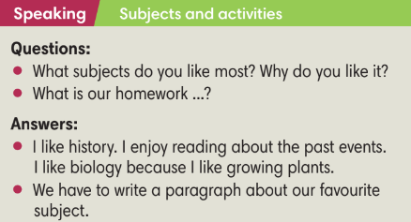
3. (5’) Listen to the activities. Circle the school subjects students are describing.  (Ex 3 – SB p.66)  - T asks Ss to look at all student names and school subjects.  - T plays the audio for students to check. | Answer keys:  Linh: music  Stephanie: maths  Bình: literature  Hạnh: chemistry  Dreck: geography
4. (5’) Listen again. Fill in each blank with ONE word.  (Ex 4 – SB p.66)  - T plays the audio again for Ss to finish Exercise 4.  - T asks Ss to check answers in pairs before checking with the whole class.  - T pauses the audio and ask Ss to repeat if needed. | Answer keys:  1 love  2 like  3 into  4 good  5 like
4. POST-SPEAKING ( 8’)
ACTIVITY 4:
*Aims: To help Ss applying the new language and skills related to the topic in communicating.
* Organisation: T-Ss, Ss-Ss.
Teacher’s & Student’s activities |  | Content
5. In pair, discuss classroom activities you like and dislike. Find 1-2 classroom activities you both like.  (Ex 5 - SB p.66)  - T asks Ss to work in pairs for discussion.  - T invites 2 random students to make a conversation in front of the class. Other Ss listen and provide feedback.  - T tells students to look at the speaking box in their student book again and work in groups to prepare for the task.  - T sets time for Ss to prepare and practice speaking.  - T walks around the class to listen and provide feedback.  - T asks 5 groups to practice the conversation in front of the class.  - T does a quick class vote to find the most/ least favourite school activities. |  | 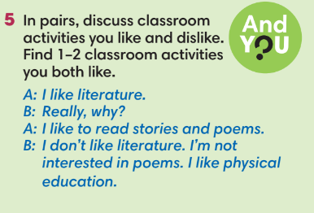
WRAP-UP & HOME WORK (3’)
- T asks Ss to talk about what they have learnt in the lesson.
favorite subjects and activities at school.
* HOME WORK
- Do exercises in the workbook page 57.
- Prepare for Lesson 6.7: English in use.

=====================

