Date of planning:11/12/2022  Date of teaching: 17/12/2022 | UNIT 4: HEALTH AND FITNESS  Period 45: Lesson 4.7: English in Use
I. OBJECTIVES:
By the end of the lesson, Ss are able to:
- use phrasal verbs to talk about health.
1. Knowledge:
* Grammar:
- Understand and use correctly some phrasal verbs provided in the lesson.
- Talk about health and how to keep fit.
2. Competence: Ss understand and use the vocabulary about illnesses and understand the use of phrasal verbs in context (a cartoon), then do the tasks assigned in the textbook; use the correct tense of verbs, phrasal verbs to talk about health.
3. Quality/ behavior: To teach Ss to be hard-working and attentive in class. Ss have a positive attitude to working in groups, individual work, pair work, cooperative learning and working.
II. TEACHING AIDS:
- Teacher: Grade 7 textbook, Unit 4 (SB p. 47), laptop/computer connected to the Internet, loudspeaker, projector/TV, PPT slides…
- Students: Text books, studying equipment…
- Method: Active teach, T-WC; group works; individual ……
III. PROCEDURE:
1. WARM UP (5’)
* Aim:
- To create a positive classroom atmosphere to start a new lesson.
- To review words of illnesses and giving advice.
* Content: Game: SUPER DOCTOR GAME (about health)
* Outcome: Ss guess and choose the correct advice for the problem.
* Organization of implementation
Teacher’s & Student’s activities | Content
Extra activity 1: SUPER DOCTOR GAME  - T asks Ss How are you feeling? Do you remember vocabulary from Unit 4-Lesson 5?  - T tells students that they are playing a game with words of illnesses and giving advice.  - T explains the game rules then checks instructions.  - T uses the slides to lead the game  - Ss join in the game individually.  - T corrects Ss’s pronunciation if necessary.  - T tells students to recall all vocabulary from the game.  - T introduces the new lesson and writes on board:  Unit 4/ Lesson 7: English in use | Game rules:  - Look at the picture. Read the sentence  - Guess correct advice for the problem.  - 1 correct answer makes the doctor happy.
2. LEAD-IN (3’)
* Aim:
- To lead into the new lesson.
- To provide Ss with reasons for reading the cartoon in exercise 1 (SB p.47).
* Content: Describe the situation in the cartoon.
* Outcome: Guess the correct answers to the questions.
* Organisation: T_ Ss ..….
Teacher’s & Student’s activities | Content
Extra activity 2: See – think – wonder.  - T shows the cartoon pictures on the slide then asks students four questions.  (1) What can you see in the pictures?  (2) Who are in the pictures?  (3) What’s the boys doing in each picture?  (4) Is the boy happy? Why?  - T sets a time limit for Ss’ quick discussion.  - Ss work in pairs to make guesses about the pictures then give answers.  - T calls some Ss to give answers then checks with the whole class.  - T introduces “This boy felt terrible, so he and his friend decided to go home.” | 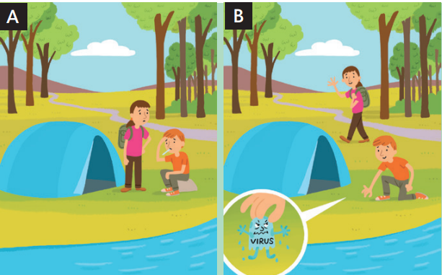
3. PRESENTATION (7’)
ACTIVITY 1:
* Aim:
- To present the new phrasal verbs through a context.
- To introduce the Language Box through the reading tasks.
* Content: Exercises about health and illness.
* Outcome: Do the exercise to improve grammar.
* Organisation : T_ Ss ..….
Teacher’s & Student’s activities | Content
1. (3’) Look at the cartoons. Which version, A or B, matches the text? Read the information about phrasal verbs to check your answer.  (Exercise 1 – SB p.47)  - T asks Ss to open their SB page 47, look at exercise 1.  - T calls a student to read the instruction then checks Ss’ understanding of it.  - T tells Ss that they are going to read the text to find the answers.  - T refers students to the Language box before they read the sentences and answer the question.  - Ss work individually, read, and note down the answers to the given question.  - T calls some Ss to give answers then shows the answers on the slide.  - T elicits the meaning of pick-up using slide.  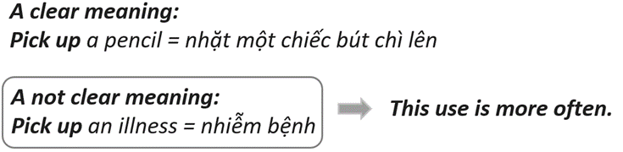  - T provides another cartoon picture for student to practice.  - Ss listen to the teacher carefully and learn another phrasal verb: go off | Answer keys:  Version A matches the text.  Version B show the literal meaning of the words in the phrasal verb, but it doesn’t show the true meaning.
4. PRACTICE (8’)
ACTIVITY 2 + 3:
* Aim: To reinforce the use of phrasal verbs.
* Content: Use the phrasal verbs to do the excercise.
* Outcome: Match and complete sentences crroectly.
* Organisation : T_ Ss.. ….
Teacher’s & Student’s activities | Content
5. (4’) Match the phrasal verbs in sentences 1 – 7 with meanings a – g.  (Exercise 2 – SB p.47)  - T asks Ss to open their SB page 47, look at exercise 2.  - T calls a student to read the instruction then checks Ss’ understanding of it.  - T gives students a time limit to work individually.  - T allows Ss to share their answers massively before checking the final ones as the whole class.  - T provides the meanings of the phrasal verbs if needed. | Answer keys: 2-c, 3-a, 4-f, 5-e, 6-d, 7-g
3. (4’) Complete the text with one word in each gap  (Exercise 3 – SB p.47)  - T asks Ss to open their SB page 47, look at exercise 3.  - T calls a student to read the instruction then checks Ss’ understanding of it.  - T gives students a time limit to work individually.  - T allows Ss to share their answers massively before checking the final ones as the whole class.  - T provides the meanings of the phrasal verbs if needed  - T encourages Ss to make sentences using the phrasal verbs they learnt from Unit 2 & 3. | Answer keys: 1 – look, 2 – up, 3 – give, 4 - find
5. FURTHER PRACTICE (6’)
* Aim: To reinforce the use of phrasal verbs.
* Content: Playing game: STAMP GAME (with the phrasal verbs).
* Outcome: Complete the phrasal verbs correctly.
* Organisation : T_ Ss.. ….
Teacher’s & Student’s activities | Content
Extra activity 3: STAMP GAME  - T tells students that they are playing a game with the phrasal verbs  - T explains the game rules then checks instructions.  - T uses the slides to lead the game  - T reminds Ss that sometimes they have to choose a preposition, sometimes a verb.  - Ss join in the game individually.  - T corrects Ss’s pronunciation if necessary.  - T tells students to recall all phrasal verbs from the game. | Game rules:  - Look at the picture. Read the sentence  - Fill in the blank to complete the phrasal verbs  - 1 correct answer = 2 points
6. PRODUCTION (7’)
ACTIVITY 4:
* Aim: To help students applying the vocabulary items and grammar points related to the topic in communicating.
* Content: Make sentences about what should you do to keep fit.
* Outcome: Write about keeping fit and use phrasal verbs.
* Organisation : T_ Ss.. ….
Teacher’s & Student’s activities
4. Write four sentences about what should you do to keep fit. Use the phrasal verbs in exercise 2 in your sentences.  (Exercise 4 – SB p.47)  - T asks Ss to look at exercise 4 (SB page 47).  - T calls a student to read the instructions then checks Ss’ understanding of it.  - T lets students work individually to write their sentences first (E.g., I should give up eating sweets/eating chocolate/ drinking coke.)  - Then T pairs students up and asks them to share their sentences with their friends and choose four best sentences from the eight sentences they had.  - Teacher may continue to make groups of four (by joining two pairs together) and asks students to share their pairs’ sentences and choose 4 sentences for their groups.  - Teacher may collect the groups’ sentences to give feedback or ask some groups to share their sentences and give feedback. | 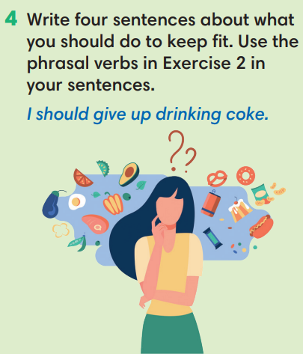
WRAP-UP & HOME WORK (3’)
- T asks Ss to talk about what they have learnt in the lesson.
- Phrasal verbs
- Talk about health & fitness
* HOME WORK:
- Do exercises in the workbook page 40.
- Prepare for Lesson 4.8: Vocabulary in action and Pronunciation

*************************************************************************

